**CONTENTS**

1. Title of the Project
2. Introduction of the Project
3. Objective and Scopes
   1. Objectives
   2. Scope
4. Tools & Platforms
5. Analysis Document
   1. E-R Diagram
   2. Activity Diagram
   3. DFD
6. Design Documents
   1. Module Description
   2. Data Integrity & Constraints
   3. Data Dictionary
   4. Procedural Design
      1. Flow Chart
      2. Algorithm Design
   5. User Interface Design
7. Input and Outputs Screens
8. Program Code
9. Testing
10. Implementation of Security
11. Limitation of the Project
12. Future Application of the Project
13. Are You Doing This Project For Company
14. Bibliography

**TITLE OF THE PROJECT**

“**Online Job Portal”**

**INTRODUCTION TO THE PROJECT**

The word “online job portal” is such a common word, which needs no definition. This word itself defines its meaning which is to provide portal to employer and employee for job.

Now in this changing world the necessity of job has increased out of proportion. In pre-industrial era, mankind were used to search for jobs offline, as for example they used to go for any vacancy notice through walkin. Today we have many other methods and options to find jobs, as for example we have newspaper, online job portals.

Online job portal is a web application built in java. It provides the candidates ability toregister to this application and search for jobs, manage their accounts. Each candidatewill have their own account with their own home page.

On the other hand companies that are willing to publish the jobs for their company tocandidates can register to the job portal and get their own account created and can post jobs to portal‘s database .

Registered companies can add or remove jobs and these jobs can be seen by variouscandidates and they can contact the company person for the job. Main aim of thisweb application is to make a good web application that can make this job searchoption easy and accessible to everyone who are interested.

It provides the Recruitment of people with all the necessary tools to schedulethe interview and applicants to register and apply for jobs and interviewers to view theinterview details. It provides the users with all the necessary privileges to access andmodify the data intended for them.

Our this system which is named as “online job portal” actually deals with this problem of announcement of vacancies for employer and getting info of announced vacancy for jobseeker.

To implement this working system, I have developed a web based project. The World Wide Web and the internet that empowers it are the most important developments in the history of computing. These technologies have drawn us all into the information age. With the help of web we can share information from any one who presents at large distance from us. We can get a lot of information from here instantly and can deliver any textual or graphical message to any where within a second.

**OBJECTIVES & SCOPE**

**OBJECTIVES**

Every project has some objectives, there are some objectives also associated with this project too.

While working on the problem area of the overall online job portal, I have found many drawbacks in the existing system:

* Cannot Upload and Download the latest updates.
* No use of Web Services and Remoting.
* Risk of mismanagement and of data when the project is under development.
* Less Security.
* No proper coordination between different Applications and Users.
* Fewer Users – Friendly

There are many problems with the present system. My System’s main objective is of course to eradicate them in totality but the central objective of my system is as follows:

* User Friendly Interface
* Maximum Jobs Listing
* Minimum Cost
* Minimum Time To Find Desired Job For Jobseekers
* Minimum Time To Find Desired Jobseekers For Employer
* Information Sharing Within Jobseeker And Employer
* Proper Security
* Proper Privacy To All Users

**SCOPE**

My project is a web based project. Here I follow several methodology for gathering information related with project development. I always tried to develop such a project which could be used in any department, which perform same type of work, without or very less modification..

My project mainly focuses on providing better user satisfaction and to provide more profit to the company. My project tag is:

***“Within minimum cost & minimum time, find suitable job/jobseeker”***

This system can be used as an Online Job Portal for the Placements providing to the un employees who are seeking for a job placement. Job Seeker logging into the system and he can should be able to upload their information in the form of a CV. Visitors/Company representatives logging in may also access/search any information put up by Job Seeker.

**TOOLS / PLATFORMS USED**

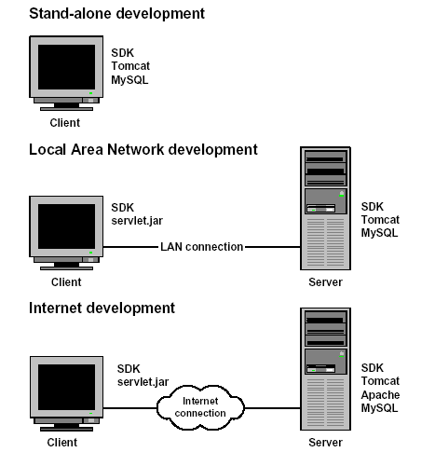

**Tools required for development environment.**

Hardware requirement:

No. of machine: 1.

Processor: Pentium 4 & upward.

Hard disk: 80 GB

RAM: 256 MB & upward

Modem

Keyboard

Mouse

Color Monitor

Software requirement:

Java: JDK8.1, JRE8.0

Server: Apache tomcat 7.0

Html Editor: PageBreeze.

Java Editor: Sun one

Database: Oracle10g

MS-office2013

Operating system: Windows-xp & upward



**Tools required for quality control environment.**

Hardware requirement:

No. of machine: More than 1.

Processor: Pentium 4 & upward.

Hard disk: 80 GB

RAM: 256 MB & upward

LAN card (Each system)

Keyboard

Mouse

Color Monitor.

Networking environment

Software requirement:

For server:

Java: JRE5.0

Server: Apache tomcat 5.5

Database: Oracle9i

Operating system: Windows-xp & upward

For client system:

New version of java enabled web browser.

Operating system: Windows-xp & upward



**Tools required for deployment environment.**

Hardware requirement:

Processor: Pentium 4 & upward.

Hard disk: 80 GB

RAM: 256 MB & upward

Modem card

Keyboard

Mouse

Color Monitor.

Software requirement:

For server:

Java: JRE8.0

Server: Apache tomcat 7.0

Database: Oracle10g

Operating system: Windows-xp & upward

For client system:

New version of java enabled web browser.

Operating system: Windows-xp & upward

**ANALYSIS DOCUMENT**

**E-R DIAGRAMS**

RECRUITER ENTITY

for

Job

do

JobSeeker

to

upload

Resume

Login

post

Messages

Recruiter

Login

Recruiter

LOGIN ENTITYMESSAGE ENTITY

Resume

Message

RESUME ENTITYJOBSEEKER ENTITYJOB ENTITY

JobSeeker

Job

**ACTIVITY DIAGRAMS**

**Login Activity**



Enter Username Password and Type

**JobSeeker Registration Activity**



**Job Recruiter Registration Activity**



**Job Recuriter Activity**



**DATA FLOW DIAGRAM**

1st Level DFD’s

## DFD For New Job Seeker Creation

Check for Registration Details

Registration Details

Job Seeker Details

Insert New

Job Seeker

Job Seeker Details

## DFD For New Recruiter Creation

Check for Registration Details

Recruiter Details

Registration Details

Insert New

Recruiter

Recruiter Details

## DFD For New Job Search Creation

Check for Registration

Details

Insert New

Job Seeker

Job Seeker Details

Registration Details

Job Seeker

Details

Search Job Details

Check for Job

2nd Level DFD’s

##### DFD For New Recruitment Creation

Check for Job Provider

Check for Type

Check for Status

Insert New

Job Seeker

Job Seeker Details

Job Seeker Details

Recruiter Details

Designation Type Details

Recruiter Status Details

Job Seeker Details

Job Seeker Details

Check for Designation

Check for Job Seeker Info

3rd Level DFD’S

***DFD For New Recruitment Creation***

Job Seeker status Details

Recruiter Status Details

Job Seeker Details

Designation Type Details

Job Seeker Details

Recruiter Details

Database Updated

Request for new Job Seeker

**DESIGN DOCUMENTS**

**MODULE DESCRIPTION**

1. **Job Seeker Module:**
   * Authentication Module:

This module is responsible for verifying the user whether they are valid or not or comes in which category.

* Job Search Module:

This module will help Job Seeker to search jobs across portal based on there location and profile.

* + Apply for Job Module:

This module is responsible for applying for jobs. Here Job Seeker can apply for jobs from any where, any time.

* Check Job Status:

Within this module Job Seeker can check their job status for which they applied for..

* Feedback:

Through this a user can pass their opinion about the company to the server.

1. **Job Recruiter Module:**
   * Authentication Module:

This module is responsible for verifying the user whether they are valid or not or comes in which category.

* Post Job Module:

Through this module recruiter can post jobs.

* Job Seeker Search Module:

This module will help recruiters to find job seekers. Based on job profile and location recruiter can search for job seekers.

* Select for Interview Module:

Through this module Recruiter can select job seeker for interview.

* Feedback:

Through this a user can pass their opinion about the company to the server.

1. **Administrative module:**
   * Authentication Module:

This module is responsible for verifying the user whether they are valid or not or comes in which category.

* + Reports Module:

Within this module administrator can view various reports like list of jobs/jobseekers/recruiters.

* + Deletion Module:

Through this module, administrator can remove job seeker profiles/ recruiter profiles/jobs.

**DATA INTEGRITY & CONSTRAINTS**

Data integrity (for database) is the mechanism that is applied to ensure that the data in the database is correct and consistent. I applied “**Semantic Integrity**” i.e. need for maintaining database integrity in process of user modifications. It is handled both implicitly by the data model (RDBMS : Oracle) and explicitly by the checks and constraints on data that could be entered by the user .

The following semantic integrity and constraint explicitly are imposed by the s/w developed. These constraints are applied by keeping in mind customer requirements as well as consistent working of the system: --------

**Table (i) : Data Integrity & Constraint Applied in S/w**

|  |  |
| --- | --- |
| **Module Name** | **Applied constraint to maintain data integrity** |
| JOB SEARCH | * Search query need to be entered else entry denied. * Only registered job seekers can search for job. |
| POST JOB | * Only registered recruiters can post jobs. * Job details need to be entered otherwise denied. |
| JOB STATUS | * Registered users except admin can see job status. * Only status of applied job will be shown. |

**Security & Other Constraints**

* Each profile must be created or deleted by owner of profile or administrator.
* (username, password, type) pair constraint to be unique for each profile.
* Module name can be one of the possible modules existing in the system (viz. Job Search, Job Status , Reports, Post Job etc)

**DATA DICTIONARY**

After carefully understanding the requirements of the client the entire data storage requirements are divided into tables. The below tables are normalized to avoid any anomalies during the course of data entry.

LOGIN

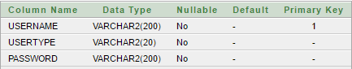

MESSAGE

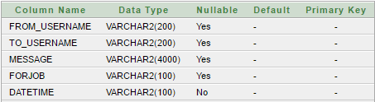

JOBSEEKERRESUME

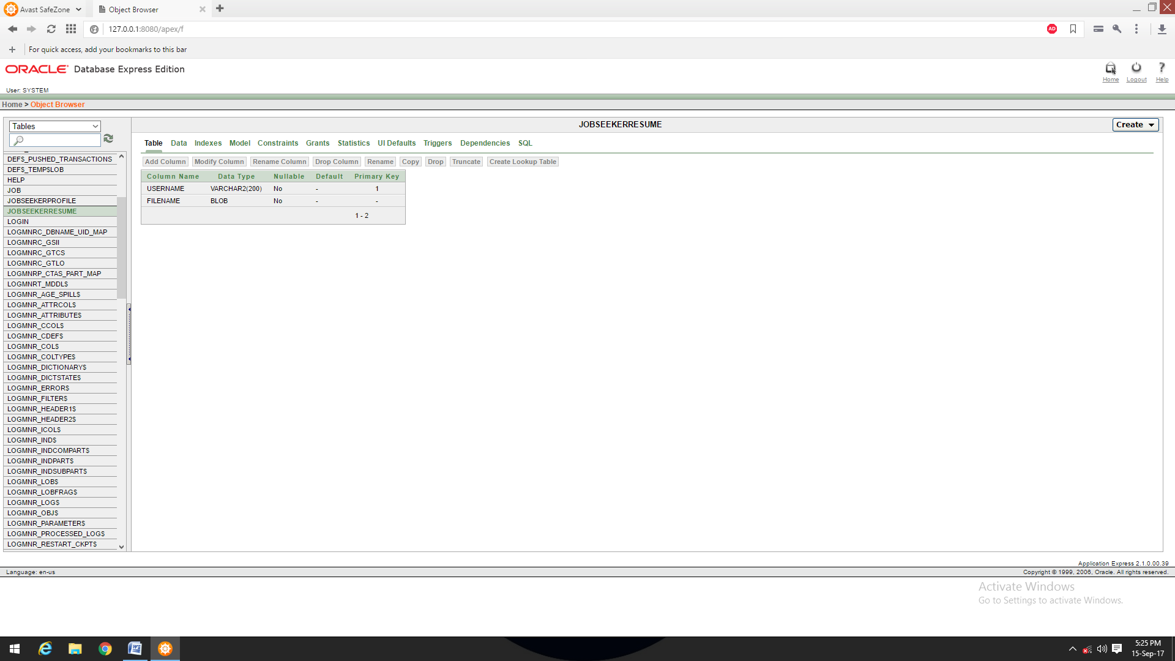

JOBSEEKERPROFILE

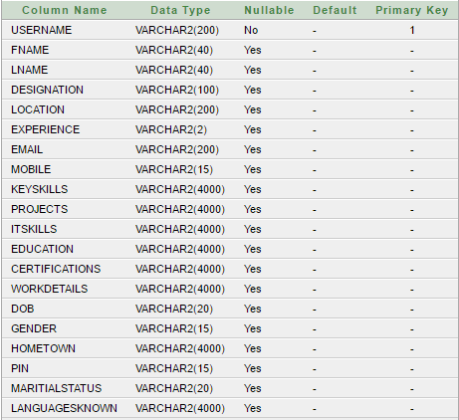

JOB

-JobID:int

-Title:String

-Location:String

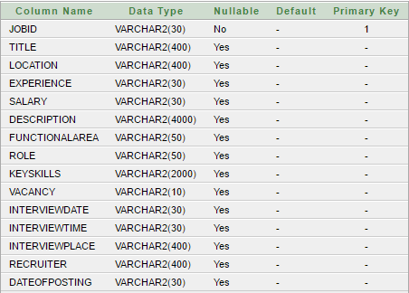

RECRUITERPROFILE

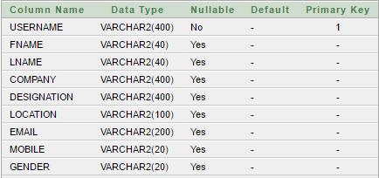

**PROCEDURAL DESIGN**

**1. Flow chart**

FLOW CHART FOR USER AUTHENTICATION

1

Read username, password, type

Valid entry? 2

no

yes

yes

3

Verify from DB

4

Correct=?

reentry=?

6

message

no

yes

no

5

Open homepage

**Fig: flowchart1**

FLOW CHART FOR JOB SEARCH

1

Read keyword, location, experience, expectedsalary

2

Flag=checkvalidity(keyword, location, experience, expectedsalary)

yes

reentry=?

3

flag=?

no

yes no

4

Search from DB

5

Show List of Jobs

6

selectjob=?

no

yes

8

Show jobdetails

**Fig: flowchart2**

**2. Algorithm design**

ALGORITHM FOR VARIFICATION OF USER

**Algorithm:**

**Input:** username, password, type;

**Output:** allow/denied access to home page

**Process:**

* + 1. Prompt the username, password, type input
    2. Perform syntactical validation on entry
    3. If entry is invalid

Then

Information to the user &return from program

* + 1. Else

4.1 check with database

4.2 If entry is invalid

Then

Information to the user & prompt again for entry

if yes then

goto step1

else

return from program

else

Open home page

**ALGORITHM FOR JOB SEARCH MODULE**

**Now Booking**

**Algorithm:**

**Input:** keyword, location, experience, expectedsalary

**Output:** List of Mathing Jobs

**Process:**

* + 1. Prompt the user for search query
    2. Check whether entry is valid or not
    3. If entry is invalid

Then

Information to the user & prompt again for entry

1. Else

4.1 check with database

4.2 If entry is invalid

Then

Information to the user & prompt again for entry

if yes then

goto step1

else

return from program

else

show list of jobs

**USER INTERFACE DESIGN**

While creating user interface I followed all 3 golden rules of “**Mandel”:---**

* Placed the user in control with program the interface do what the user desire.
* Reduced the user’s memory load with less command based and intuitive shortcuts.
* Make the interface consistent, however this is not relevant to my s/w project, because it is not a incremental series s/w product where I’ve to face interface consistent.

As we know the analysis & design of user interface is “**Iterative**” and can be represented by a spiral --------->

**1.UserTask & Environment**

**3.Implemetation & Inteface construction**

**4.Interface Validation**

**2.Interface Design**

**Figure (i) :User Interface Design Process**

**Phase 1 : Interface Analysis**

Because the system is not very complex and also the firm has some computer literate (so training is easy) person who presented the need, thus these interface design process were straightforward to comprehend with little endeavor,also not each step of UID is applicable. I conducted ---- >

* **User Interview:** Here , I met with few personnel of various firm and got the idea that what they expect of how the interface would look and which kind of interaction they like.

Response was obvious a typical GUI-based facility providing interface. Some of the questions asked were----

* + - Are user trained, clerical, technician workers?

Ans.: Computer literate (so training is easy) .

* + - What level of formal education does the average user have?

Ans : Operator or users of system are literate enough to work with system. .

* + - Are users expert typist or keyboard phobic?

Ans.: Depend on the kind of user(both).

* + - Is s/w an integral part of the system or used only occasionally?

Ans. :Yes,it is not use occasionally.

* **Task Analysis:**Relevant fact findings were:----
  + - What work the user will perform in special circumstances?

Ans.: Job Search, Job Post, Report generation,

* + - What is the sequence of work task of job search(workflow) ?

Ans. :The work flow is--

Enter job details => Search for job => Show list of jobs => Apply for Job=> Report generation (if required)

**Phase 2: Interface Design**

Interface design is an iterative process. Here, I identified different interface objects and actions iteratively. Based on this following (an excerpt), objects and data items are identified.-------

* Enter “**Password**” to access home page.
* “**Main Screen**” with different options (modules) appears.
* User selects or clicks on desired “**Modules**”
* Particular “**Form**” is opened and “**Data Fields**” are displayed
* User clicks on the options available on form screen.
* Relevant actions are performed.
* “**Reports**“ or “**Enquiry**” in report module are generated on wish.
* **UID Patterns:**It is an abstraction that prescribe a design solution to a specific, well bounded design problem. Among hundreds of UID patterns one I used has following description:--

**Whole UI:**Provides design guidance for top level structure and navigation.

**Pattern:**Top-level Navigation

**Brief Description:** Provide a top-level menu coupled with identifying graphic or text button that direct navigation to any of the system’s major functions.

**Phase 3 & 4 : Design, Evaluation & Validation**

This phase has completed by going through **User Interface Evaluation cycle**with 2 or 3 iterations as system was not very complex. for my problem n=3 (iterations)

**PRELIMINARY DESIGN**

**BUILD PROTOTYPE #n**

**INTERFACE**

**DESIGN MODIFICATIONS ARE MADE**

**EVALUATION IS STUDIED BY THE DESIGNERS**

**USER [AVI]**

**EVALUATION INTERFACE**

**BUILD PROTOTYPE #1**

**INTERFACE**

**INPUT AND OUTPUTS**

**LOGIN PAGE**

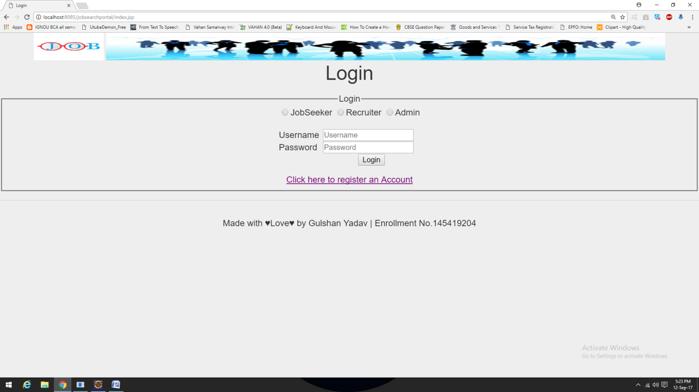

This page is for user verification purpose. Only registered users can access website.

Default username and password for admin login are

Username : admin

Password : admin

Recruiter and JobSeekers have to register before trying to access website contents.

**When Trying to Login Without Selecting Usertype**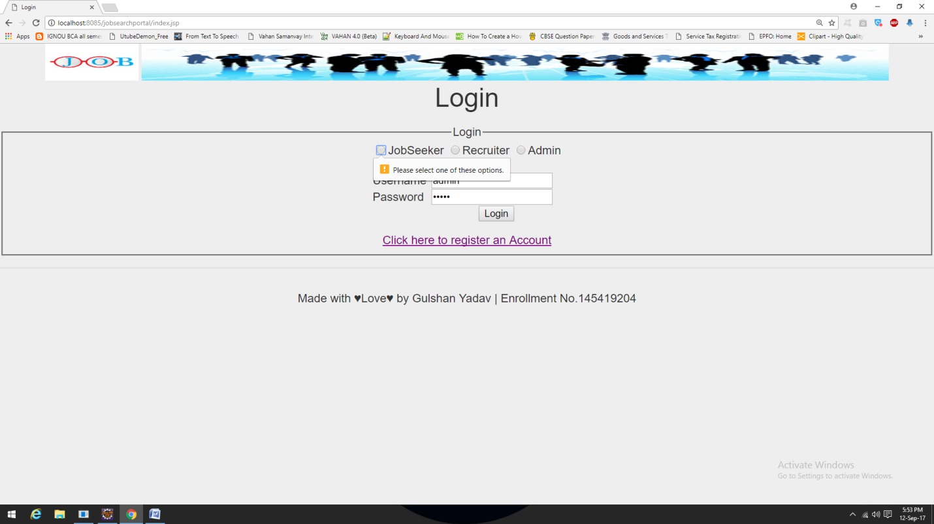

**When Trying to Login Without Entering Password** 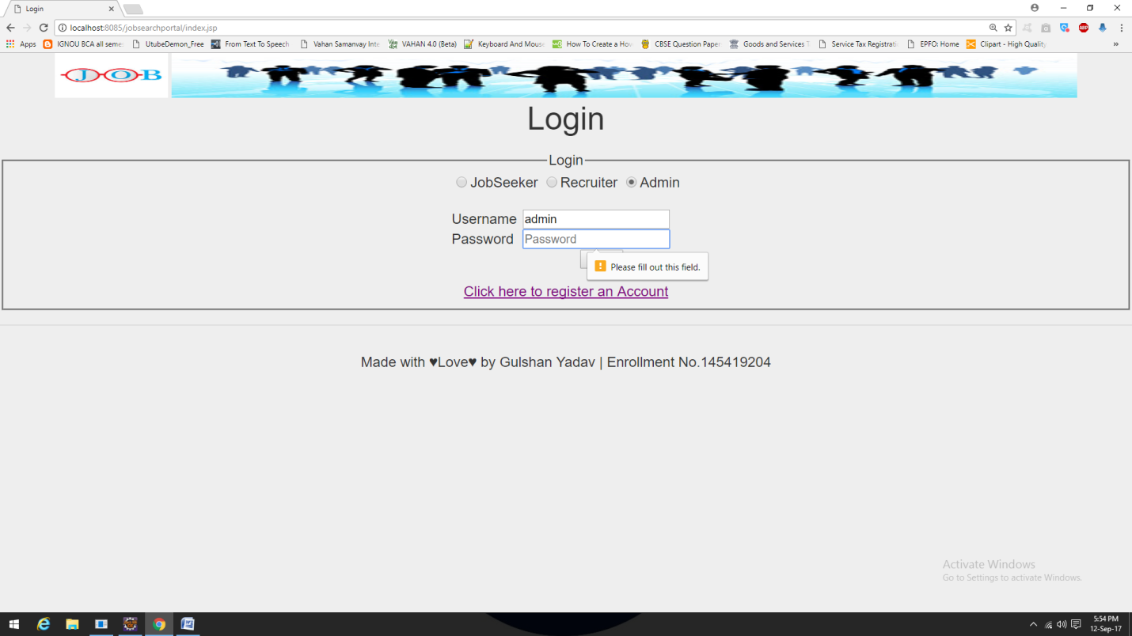

**When Trying to Login With Wrong Details**

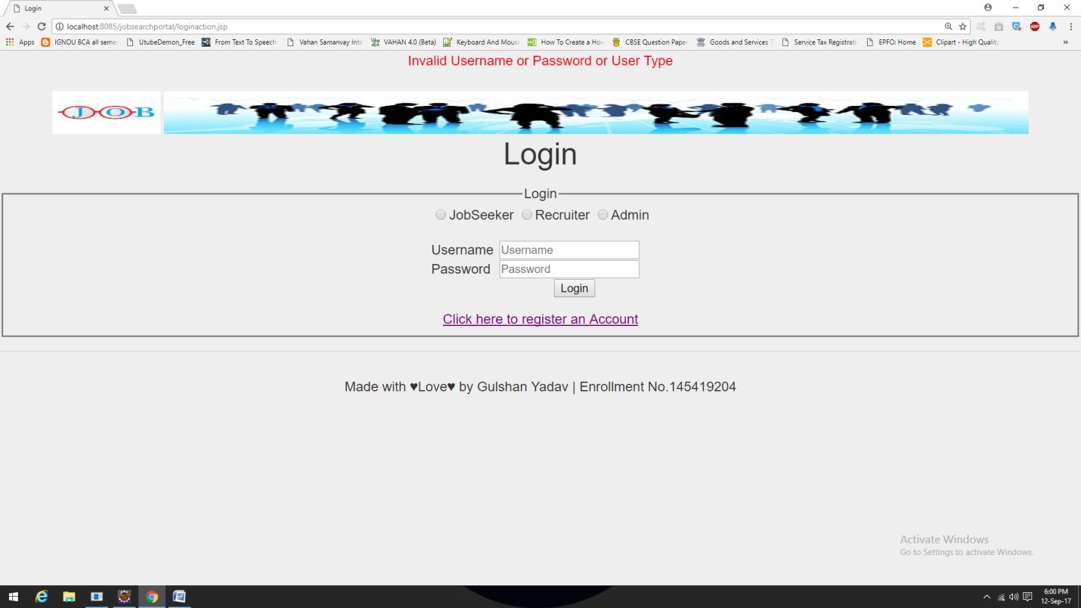

**NEW USER REGISTRATION PAGE**

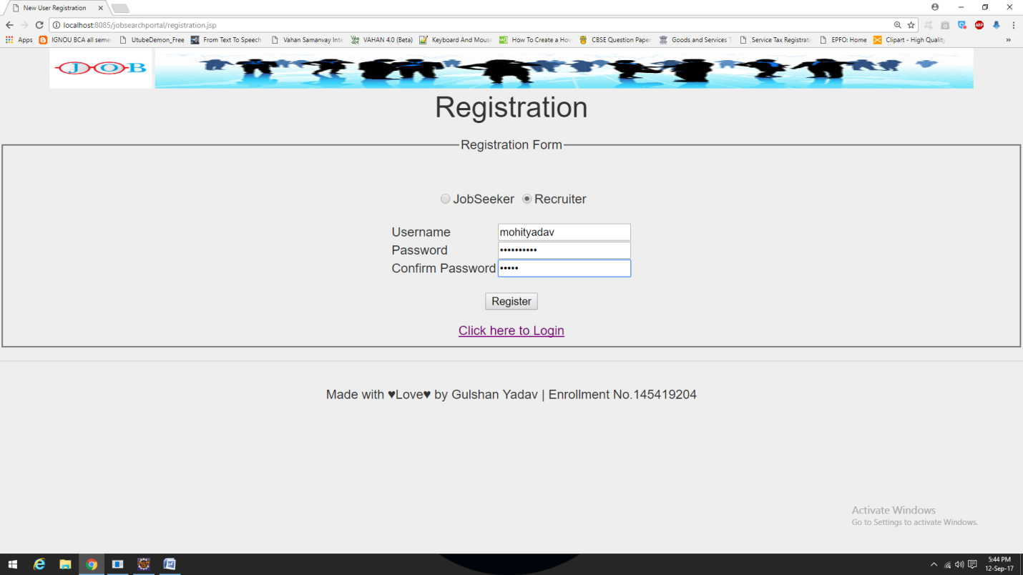

**When Passwords Don’t Match While Registration Process**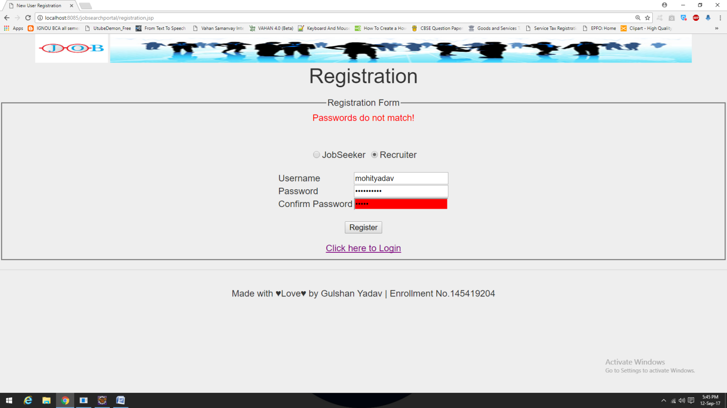

**When Registering Without Selecting Usertype**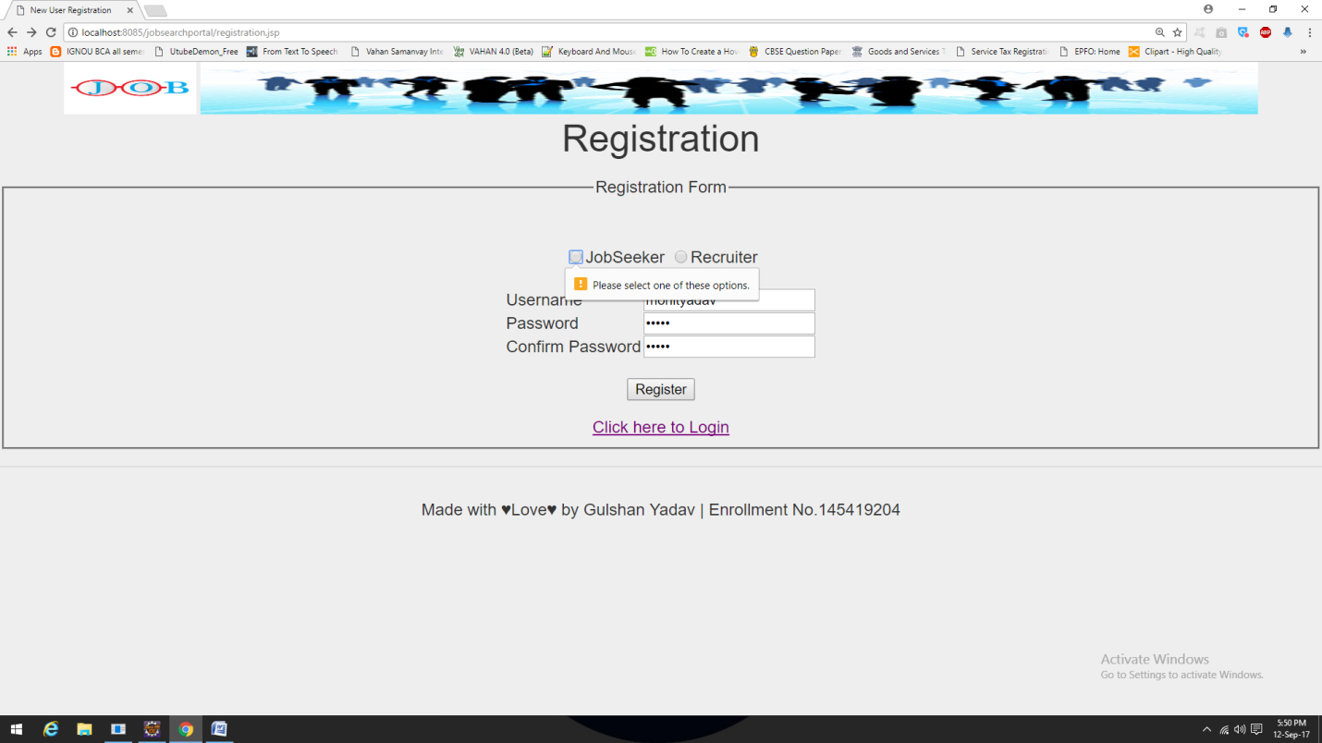

**LOGOUT PAGE**

**When User Do LogOut From Session** 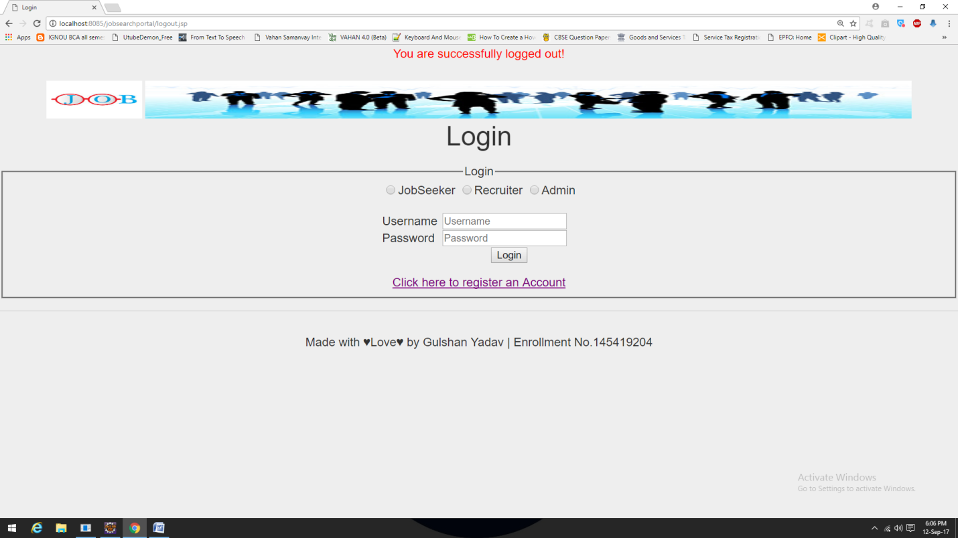

**ADMINISTRATOR HOME PAGE**

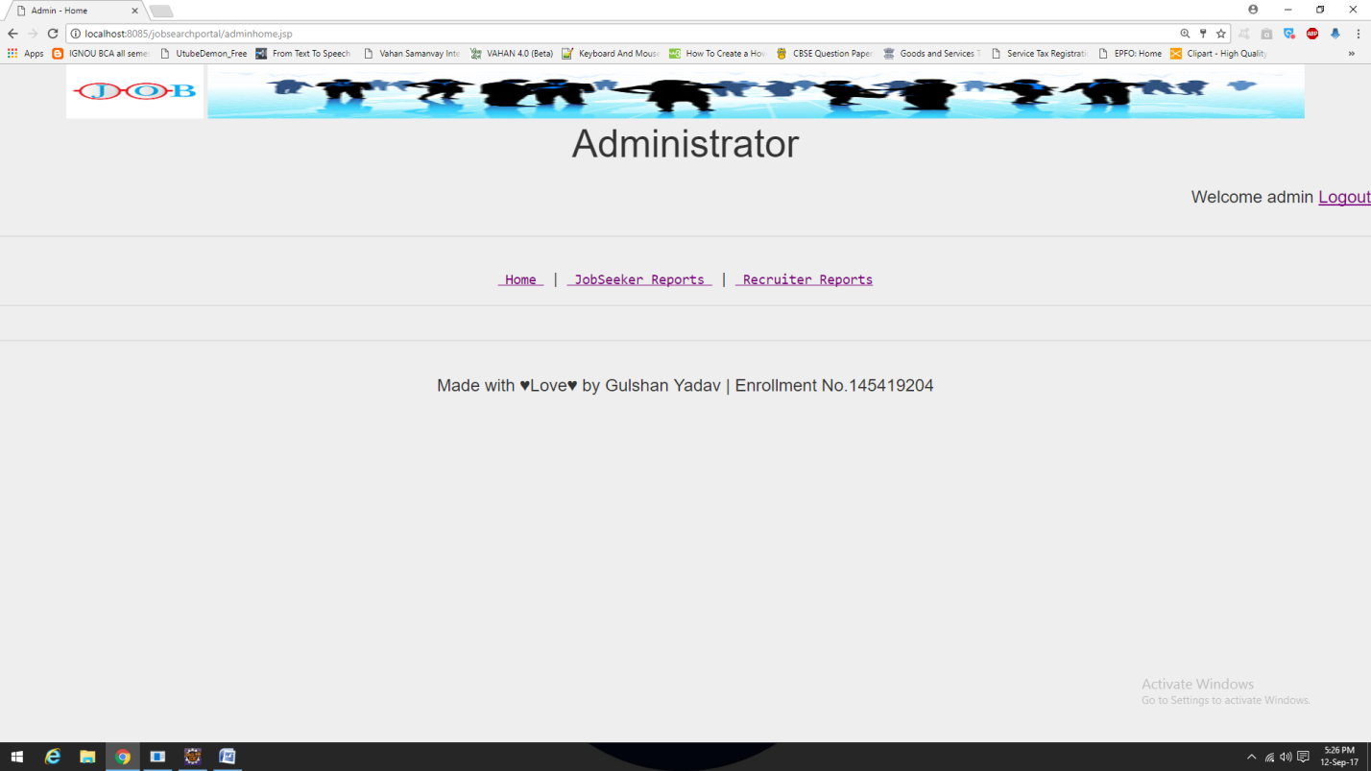

This page is for administrator. All possible activities for the administrator are listed here.

1. Home: -

This link is for administrator homepage.

1. JobSeeker Reports.:-

With the help of this link administrator can delete or view JobSeekers profile.

1. Recruiter Reports:

From this link administrator can manage recruiters profile.

**‘JOBSEEKER REPORTS’ PAGE ON ADMINISTRATOR**

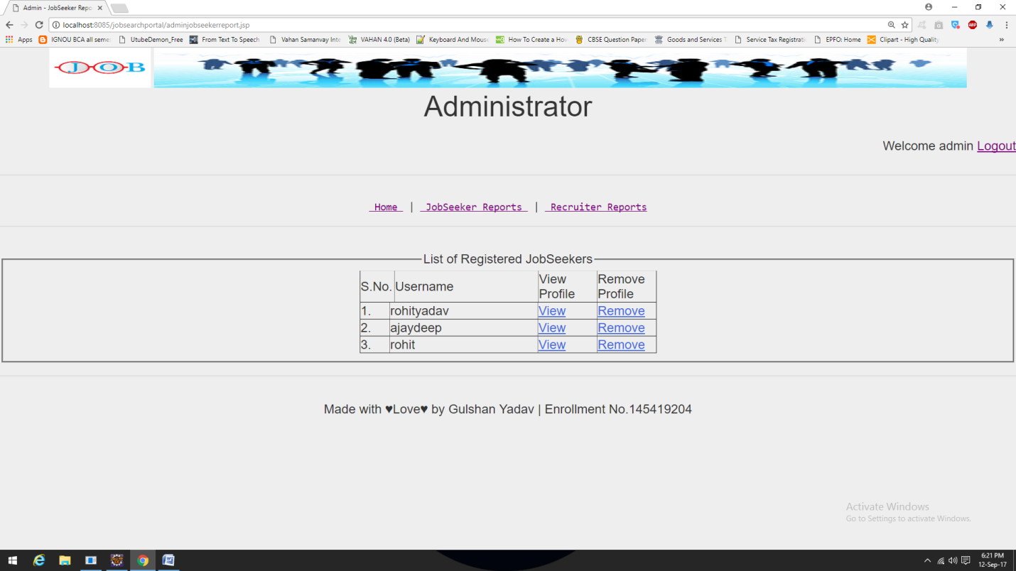

This page is for administrator. All possible activities for the administrator are listed here.

1. View: -

This link will open correspondence jobseeker’s profile page.

1. Remove: -

This link will remove correspondence jobseeker’s profile from database.

**‘RECRUITER REPORTS’ PAGE ON ADMINISTRATOR**

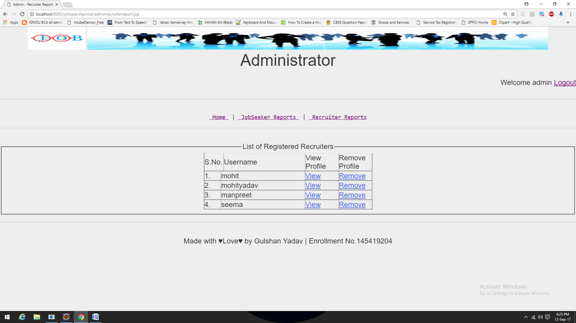

This page is for administrator. All possible activities for this page are listed here.

1. View: -

This link will open correspondence recruiter’s profile page

1. Remove: -

This link will remove correspondence recruiter’s profile from database.

**RECRUITER HOME PAGE**

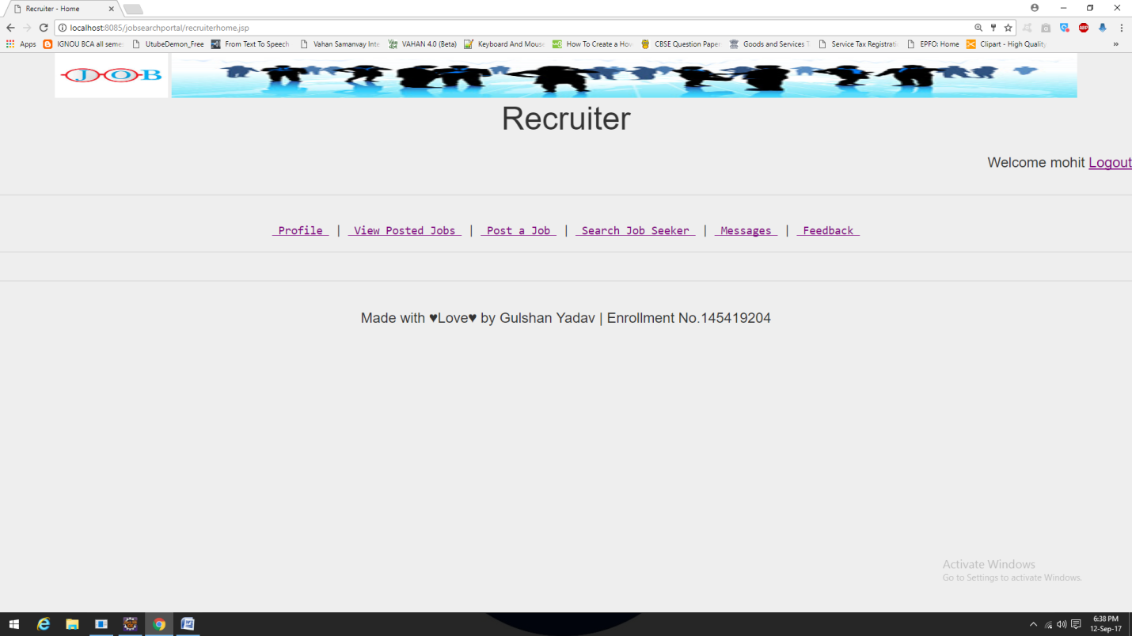

Profile View Posted Job Post a Job Search Jobseeker Message Feedback

This page is for Recruiter. All possible activities for the recruiters are listed below.

1. Profile :-

This link is used to view/update profile of logged recruiter.

1. View Posted Jobs:-

This link will show jobs that is posted by current logged in user.

1. Post a Job:-

This link is used to post new job.

1. Search JobSeeker:-

This link is used to search registered jobseekers.

1. Message:-

This link is used to message box which contains information about jobseekers who have applied to jobs.

1. Feedback:-

This link is used to submit feedback about website.

**‘PROFILE’ PAGE ON RECRUITER**

**When Recruiter Updated There Details**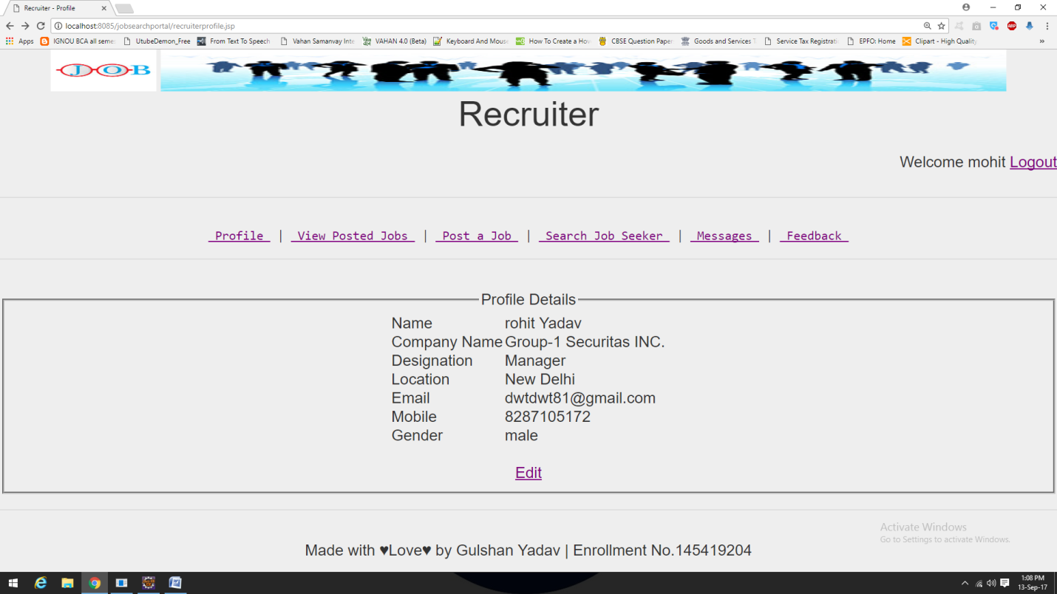

This page is for recruiter. All possible activities for the recruiter are listed here.

1. Edit: -

This link is used to edit/update logged recruiter’s profile details.

**When Recruiter Clicks On ‘Edit’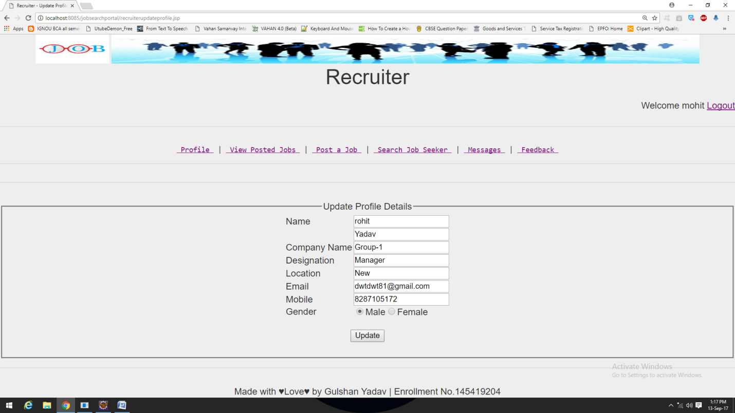**By clicking on **‘Update’** Button Recruiter can update there profile details.

**When Recruiter Is New**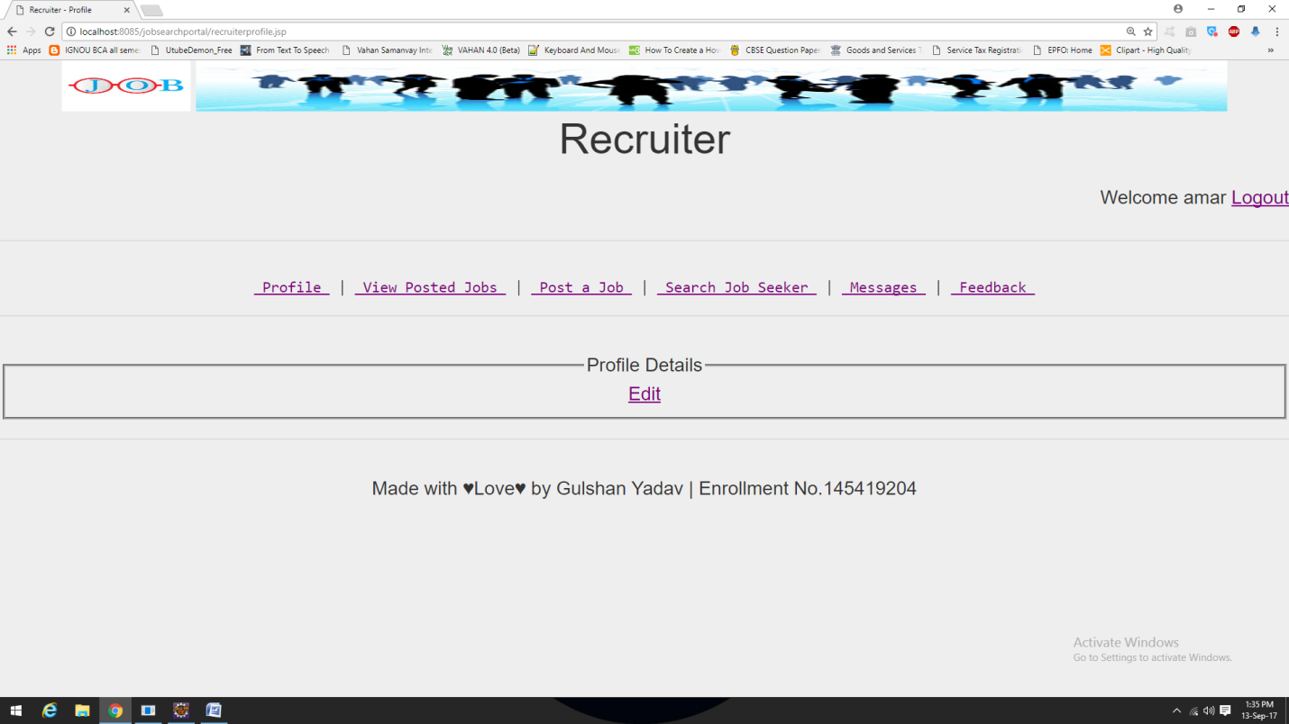By clicking on’**Edit**’ recruiter can edit there profile details

**‘VIEW POSTED JOBS’ PAGE ON RECRUITER**

**When There Is No Job Posted By Recruiter**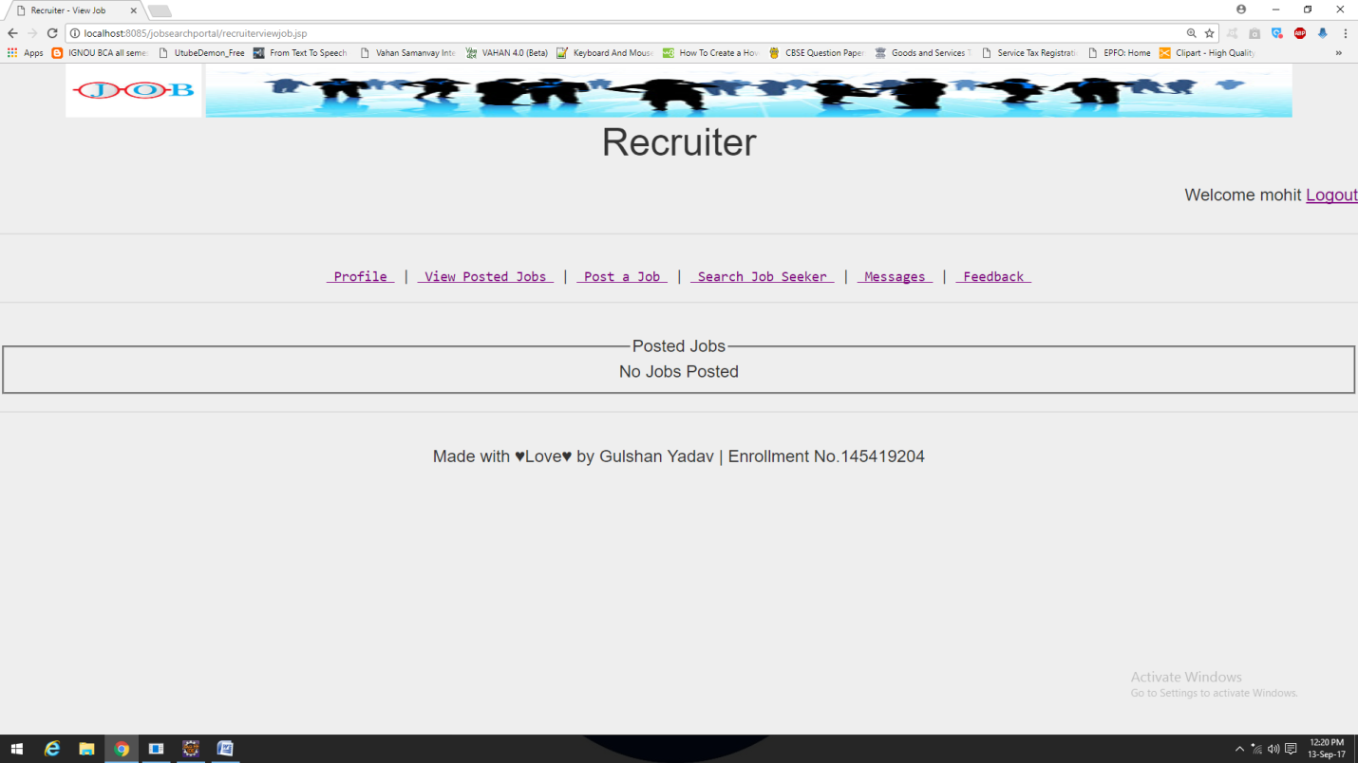

**When There Are Jobs Posted By Rectuiters**

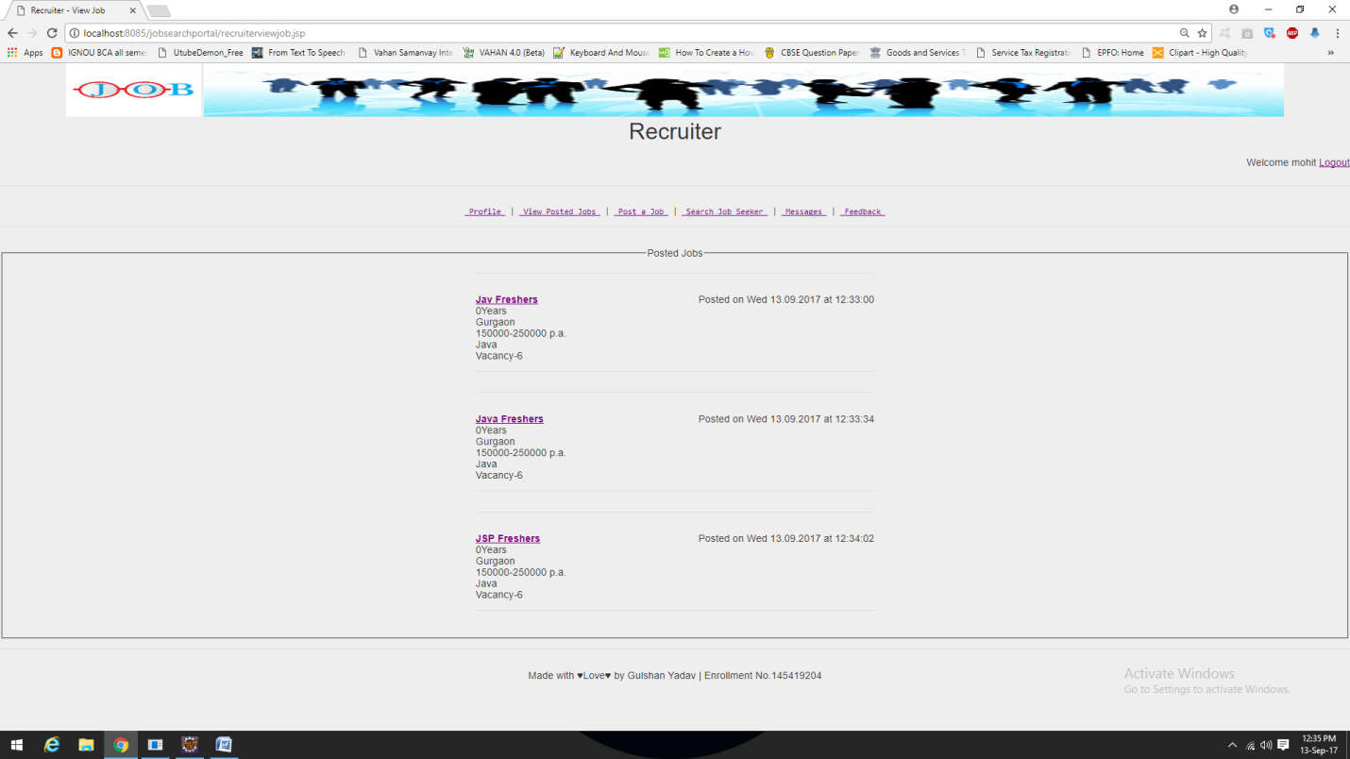 Recruiter can open JobSeeker’s Profile Page by clicking on that JobSeeker’s name.

**‘POST A JOB’ PAGE ON RECRUITER**

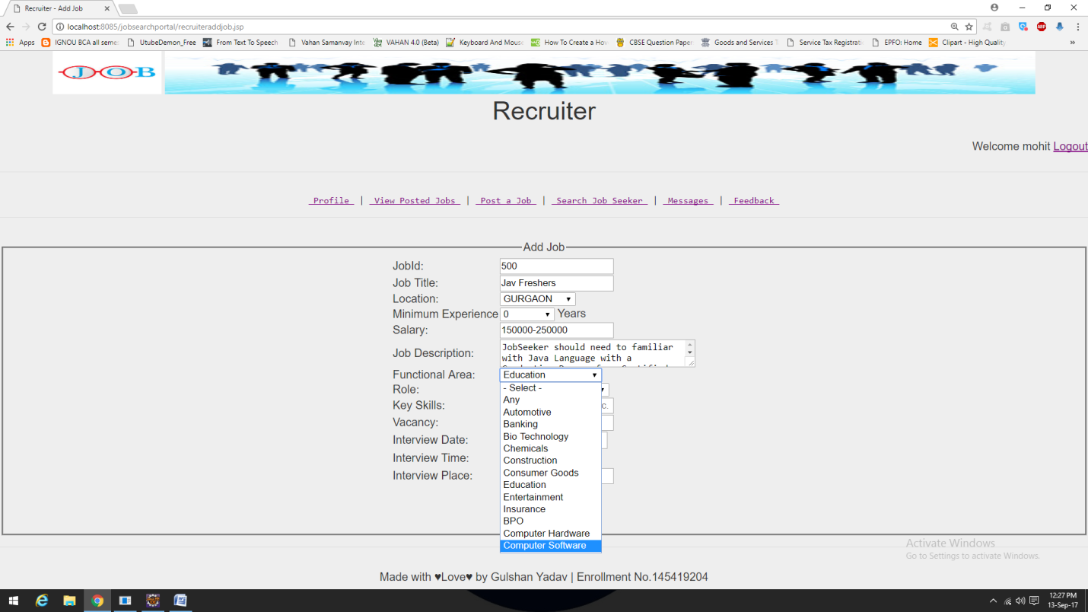

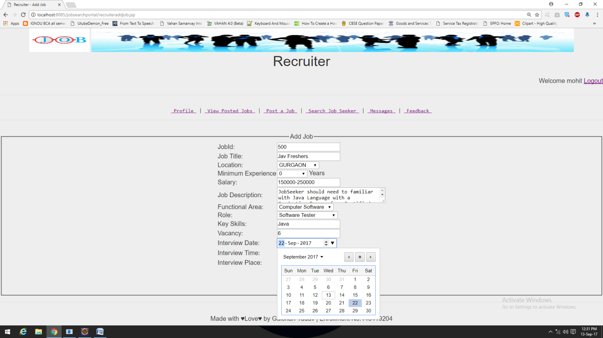

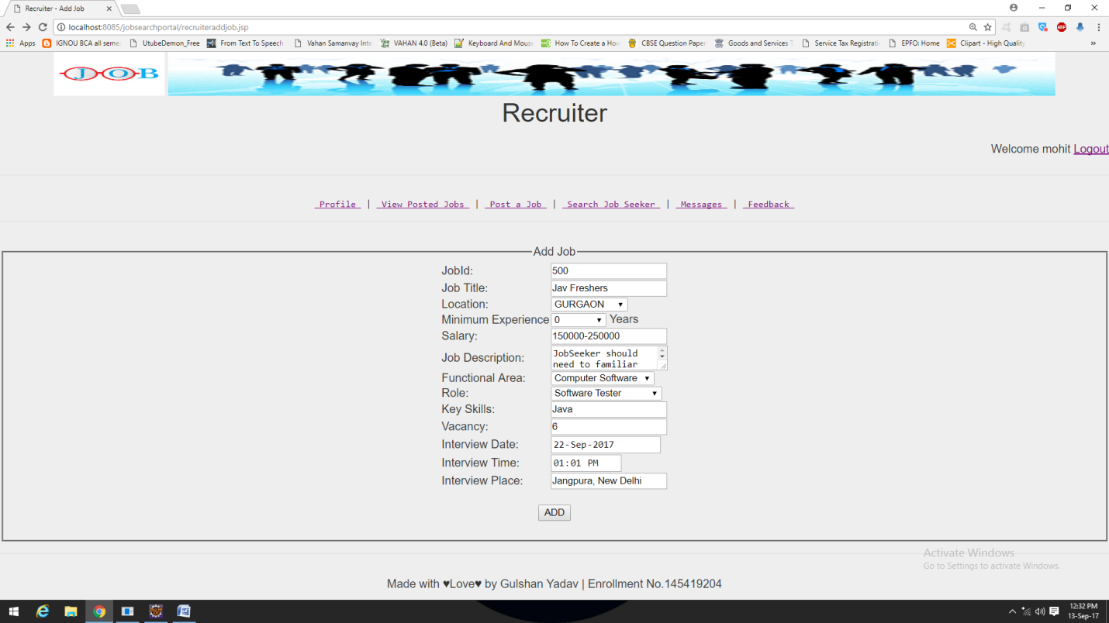

**JOB DETAILS PAGE ON RECRUITER**

**When Recruiter Views Jobs There Are No “Apply For Job” Option**

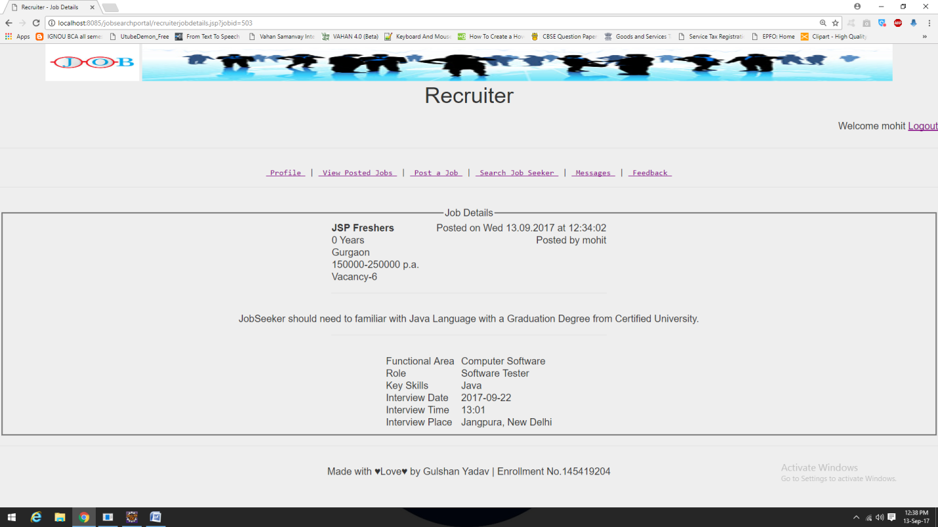

**‘SEARCH JOB SEEKER’ PAGE ON RECRUITER**

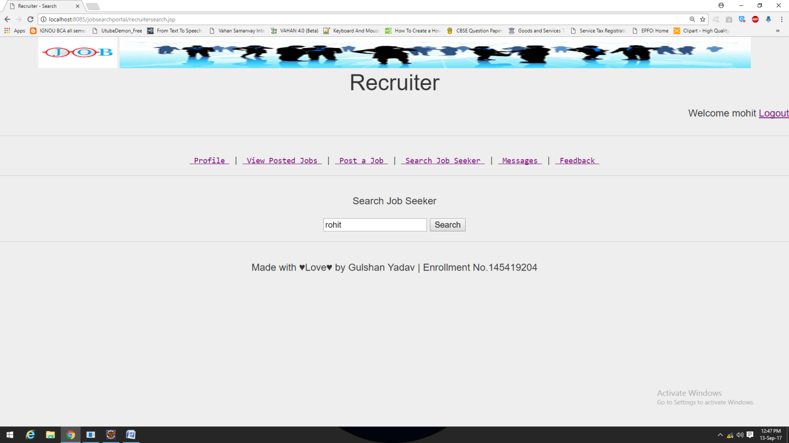

**Search Result Page When Searched For “rohit”**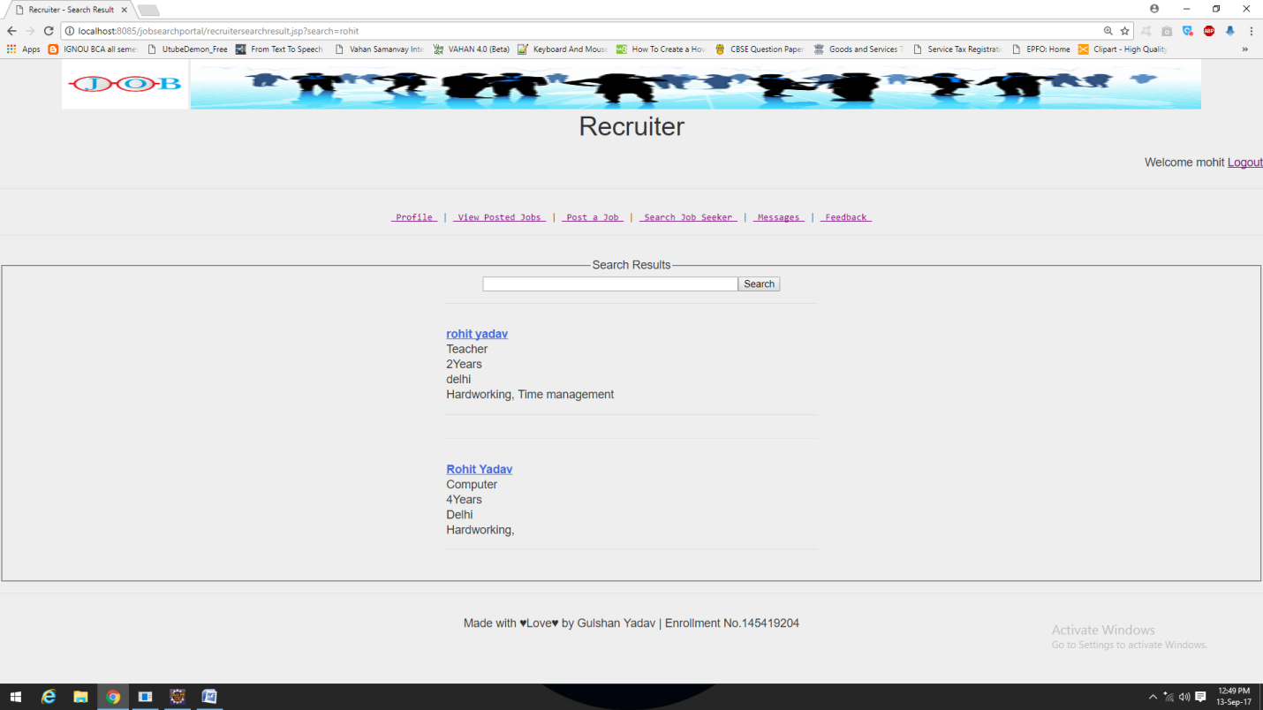

**JOBSEEKER PROFILE PAGE ON RECRUITER**

**When Recruiter Is Accessing JobSeeker Profile There Is ‘Send Message’ Option By Which Recruiter Can Send Message To That Perticular JobSeeker.**

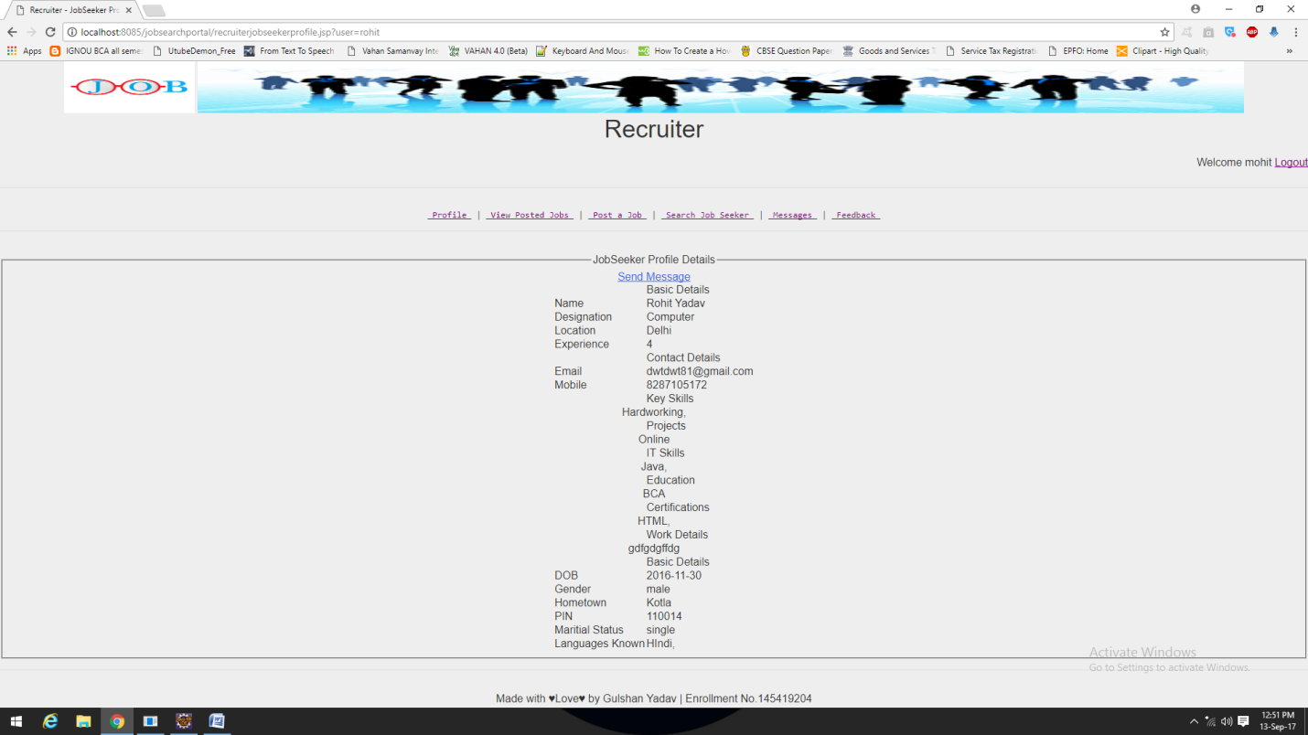

**‘Send Message’ Page**

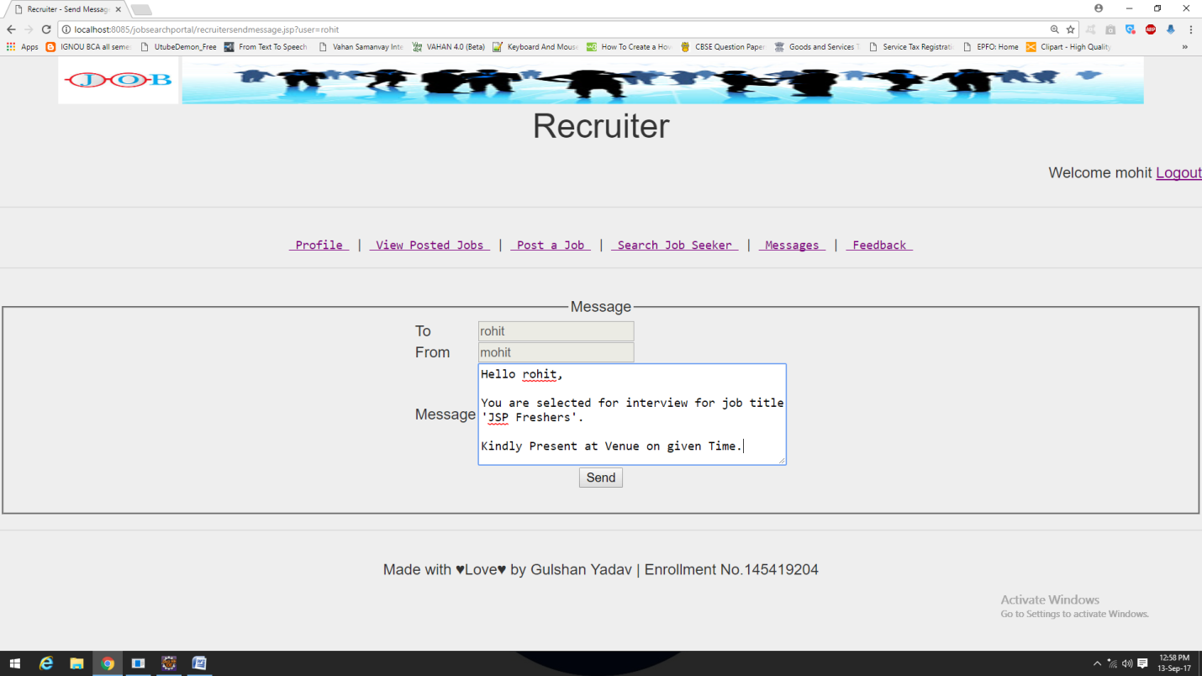

**‘MESSAGES’ PAGE ON RECRUITER**

**When There Is No Message For Recruiter**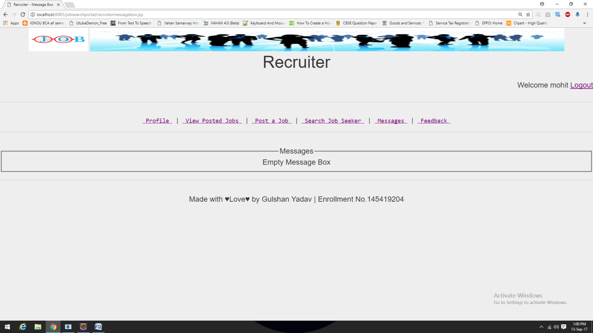

**When There Are Messages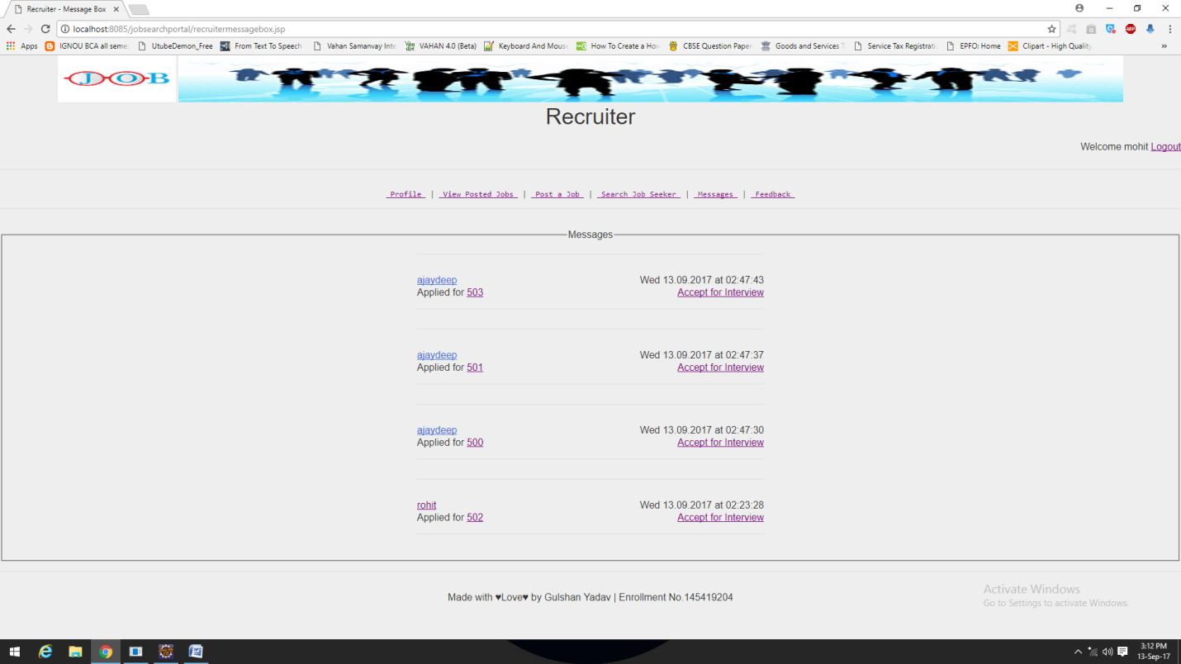In First Message ‘ajaydeep’ applied for job id 503 on Wednesday 13.09.2017 at 02:47:43**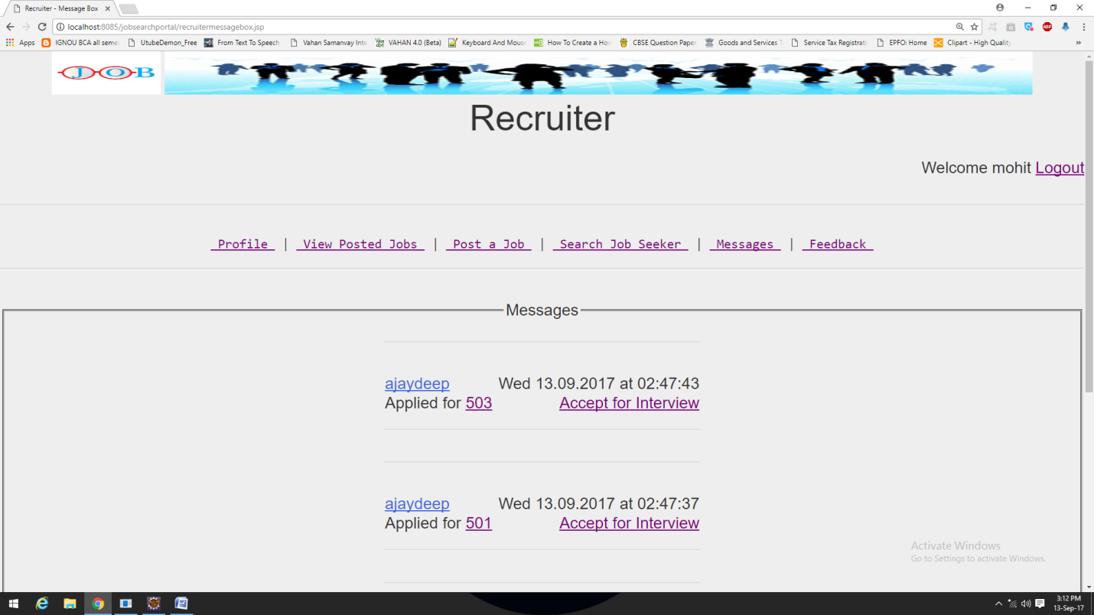

By clicking on ‘503’ job details page will open which is saved in database as jobid=501.

By clicking on ‘Accept for Interview’ a message will send to’ajaydeep’ (who is a jobseeker) that he is got selected for interview.

By clicking on ‘ajaydeep’ (who is a jobseeker) jobseeker profile page will open.

**‘FEEDBACK’ PAGE ON RECRUITER**

**Recruiter’s Feedback Page**

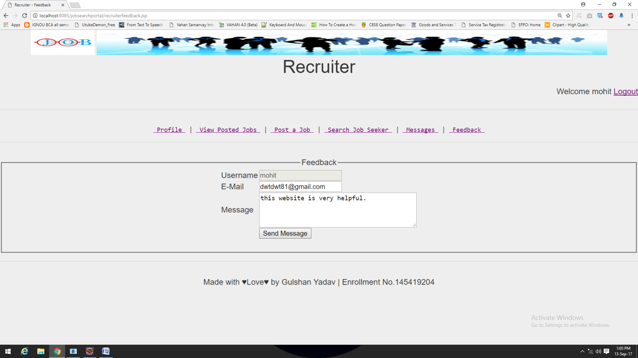

**JOBSEEKER HOME PAGE**

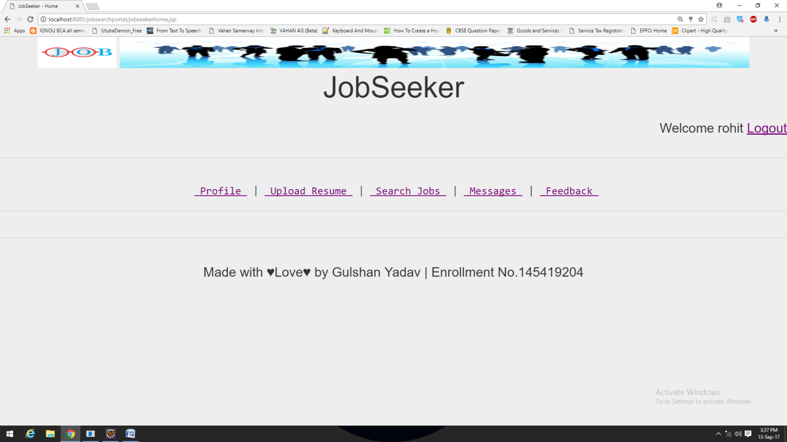

This page is for Recruiter. All possible activities for the recruiters are listed below.

1. Profile: -

This page will open profile page of current logged in user.

1. Upload Resume:-

This link is used to upload resume.

1. Search Jobs:-

This link is used to search jobs posted by recruiters.

1. Messages:-

This link is used to view received messages about job selection.

1. Feedback:-

This link is used for feedback page to submit a feedback about website.

**‘PROFILE’ PAGE ON JOBSEEKER**

**When JobSeeker Updated There Details**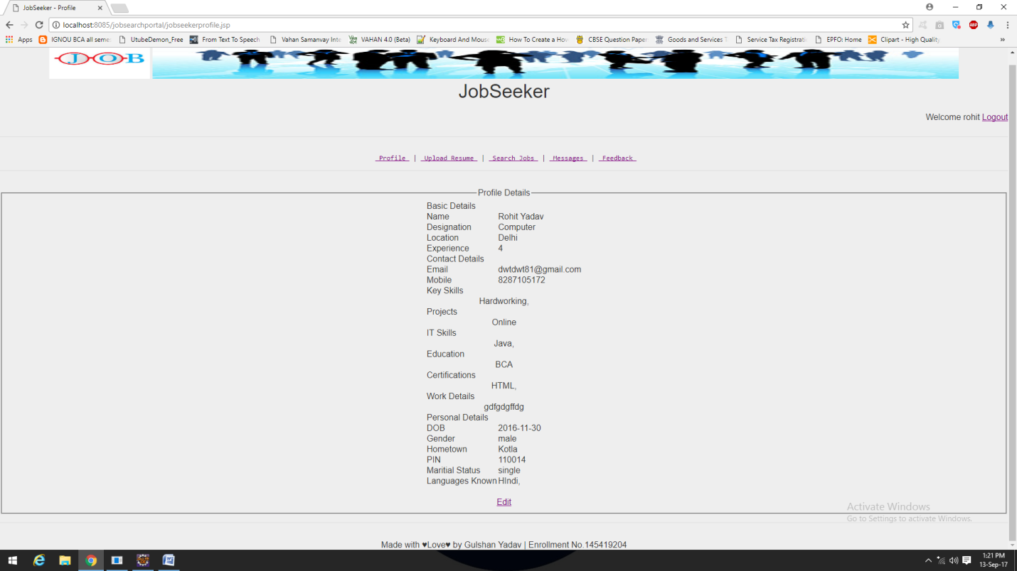 This page is forjobseeker. All possible activities for the jobseeker are listed here.

1. Edit: -

This link is used to edit/update logged jobseeker’s profile details.

**When JobSeeker Clicks On ‘Edit’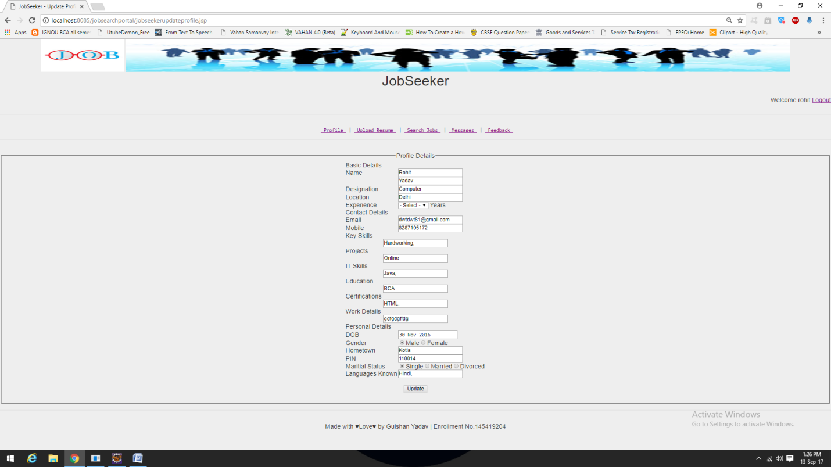**By clicking on ‘**Update**’ Button JobSeeker can update there profile details.

**When JobSeeker Is New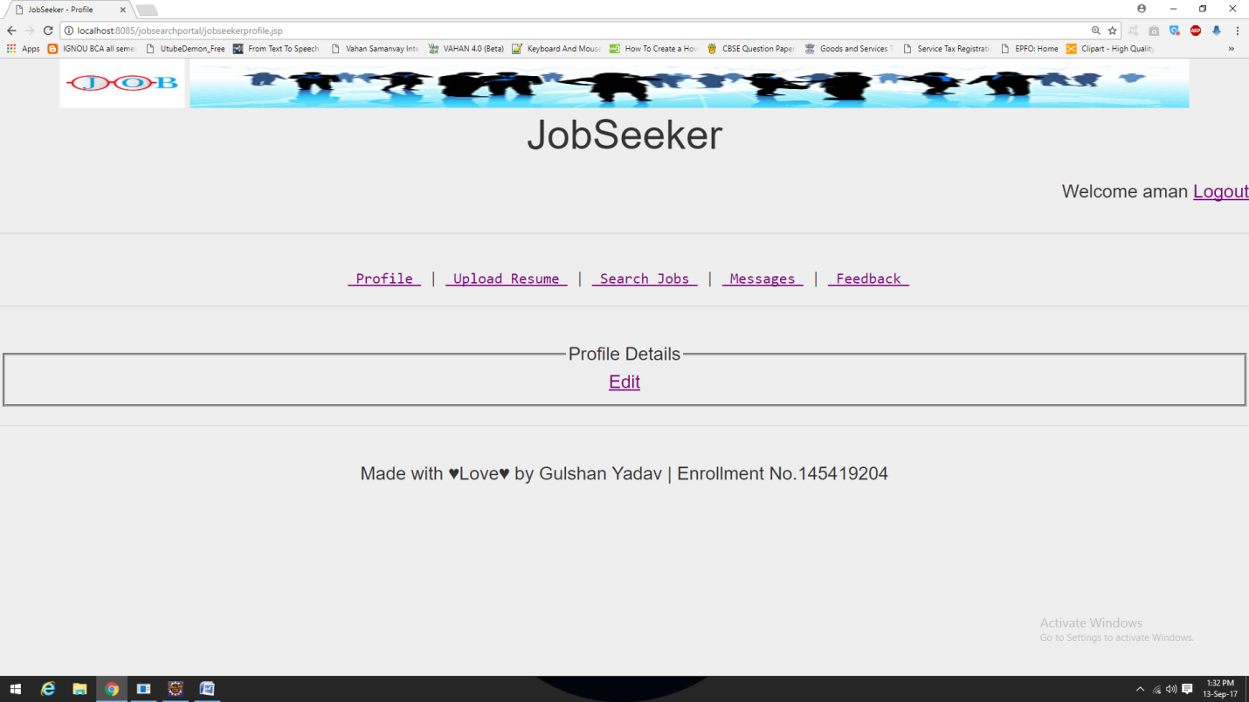**By clicking on **‘Edit’** JobSeeker can edit profile details.

**‘UPLOAD RESUME’ PAGE ON JOBSEEKER**

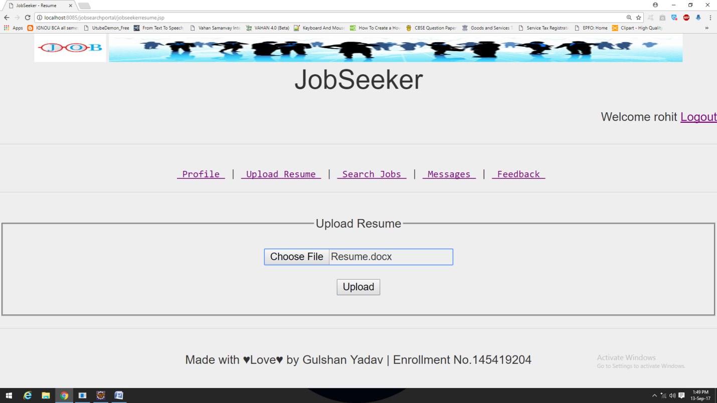By Clicking on **“Upload”** JobSeeker can upload there resume on website.

**‘SEARCH JOBS’ PAGE ON JOBSEEKER**

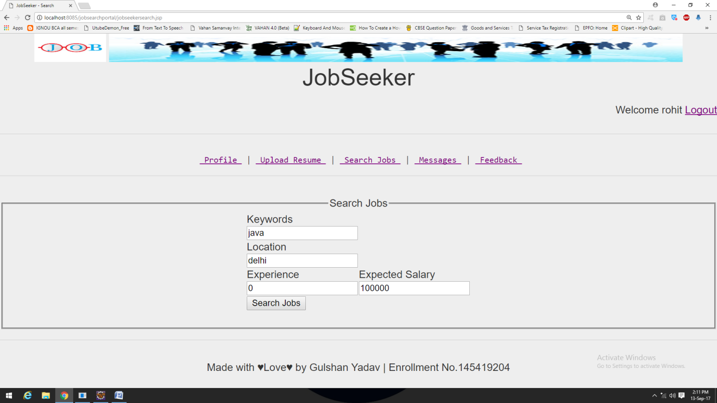

**Search Result Page When Searched For “Keywords:java, Location:delhi, Experience:0, Expected Salary:100000”**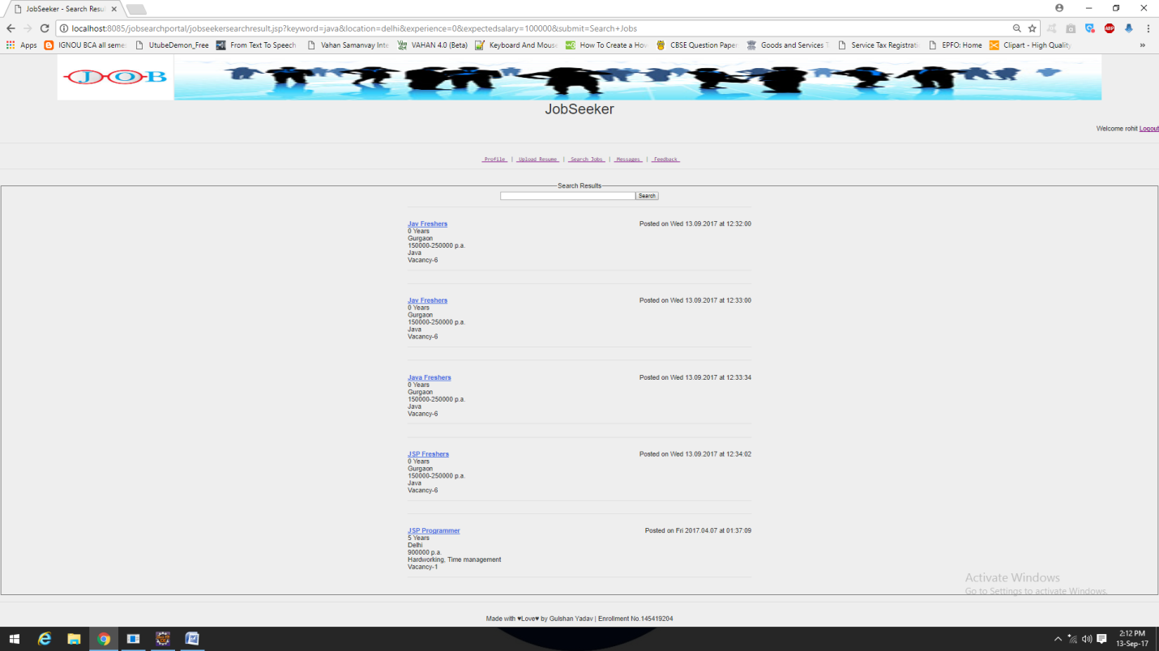

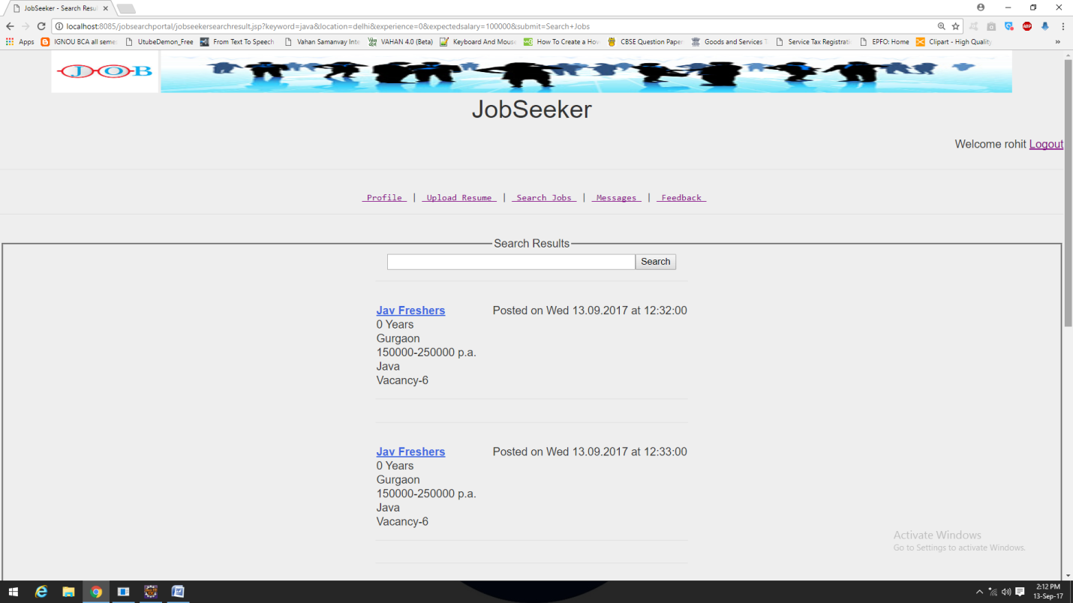

**JOB DETAILS PAGE ON JOBSEEKER**

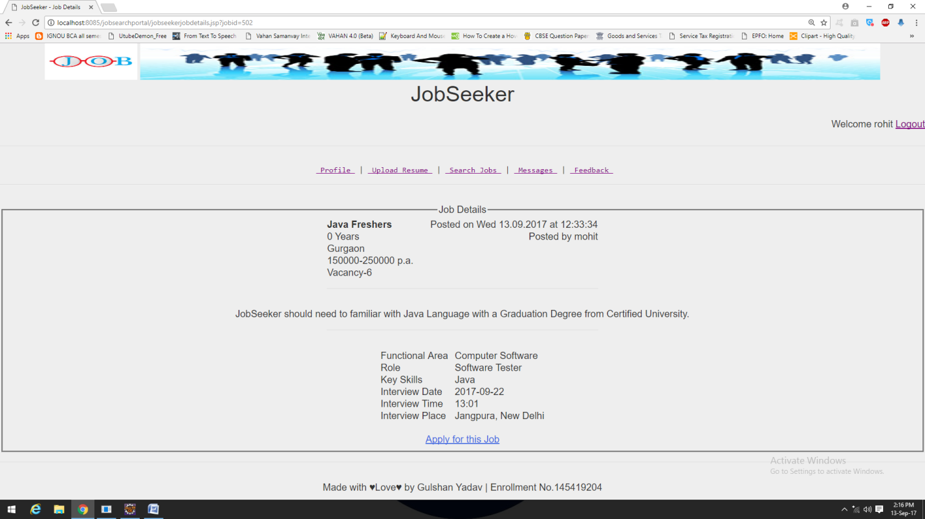By clicking on “**Apply for this Job**” JobSeeker can apply for selected job.

**‘MESSAGES’ PAGE ON JOBSEEKER**

**When There Is No Message**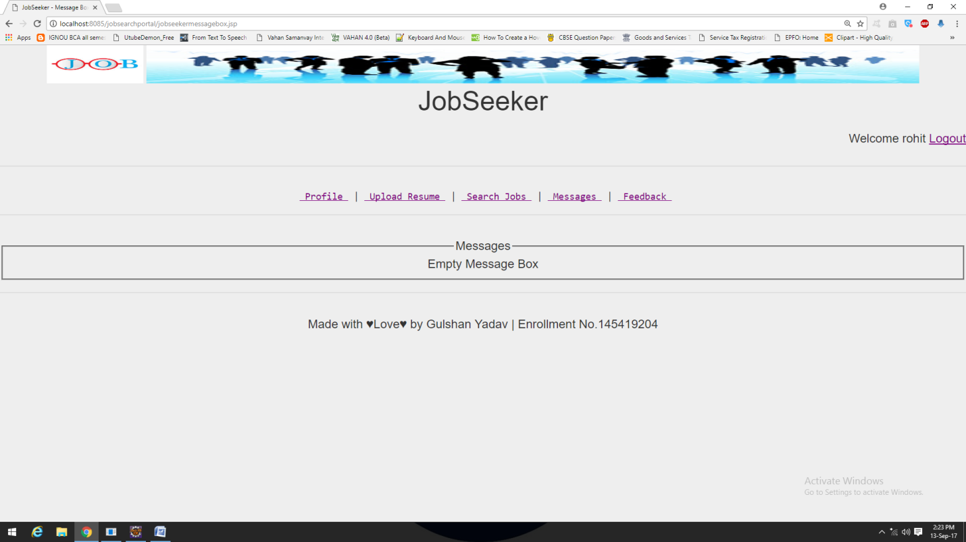

**In First Message ‘mohit’ (who is a recruiter) Selected the current logged user ‘ajaydeep’ for Interview for job id 501**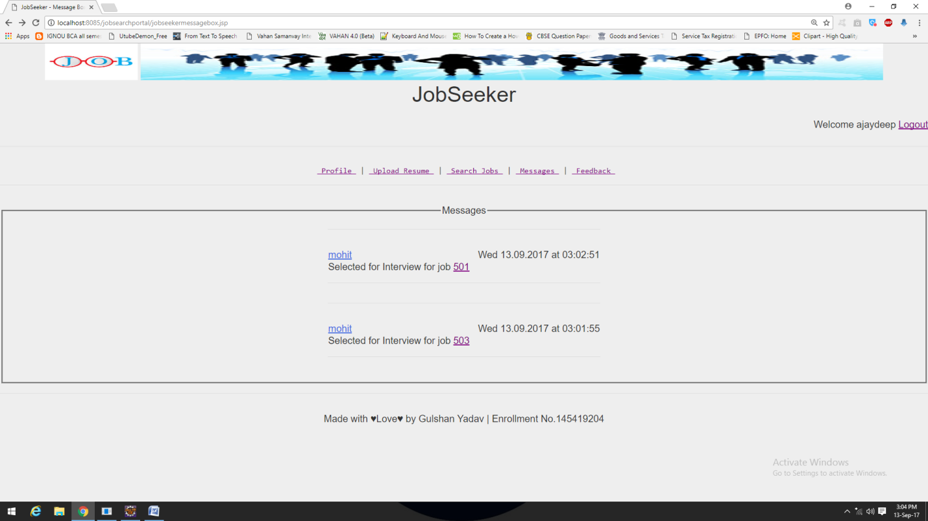

By clicking on ‘501’ job details page will open which is saved in database as jobid=501

By clicking on ‘mohit’ (who is a recruiter) recruiter profile page will open.

**‘FEEDBACK’ PAGE ON JOBSEEKER**

**JobSeeker’s Feedback Page**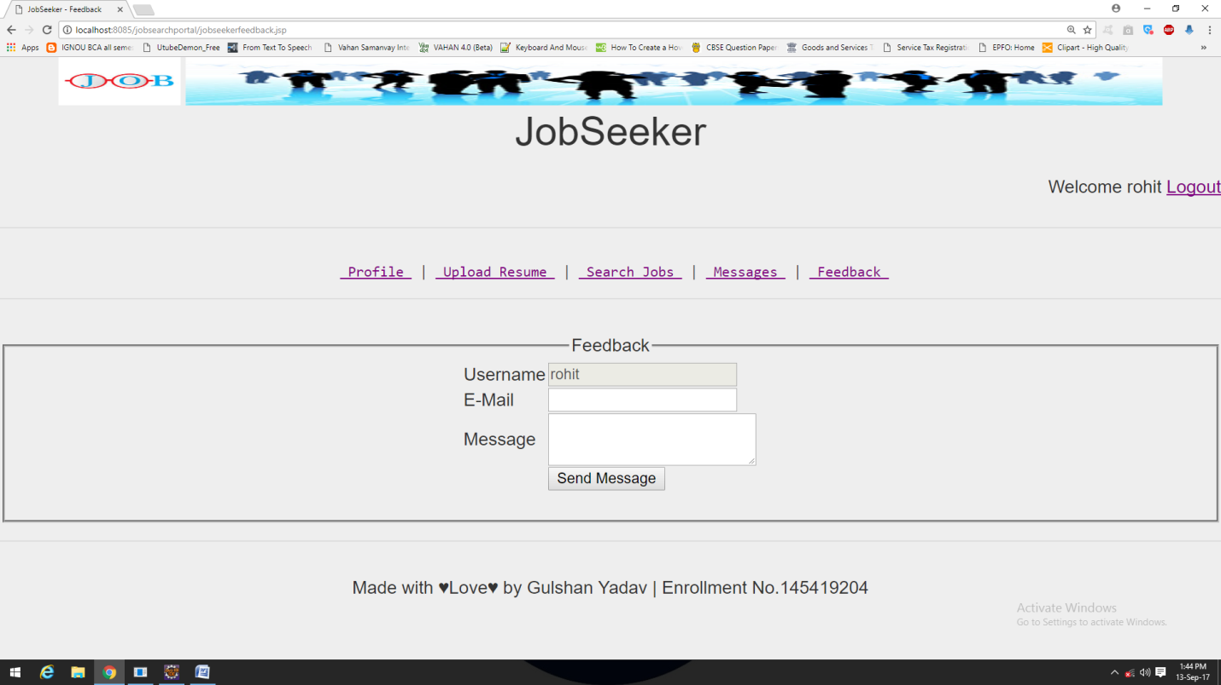

**PROGRAM CODE**

**// HERE WE ARE LISTING CODE FOR LOGIN PAGE//**

**//Code of index.jsp//**

<html>

<head>

<link rel=*"stylesheet"* href=*"styles.css"* type=*"text/css"*/>

<title>Login</title>

</head>

<body>

<fieldset><legend>Login</legend>

<form name=*"form1"* method=*"post"* action=*"loginaction.jsp"*>

<table>

<tr>

<td align=*'center'* colspan=*2*><input type=*"radio"* name=*"usertype"* value=*"jobseeker"* required>JobSeeker <input type=*"radio"* name=*"usertype"* value=*"recruiter"* required>Recruiter <input type=*"radio"* name=*"usertype"* value=*"admin"* required>Admin </td>

</tr>

<tr>

<td>&nbsp</td>

</tr>

<tr>

<td>Username</td>

<td><input name=*"username"* type=*"text"* placeholder=*"Username"* required></td>

</tr>

<tr>

<td>Password</td>

<td><input name=*"password"* type=*"password"* placeholder=*"Password"* required></td>

</tr>

<tr>

<td></td>

<td align=*"center"* colspan=*2*><input type=*"submit"* name=*"Submit"* value=*"Login"*></td>

</tr>

</table>

</form>

<a href=*"registration.jsp"*>Click here to register an Account</a>

</fieldset>

<jsp:include page=*"footer.jsp"*/>

</body>

</html>

**//Code of loginaction.jsp//**

<%@ page import=*"java.sql.*"* %>

<html>

<head>

<title>Login</title>

</head>

<body>

<%

**try**

{

String username=request.getParameter("username");

String password=request.getParameter("password");

String usertype=request.getParameter("usertype");

**if**(username.equals("admin") && password.equals("admin") && usertype.equals("admin"))

{

session.setAttribute("username",username);

session.setAttribute("usertype","admin");

response.sendRedirect("adminhome.jsp");

}

Connection con=**null**;

Statement stmt=**null**;

ResultSet rs=**null**;

Class.forName("oracle.jdbc.driver.OracleDriver");

String url="jdbc:oracle:thin:@localhost:1521";

con=DriverManager.getConnection(url,"system","system");

stmt=con.createStatement();

rs=stmt.executeQuery("select * from Login where username='"+username+"' and password='"+password+"' and usertype='"+usertype+"' ");

**if**(rs.next())

{

session.setAttribute("username",username);

rs.close();

stmt.close();

con.close();

**if**(usertype.equals("jobseeker"))

{

session.setAttribute("usertype","jobseeker");

response.sendRedirect("jobseekerhome.jsp");

}

**else** **if**(usertype.equals("recruiter"))

{

session.setAttribute("usertype","recruiter");

response.sendRedirect("recruiterhome.jsp");

}

}

**else**

{

%>

Invalid Username or Password or User Type

<jsp:include page=*"index.jsp"*/>

<%

}

}

**catch**(NullPointerException e)

{

out.print("Please Enter Login Details");

%>

<jsp:include page=*"index.jsp"*/>

<%

}

**catch**(Exception e)

{

out.print(e);

}

%>

</body>

</html>

**// HERE WE ARE LISTING CODE FOR LOGOUT PAGE//**

**//Code of logout.jsp//**

<html>

<head>

<meta http-equiv=*"Content-Type"* content=*"text/html; charset=ISO-8859-1"*>

<title>Login</title>

</head>

<body>

<%

request.getSession();

session.removeAttribute("username");

session.removeAttribute("usertype");

session.invalidate();

%>

You are successfully logged out!

<jsp:include page=*"index.jsp"*/>

</body>

</html>

**// HERE WE ARE LISTING CODE FOR FOOTER PAGE//**

**//Code of footer.jsp//**

<footer>

<hr>

Made with &hearts;Love&hearts; by Gulshan Yadav | Enrollment No.145419204

</footer>

**// HERE WE ARE LISTING CODE FOR USER REGISTRATION//**

**//Code of registration.jsp//**

<%@ page language=*"java"* contentType=*"text/html; charset=ISO-8859-1"*

pageEncoding=*"ISO-8859-1"*%>

<!DOCTYPE html PUBLIC "-//W3C//DTD HTML 4.01 Transitional//EN" "http://www.w3.org/TR/html4/loose.dtd">

<html>

<head>

<link rel=*"stylesheet"* href=*"styles.css"* type=*"text/css"*/>

<title>New User Registration</title>

</head>

<body>

<jsp:include page=*"header.jsp"*/>

<h1>Registration</h1>

<fieldset>

<legend>Registration Form</legend>

<p style="color:*red*;" id=*"divCheckPasswordMatch"*></p>

<form method=*"post"* action=*"registrationaction.jsp"* name=*"myForm"*>

<table align=*'center'*>

<tr>

<td align=*'center'* colspan=*2*><input type=*"radio"* name=*"usertype"* value=*"jobseeker"* required>JobSeeker <input type=*"radio"* name=*"usertype"* value=*"recruiter"* required>Recruiter </td>

</tr>

<tr><td>&nbsp;</td></tr>

<tr>

    <td align=*'left'*>Username</td>

    <td><input type=*'text'* name=*'username'* placeholder=*"Username"* required></td>

</tr>

<tr>

    <td align=*'left'*>Password</td>

    <td> <input type=*"password"* name=*"password"* placeholder=*"Password"* id=*"password"* required></td>

</tr>

<tr>

    <td align=*'left'*>Confirm Password</td>

    <td><input type=*"password"* placeholder=*"Confirm Password"* id=*"confirm_password"* onChange=*"checkPasswordMatch();"* onClick="style.backgroundColor='white'" required ></td>

</tr>

<script type=*"text/javascript"*>

**function** checkPasswordMatch()

{

**var** password = document.getElementById("password").value;

**var** confirmPassword = document.getElementById("confirm_password").value;

**if** (password != confirmPassword)

{

document.getElementById("divCheckPasswordMatch").innerHTML="Passwords do not match!";

document.getElementById("confirm_password").style.backgroundColor="red";

}

}

</script>

<table align=*'center'*>

<tr>

    <td align=*'center'*><input type=*'submit'* name=*'register'* value=*"Register"*></td>

</tr>

</table>

</form>

<a href=*"index.jsp"*>Click here to Login</a>

</fieldset>

<jsp:include page=*"footer.jsp"*/>

</body>

</html>

**//Code of registrationaction.jsp//**

<%@ page language=*"java"* contentType=*"text/html; charset=ISO-8859-1"*

pageEncoding=*"ISO-8859-1"*%>

<%@ page import=*"java.sql.*"* %>

<!DOCTYPE html PUBLIC "-//W3C//DTD HTML 4.01 Transitional//EN" "http://www.w3.org/TR/html4/loose.dtd">

<html>

<head>

<meta http-equiv=*"Content-Type"* content=*"text/html; charset=ISO-8859-1"*>

<title>New User Registration</title>

</head>

<body>

<%

**try**

{

String usertype=request.getParameter("usertype");

String username=request.getParameter("username");

String password=request.getParameter("password");

String blank=" ";

Connection con=**null**;

Statement stmt=**null**;

ResultSet rs=**null**;

ResultSet rs1=**null**;

Class.forName("oracle.jdbc.driver.OracleDriver");

String url="jdbc:oracle:thin:@localhost:1521";

con=DriverManager.getConnection(url,"system","system");

stmt=con.createStatement();

rs=stmt.executeQuery("insert into login values('"+usertype+"','"+username+"','"+password+"')");

session.setAttribute("username",username);

**if**(usertype=="jobseeker")

{

rs1=stmt.executeQuery("insert into jobseekerprofile values('"+username+"','"+blank+"','"+blank+"','"+blank+"','"+blank+"','"+blank+"','"+blank+"','"+blank+"','"+blank+"','"+blank+"','"+blank+"','"+blank+"','"+blank+"','"+blank+"','"+blank+"','"+blank+"','"+blank+"','"+blank+"','"+blank+"','"+blank+"')");

rs.close();

con.close();

session.setAttribute("usertype","jobseeker");

response.sendRedirect("jobseekerhome.jsp");

}

**else** **if**(usertype=="recruiter")

{

rs1=stmt.executeQuery("insert into recruiterprofile values('"+username+"','"+blank+"','"+blank+"','"+blank+"','"+blank+"','"+blank+"','"+blank+"','"+blank+"','"+blank+"')");

rs.close();

con.close();

session.setAttribute("usertype","recruiter");

response.sendRedirect("recruiterhome.jsp");

}

stmt.close();

con.close();

}

**catch**(NullPointerException e)

{

out.print("Please Enter All Required Details");

%>

<jsp:include page=*"registration.jsp"*/>

<%

}

**catch**(Exception e)

{

out.print(e);

}

%>

</body>

</html>

**// HERE WE ARE LISTING CODE FOR STYLESHEET//**

**//Code of style.css//**

**body**

{

height:*80%*;

text-align:*center*;

vertical-align: *middle*;

padding-bottom:*60px*;

width:*100%*;

margin: *0*;

padding: *0*;

color: *#333*;

background-color: *#eee*;

font: *1em/1.2* *"Helvetica Neue",* *Helvetica,* *Arial,* *Geneva,* *sans-serif*;

}

**h1,h2,h3,h4,h5,h6**

{

margin: *0* *0* *.5em*;

font-weight: *500*;

line-height: *1.1*;

}

**h1** { font-size: *2.25em*; } /* 36px */

**h2** { font-size: *1.75em*; } /* 28px */

**h3** { font-size: *1.375em*; } /* 22px */

**h4** { font-size: *1.125em*; } /* 18px */

**h5** { font-size: *1em*; } /* 16px */

**h6** { font-size: *.875em*; } /* 14px */

**p**

{

margin: *0* *0* *1.5em*;

line-height: *1.5*;

}

**blockquote**

{

padding: *1em* *2em*;

margin: *0* *0* *2em*;

border-left: *5px* *solid* *#eee*;

}

**hr**

{

height: *0*;

margin-top: *1em*;

margin-bottom: *2em*;

border: *0*;

border-top: *1px* *solid* *#ddd*;

}

**table**

{

margin:*auto*;

background-color: *transparent*;

border-spacing: *0*;

border-collapse: *collapse*;

border-top: *0px* *solid* *#ddd*;

}

**th**

{

padding: *.5em* *1em*;

vertical-align: *top*;

text-align: *left*;

}

**a***:link* { color: *royalblue*; }

**a***:visited* { color: *purple*; }

**a***:focus* { color: *black*; }

**a***:hover* { color: *green*; }

**a***:active* { color: *red*; }

/* -----------------------

Layout styles

------------------------*/

*.container*

{

max-width: *50em*;

margin: *0* *auto*;

}

*.header*

{

color: *#fff*;

background: *#555*;

padding: *1em* *1.25em*;

}

*.header-heading* { margin: *0*; }

*.nav-bar*

{

background: *#000*;

padding: *0*;

}

*.content*

{

padding: *1em* *1.25em*;

background-color: *#fff*;

}

*.footer*

{

color: *#fff*;

background: *#000*;

padding: *1em* *1.25em*;

}

/* -----------------------

Nav

------------------------*/

*.nav*

{

margin: *0*;

padding: *0*;

list-style: *none*;

}

*.nav* **li**

{

display: *inline*;

margin: *0*;

}

*.nav* **a**

{

display: *block*;

padding: *.7em* *1.25em*;

color: *#fff*;

text-decoration: *none*;

border-bottom: *1px* *solid* *gray*;

}

*.nav* **a***:link* { color: *white*; }

*.nav* **a***:visited* { color: *white*; }

*.nav* **a***:focus*

{

color: *black*;

background-color: *white*;

}

*.nav* **a***:hover*

{

color: *white*;

background-color: *green*;

}

*.nav* **a***:active*

{

color: *white*;

background-color: *red*;

}

/* -----------------------

Single styles

------------------------*/

*.img-responsive* { max-width: *100%*; }

*.btn*

{

color: *#fff* *!important*;

background-color: *royalblue*;

border-color: *#222*;

display: *inline-block*;

padding: *.5em* *1em*;

margin-bottom: *0*;

font-weight: *400*;

line-height: *1.2*;

text-align: *center*;

white-space: *nowrap*;

vertical-align: *middle*;

cursor: *pointer*;

border: *1px* *solid* *transparent*;

border-radius: *.2em*;

text-decoration: *none*;

}

*.btn:hover*

{

color: *#fff* *!important*;

background-color: *green*;

}

*.btn:focus*

{

color: *#fff* *!important*;

background-color: *black*;

}

*.btn:active*

{

color: *#fff* *!important*;

background-color: *red*;

}

*.table*

{

width: *100%*;

max-width: *100%*;

margin-bottom: *20px*;

}

*.list-unstyled*

{

padding-left: *0*;

list-style: *none*;

}

*.list-inline*

{

padding-left: *0*;

margin-left: *-5px*;

list-style: *none*;

}

*.list-inline* > **li**

{

display: *inline-block*;

padding-right: *5px*;

padding-left: *5px*;

}

/* -----------------------

Wide styles

------------------------*/

@media (min-width: 42em)

{

*.header* { padding: *1.5em* *3em*; }

*.nav-bar* { padding: *1em* *3em*; }

*.content* { padding: *2em* *3em*; }

*.footer* { padding: *2em* *3em*; }

*.nav* **li**

{

display: *inline*;

margin: *0* *1em* *0* *0*;

}

*.nav* **a**

{

display: *inline*;

padding: *0*;

border-bottom: *0*;

}

}

**// HERE WE ARE LISTING CODE FOR ADMIN//**

**//Code of adminhome.jsp//**

<html>

<head>

<link rel=*"stylesheet"* href=*"styles.css"* type=*"text/css"*/>

<title> Admin - Home </title>

</head>

<body>

<jsp:include page=*"header.jsp"*/>

<h1>Administrator</h1>

<%

String username=(String)session.getAttribute("username");

String usertype=(String)session.getAttribute("usertype");

**if**(username==**null** || usertype!="admin") //to check user is logged in, if user is not logged username will be null and page will redirect to index.jsp

{

response.sendRedirect("index.jsp");

}

%>

<p style="text-align:*right*;"> Welcome <%=username %> <a href=*"logout.jsp"*> Logout </a></p>

<jsp:include page=*"adminmenu.jsp"*/>

<jsp:include page=*"footer.jsp"*/>

</body>

</html>

**//Code of adminjobseekerprofile.jsp//**

<%@ page import=*"java.sql.*"* %>

<html>

<head>

<link rel=*"stylesheet"* href=*"styles.css"* type=*"text/css"*/>

<title> Admin – JobSeeker Profile </title>

</head>

<body>

<jsp:include page=*"header.jsp"*/>

<h1>Administrator</h1>

<%

String username=(String)session.getAttribute("username");

String usertype=(String)session.getAttribute("usertype");

**if**(username==**null** || usertype!="admin") //to check user is logged in, if user is not logged username will be null and page will redirect to index.jsp

{

response.sendRedirect("index.jsp");

}

%>

<p style="text-align:*right*;"> Welcome <%=username %> <a href=*"logout.jsp"*> Logout </a></p>

<jsp:include page=*"adminmenu.jsp"*/>

<fieldset>

<legend>Profile Details</legend>

<%

String user=request.getParameter("user");

Connection con=**null**;

Statement stmt=**null**;

ResultSet rs=**null**;

Class.forName("oracle.jdbc.driver.OracleDriver");

String url="jdbc:oracle:thin:@localhost:1521";

con=DriverManager.getConnection(url,"system","system");

stmt=con.createStatement();

rs=stmt.executeQuery("select * from jobseekerprofile where username='"+user+"'");

**while**(rs.next())

{

%>

<table width=*30%*>

<th>

<td>Basic Details</td>

</th>

<tr>

<td>Name</td>

<td><%=rs.getString("FNAME") %> <%=rs.getString("LNAME") %></td>

</tr>

<tr>

<td>Designation</td>

<td><%=rs.getString("DESIGNATION") %></td>

</tr>

<tr>

<td>Location</td>

<td><%=rs.getString("LOCATION") %></td>

</tr>

<tr>

<td>Experience</td>

<td><%=rs.getString("EXPERIENCE") %></td>

</tr>

<th>

<td>Contact Details</td>

</th>

<tr>

<td>Email</td>

<td><%=rs.getString("EMAIL") %></td>

</tr>

<tr>

<td>Mobile</td>

<td><%=rs.getString("MOBILE") %></td>

</tr>

<th>

<td>Key Skills</td>

</th>

<tr align=*center*>

<td colspan=*2*><%=rs.getString("KEYSKILLS") %></td>

</tr>

<th>

<td>Projects</td>

</th>

<tr align=*center*>

<td colspan=*2*><%=rs.getString("PROJECTS") %></td>

</tr>

<th>

<td>IT Skills</td>

</th>

<tr align=*center*>

<td colspan=*2*><%=rs.getString("ITSKILLS") %></td>

</tr>

<th>

<td>Education</td>

</th>

<tr align=*center*>

<td colspan=*2*><%=rs.getString("EDUCATION") %></td>

</tr>

<th>

<td>Certifications</td>

</th>

<tr align=*center*>

<td colspan=*2*><%=rs.getString("CERTIFICATIONS") %></td>

</tr>

<th>

<td>Work Details</td>

</th>

<tr align=*center*>

<td colspan=*2*><%=rs.getString("WORKDETAILS") %></td>

</tr>

<th>

<td>Basic Details</td>

</th>

<tr>

<td>DOB</td>

<td><%=rs.getString("DOB") %></td>

</tr>

<tr>

<td>Gender</td>

<td><%=rs.getString("GENDER") %></td>

</tr>

<td>Hometown</td>

<td><%=rs.getString("HOMETOWN") %></td>

</tr>

<td>PIN</td>

<td><%=rs.getString("PIN") %></td>

</tr>

<td>Maritial Status</td>

<td><%=rs.getString("MARITIALSTATUS") %></td>

</tr>

<td>Languages Known</td>

<td><%=rs.getString("LANGUAGESKNOWN") %></td>

</tr>

<%

}

rs.close();

stmt.close();

con.close();

%>

</table>

</fieldset>

<jsp:include page=*"footer.jsp"*/>

</body>

</html>

**//Code of adminjobseekerreport.jsp//**

<%@ page import=*"java.sql.*"* %>

<html>

<head>

<link rel=*"stylesheet"* href=*"styles.css"* type=*"text/css"*/>

<title> Admin – JobSeeker Report </title>

</head>

<body>

<jsp:include page=*"header.jsp"*/>

<h1>Administrator</h1>

<%

String username=(String)session.getAttribute("username");

String usertype=(String)session.getAttribute("usertype");

**if**(username==**null** || usertype!="admin") //to check user is logged in, if user is not logged username will be null and page will redirect to index.jsp

{

response.sendRedirect("index.jsp");

}

%>

<p style="text-align:*right*;"> Welcome <%=username %> <a href=*"logout.jsp"*> Logout </a></p>

<jsp:include page=*"adminmenu.jsp"*/>

<fieldset>

<legend>List of Registered JobSeekers</legend>

<div class=*"adminlist"*>

<table width=*30%* border=*1*>

<b><tr>

<td width=*10%*>S.No.</td>

<td width=*50%*>Username</td>

<td width=*20%*>View Profile</td>

<td width=*20%*>Remove Profile</td>

</tr></b>

</table>

<%

Connection con=**null**;

Statement stmt=**null**;

ResultSet rs=**null**;

**int** count=1;

Class.forName("oracle.jdbc.driver.OracleDriver");

String url="jdbc:oracle:thin:@localhost:1521";

con=DriverManager.getConnection(url,"system","system");

stmt=con.createStatement();

rs=stmt.executeQuery("select * from jobseekerprofile");

**while**(rs.next())

{

%>

<table width=*30%* border=*1*>

<tr>

<td width=*10%*><%=count%>.</td>

<td width=*50%*><%=rs.getString("username") %></td>

<td width=*20%*><a href=*"adminjobseekerprofile.jsp?user=*<%=rs.getString("username") %>*"*>View</a></td>

<td width=*20%*><a href=*"adminremoveaction.jsp?user=*<%=rs.getString("username")%>*&type=jobseeker"*>Remove</a></td>

</tr>

</table>

</div>

<%

count++;

}

rs.close();

stmt.close();

con.close();

%>

</fieldset>

<jsp:include page=*"footer.jsp"*/>

</body>

</html>

**//Code of adminmenu.jsp//**

<hr>

<pre> <a href=*"adminhome.jsp"*> Home </a> | <a href=*""*> Inbox </a> | <a href=*"adminjobseekerreport.jsp"*> JobSeeker Reports </a> | <a href=*"adminrecruiterreport.jsp"*> Recruiter Reports</a> </pre>

<hr>

**//Code of adminrecruiterprofile.jsp//**

<%@ page import=*"java.sql.*"* %>

<html>

<head>

<link rel=*"stylesheet"* href=*"styles.css"* type=*"text/css"*/>

<title> Admin – Recruiter Profile</title>

</head>

<body>

<jsp:include page=*"header.jsp"*/>

<h1>Administrator</h1>

<%

String username=(String)session.getAttribute("username");

String usertype=(String)session.getAttribute("usertype");

**if**(username==**null** || usertype!="admin") //to check user is logged in, if user is not logged username will be null and page will redirect to index.jsp

{

response.sendRedirect("index.jsp");

}

%>

<p style="text-align:*right*;"> Welcome <%=username %> <a href=*"logout.jsp"*> Logout </a></p>

<jsp:include page=*"adminmenu.jsp"*/>

<fieldset>

<legend>Profile Details</legend>

<%

String user=request.getParameter("user");

Connection con=**null**;

Statement stmt=**null**;

ResultSet rs=**null**;

Class.forName("oracle.jdbc.driver.OracleDriver");

String url="jdbc:oracle:thin:@localhost:1521";

con=DriverManager.getConnection(url,"system","system");

stmt=con.createStatement();

rs=stmt.executeQuery("select * from recruiterprofile where username='"+user+"'");

**while**(rs.next())

{

%>

<table width=*30%*>

<tr>

<td>Name</td>

<td><%=rs.getString("FNAME") %> <%=rs.getString("LNAME") %></td>

</tr>

<tr>

<td>Company Name</td>

<td><%=rs.getString("COMPANY") %></td>

</tr>

<tr>

<td>Designation</td>

<td><%=rs.getString("DESIGNATION")%></td>

</tr>

<tr>

<td>Location</td>

<td><%=rs.getString("LOCATION") %></td>

</tr>

<tr>

<td>Email</td>

<td><%=rs.getString("EMAIL") %></td>

</tr>

<tr>

<td>Mobile</td>

<td><%=rs.getString("MOBILE") %></td>

</tr>

<tr>

<td>Gender</td>

<td><%=rs.getString("GENDER") %></td>

</tr>

</table>

<%

}

rs.close();

stmt.close();

con.close();

%>

</fieldset>

<jsp:include page=*"footer.jsp"*/>

</body>

</html>

**//Code of adminrecruiterreport.jsp//**

<%@ page import=*"java.sql.*"* %>

<html>

<head><link rel=*"stylesheet"* href=*"styles.css"* type=*"text/css"*/>

<title> Admin – Recruiter Report </title>

</head>

<body>

<jsp:include page=*"header.jsp"*/>

<h1>Administrator</h1>

<%

String username=(String)session.getAttribute("username");

String usertype=(String)session.getAttribute("usertype");

**if**(username==**null** || usertype!="admin") //to check user is logged in, if user is not logged username will be null and page will redirect to index.jsp

{

response.sendRedirect("index.jsp");

}

%>

<p style="text-align:*right*;"> Welcome <%=username %> <a href=*"logout.jsp"*> Logout </a></p>

<jsp:include page=*"adminmenu.jsp"*/>

<fieldset>

<legend>List of Registered Recruiters</legend>

<div class=*"adminlist"*>

<table width=*30%* border=*1*>

<b><tr>

<td width=*10%*>S.No.</td>

<td width=*50%*>Username</td>

<td width=*20%*>View Profile</td>

<td width=*20%*>Remove Profile</td>

</tr></b>

</table>

<%

Connection con=**null**;

Statement stmt=**null**;

ResultSet rs=**null**;

**int** count=1;

Class.forName("oracle.jdbc.driver.OracleDriver");

String url="jdbc:oracle:thin:@localhost:1521";

con=DriverManager.getConnection(url,"system","system");

stmt=con.createStatement();

rs=stmt.executeQuery("select * from recruiterprofile");

**while**(rs.next())

{

%>

<table width=*30%* border=*1*>

<tr>

<td width=*10%*><%=count%>.</td>

<td width=*50%*><%=rs.getString("username") %></td>

<td width=*20%*><a href=*"adminrecruiterprofile.jsp?user=*<%=rs.getString("username") %>*"*>View</a></td>

<td width=*20%*><a href=*"adminremoveaction.jsp?user=*<%=rs.getString("username")%>*&type=recruiter"*>Remove</a></td>

</table>

</div>

<%

count++;

}

rs.close();

stmt.close();

con.close();

%>

</fieldset>

<jsp:include page=*"footer.jsp"*/>

</body>

</html>

**//Code of adminremoveaction.jsp//**

<%@ page import=*"java.sql.*"* %>

<html>

<head>

<title>Admin Remove Action</title>

</head>

<body>

<%

String username=(String)session.getAttribute("username");

String usertype=(String)session.getAttribute("usertype");

**if**(username==**null** || usertype!="admin") //to check user is logged in, if user is not logged username will be null and page will redirect to index.jsp

{

response.sendRedirect("index.jsp");

}

%>

<%

String user=request.getParameter("user");

String type=request.getParameter("type");

Connection con=**null**;

Statement stmt=**null**;

ResultSet rs=**null**;

ResultSet rs1=**null**;

ResultSet rs2=**null**;

Class.forName("oracle.jdbc.driver.OracleDriver");

String url="jdbc:oracle:thin:@localhost:1521";

con=DriverManager.getConnection(url,"system","system");

stmt=con.createStatement();

**if**(type=="jobseeker")

{

rs=stmt.executeQuery("select * from jobseekerprofile where username='"+user+"' ");

**if**(rs.next())

{

rs1=stmt.executeQuery("delete from jobseekerprofile where username='"+user+"' ");

rs2=stmt.executeQuery("delete from login where username='"+user+"' and usertype='"+type+"' ");

rs.close();

stmt.close();

con.close();

}

response.sendRedirect("adminjobseekerreport.jsp");

}

**else** **if**(type=="recruiter")

{

rs=stmt.executeQuery("select * from recruiterprofile where username='"+user+"' ");

**if**(rs.next())

{

rs1=stmt.executeQuery("delete from recruiterprofile where username='"+user+"' ");

rs2=stmt.executeQuery("delete from login where username='"+user+"' and usertype='"+type+"' ");

rs.close();

stmt.close();

con.close();

}

response.sendRedirect("adminrecruiterreport.jsp");

}

%>

</body>

</html>

**// HERE WE ARE LISTING CODE FOR JOBSEEKER//**

**//Code of jobseekerfeedback.jsp//**

<html>

<head>

<link rel=*"stylesheet"* href=*"styles.css"* type=*"text/css"*/>

<title> JobSeeker - Feedback </title>

</head>

<body>

<jsp:include page=*"header.jsp"*/>

<h1> JobSeeker </h1>

<%

String username=(String)session.getAttribute("username");

String usertype=(String)session.getAttribute("usertype");

**if**(username==**null** || usertype!="jobseeker") //to check user is logged in, if user is not logged username will be null and page will redirect to index.jsp

{

response.sendRedirect("index.jsp");

}

%>

<p style="text-align:*right*;"> Welcome <%=username %> <a href=*"logout.jsp"*> Logout </a></p>

<jsp:include page=*"jobseekermenu.jsp"*/>

<fieldset>

<legend>Feedback</legend>

<form method=*"post"* action=*"mailto:ry4761@gmail.com"* name=*"messageform"*>

<table>

<tr>

<td>Username</td>

<td><input type=*"text"* name=*"name"* value=*"*<%=username %>*"* disabled></td>

</tr>

<tr>

<td>E-Mail</td>

<td><input type=*"text"* name=*"email"*></td>

</tr>

<tr>

<td>Message</td>

<td><textarea name=*"message"* form=*"messageform"* required></textarea></td>

</tr>

<tr>

<td></td>

<td><input type=*"submit"* value=*"Send Message"*></td>

</tr>

</table>

</form>

</fieldset>

<jsp:include page=*"footer.jsp"*/>

</body>

</html>

**//Code of jobseekerhome.jsp//**

<html>

<head>

<link rel=*"stylesheet"* href=*"styles.css"* type=*"text/css"*/>

<title> JobSeeker - Home </title>

</head>

<body>

<jsp:include page=*"header.jsp"*/>

<h1> JobSeeker </h1>

<%

String username=(String)session.getAttribute("username");

String usertype=(String)session.getAttribute("usertype");

**if**(username==**null** || usertype!="jobseeker") //to check user is logged in, if user is not logged username will be null and page will redirect to index.jsp

{

response.sendRedirect("index.jsp");

}

%>

<p style="text-align:*right*;"> Welcome <%=username %> <a href=*"logout.jsp"*> Logout </a></p>

<jsp:include page=*"jobseekermenu.jsp"*/>

<jsp:include page=*"footer.jsp"*/>

</body>

</html>

**//Code of jobseekerjobdetails.jsp//**

<%@ page import=*"java.sql.*"* %>

<html>

<head>

<link rel=*"stylesheet"* href=*"styles.css"* type=*"text/css"*/>

<title> JobSeeker – Job Details </title>

</head>

<body>

<jsp:include page=*"header.jsp"*/>

<h1> JobSeeker </h1>

<%

String username=(String)session.getAttribute("username");

String usertype=(String)session.getAttribute("usertype");

**if**(username==**null** || usertype!="jobseeker") //to check user is logged in, if user is not logged username will be null and page will redirect to index.jsp

{

response.sendRedirect("index.jsp");

}

%>

<p style="text-align:*right*;"> Welcome <%=username %> <a href=*"logout.jsp"*> Logout </a></p>

<jsp:include page=*"jobseekermenu.jsp"*/>

<fieldset>

<legend>Job Details</legend>

<%

String jobid=request.getParameter("jobid");

Connection con=**null**;

Statement stmt=**null**;

ResultSet rs=**null**;

Class.forName("oracle.jdbc.driver.OracleDriver");

String url="jdbc:oracle:thin:@localhost:1521";

con=DriverManager.getConnection(url,"system","system");

stmt=con.createStatement();

rs=stmt.executeQuery("select * from job where jobid='"+jobid+"'");

**while**(rs.next())

{

%>

<div class=*"jobdetails"*>

<table width=*30%*>

<tr>

<td><b><%=rs.getString("title") %></b></td>

<td style="text-align:*right*;">Posted on <%=rs.getString("dateofposting") %></td>

</tr>

<tr>

<td><%=rs.getString("experience") %>&nbsp;Years</td>

<td style="text-align:*right*;">Posted by <%=rs.getString("recruiter") %></td>

</tr>

<tr>

<td><%=rs.getString("location") %></td>

</tr>

<tr>

<td><%=rs.getString("salary") %> p.a.</td>

</tr>

<tr>

<td>Vacancy-<%=rs.getString("vacancy") %></td>

</tr>

</table>

<hr width=*30%*>

<table>

<tr>

<td><%=rs.getString("description") %></td>

</tr>

</table>

<hr width=*30%*>

<table>

<tr>

<td>Functional Area &nbsp; </td>

<td><%=rs.getString("functionalarea") %></td>

</tr>

<tr>

<td>Role &nbsp;</td>

<td><%=rs.getString("role") %></td>

</tr>

<tr>

<td>Key Skills &nbsp;</td>

<td><%=rs.getString("keyskills") %></td>

</tr>

<tr>

<td>Interview Date &nbsp;</td>

<td><%=rs.getString("interviewdate") %></td>

</tr>

<tr>

<td>Interview Time &nbsp;</td>

<td><%=rs.getString("interviewtime") %></td>

</tr>

<tr>

<td>Interview Place &nbsp;</td>

<td><%=rs.getString("interviewplace") %></td>

</tr>

</table>

</div>

<br>

<a href=*"jobseekersendmessageaction.jsp?user=*<%=rs.getString("recruiter") %>*&jobid=*<%=jobid %>*"*>Apply for this Job</a>

<%

}

rs.close();

stmt.close();

con.close();

%>

</fieldset>

<jsp:include page=*"footer.jsp"*/>

</body>

</html>

**//Code of jobseekermenu.jsp//**

<hr>

<pre> <a href=*"jobseekerprofile.jsp"*> Profile </a> | <a href=*"jobseekerresume.jsp"*> Upload Resume </a> | <a href=*"jobseekersearch.jsp"*> Search Jobs </a> | <a href=*"jobseekermessagebox.jsp"*> Messages </a> | <a href=*"jobseekerfeedback.jsp"*> Feedback </a></pre>

<hr>

**//Code of jobseekermessagebox.jsp//**

<%@ page import=*"java.sql.*"* %>

<html>

<head>

<link rel=*"stylesheet"* href=*"styles.css"* type=*"text/css"*/>

<title> JobSeeker - Message Box </title>

</head>

<body>

<jsp:include page=*"header.jsp"*/>

<h1> JobSeeker </h1>

<%

String username=(String)session.getAttribute("username");

String usertype=(String)session.getAttribute("usertype");

**if**(username==**null** || usertype!="jobseeker") //to check user is logged in, if user is not logged username will be null and page will redirect to index.jsp

{

response.sendRedirect("index.jsp");

}

%>

<p style="text-align:*right*;"> Welcome <%=username %> <a href=*"logout.jsp"*> Logout </a></p>

<jsp:include page=*"jobseekermenu.jsp"*/>

<fieldset>

<legend>Messages</legend>

<%

Connection con=**null**;

Statement stmt=**null**;

ResultSet rs=**null**;

Class.forName("oracle.jdbc.driver.OracleDriver");

String url="jdbc:oracle:thin:@localhost:1521";

con=DriverManager.getConnection(url,"system","system");

stmt=con.createStatement();

rs=stmt.executeQuery("select * from message where to_username='"+username+"' order by datetime desc ");

**if**(!rs.next())

{

%>

Empty Message Box

<%

}

**while**(rs.next())

{

%>

<hr width=*30%*>

<div class=*"inbox"*>

<table width=*30%*>

<tr>

<td><a href=*"jobseekerrecruiterprofile.jsp?user=*<%=rs.getString("from_username") %>*"*><%=rs.getString("from_username") %></a></td>

<td style="text-align:*right*;"><%=rs.getString("datetime") %></td>

</tr>

<tr>

<td><%=rs.getString("message") %><a href=*"jobseekerjobdetails.jsp?jobid=*<%=rs.getString("forjob")%>*"*><%=rs.getString("forjob") %></a></td>

</tr>

</table>

</div>

<hr width=*30%*>

<%

}

rs.close();

stmt.close();

con.close();

%>

</fieldset>

<jsp:include page=*"footer.jsp"*/>

</body>

</html>

**//Code of jobseekerprofile.jsp//**

<%@ page import=*"java.sql.*"* %>

<html>

<head>

<link rel=*"stylesheet"* href=*"styles.css"* type=*"text/css"*/>

<title> JobSeeker - Profile </title>

</head>

<body>

<jsp:include page=*"header.jsp"*/>

<h1> JobSeeker </h1>

<%

String username=(String)session.getAttribute("username");

String usertype=(String)session.getAttribute("usertype");

**if**(username==**null** || usertype!="jobseeker") //to check user is logged in, if user is not logged username will be null and page will redirect to index.jsp

{

response.sendRedirect("index.jsp");

}

%>

<p style="text-align:*right*;"> Welcome <%=username %> <a href=*"logout.jsp"*> Logout </a></p>

<jsp:include page=*"jobseekermenu.jsp"*/>

<fieldset>

<legend>Profile Details</legend>

<table>

<%

Connection con=**null**;

Statement stmt=**null**;

ResultSet rs=**null**;

Class.forName("oracle.jdbc.driver.OracleDriver");

String url="jdbc:oracle:thin:@localhost:1521";

con=DriverManager.getConnection(url,"system","system");

stmt=con.createStatement();

rs=stmt.executeQuery("select * from jobseekerprofile where username='"+username+"'");

**while**(rs.next())

{

%>

<tr>

<td>Basic Details</td>

</tr>

<tr>

<td>Name</td>

<td><%=rs.getString("FNAME") %> <%=rs.getString("LNAME") %></td>

</tr>

<tr>

<td>Designation</td>

<td><%=rs.getString("DESIGNATION") %></td>

</tr>

<tr>

<td>Location</td>

<td><%=rs.getString("LOCATION") %></td>

</tr>

<tr>

<td>Experience</td>

<td><%=rs.getString("EXPERIENCE") %></td>

</tr>

<tr>

<td>Contact Details</td>

</tr>

<tr>

<td>Email</td>

<td><%=rs.getString("EMAIL") %></td>

</tr>

<tr>

<td>Mobile</td>

<td><%=rs.getString("MOBILE") %></td>

</tr>

<tr>

<td>Key Skills</td>

</tr>

<tr align=*center*>

<td colspan=*2*><%=rs.getString("KEYSKILLS") %></td>

</tr>

<tr>

<td>Projects</td>

</tr>

<tr align=*center*>

<td colspan=*2*><%=rs.getString("PROJECTS") %></td>

</tr>

<tr>

<td>IT Skills</td>

</tr>

<tr align=*center*>

<td colspan=*2*><%=rs.getString("ITSKILLS") %></td>

</tr>

<tr>

<td>Education</td>

</tr>

<tr align=*center*>

<td colspan=*2*><%=rs.getString("EDUCATION") %></td>

</tr>

<tr>

<td>Certifications</td>

</tr>

<tr align=*center*>

<td colspan=*2*><%=rs.getString("CERTIFICATIONS") %></td>

</tr>

<tr>

<td>Work Details</td>

</tr>

<tr align=*center*>

<td colspan=*2*><%=rs.getString("WORKDETAILS") %></td>

</tr>

<tr>

<td>Personal Details</td>

</tr>

<tr>

<td>DOB</td>

<td><%=rs.getString("DOB") %></td>

</tr>

<tr>

<td>Gender</td>

<td><%=rs.getString("GENDER") %></td>

</tr>

<td>Hometown</td>

<td><%=rs.getString("HOMETOWN") %></td>

</tr>

<td>PIN</td>

<td><%=rs.getString("PIN") %></td>

</tr>

<td>Maritial Status</td>

<td><%=rs.getString("MARITIALSTATUS") %></td>

</tr>

<td>Languages Known</td>

<td><%=rs.getString("LANGUAGESKNOWN") %></td>

</tr>

<tr>

<td>&nbsp</td>

</tr>

<%

}

rs.close();

stmt.close();

con.close();

%>

<tr>

<td colspan=*"2"* align=*"center"*><a href=*"jobseekerupdateprofile.jsp"*>Edit</a></td>

</tr>

</table>

</fieldset>

<jsp:include page=*"footer.jsp"*/>

</body>

</html>

**//Code of jobseekerresume.jsp//**

<html>

<head>

<link rel=*"stylesheet"* href=*"styles.css"* type=*"text/css"*/>

<title> JobSeeker - Resume </title>

</head>

<body>

<jsp:include page=*"header.jsp"*/>

<h1> JobSeeker </h1>

<%

String username=(String)session.getAttribute("username");

String usertype=(String)session.getAttribute("usertype");

**if**(username==**null** || usertype!="jobseeker") //to check user is logged in, if user is not logged username will be null and page will redirect to index.jsp

{

response.sendRedirect("index.jsp");

}

%>

<p style="text-align:*right*;"> Welcome <%=username %> <a href=*"logout.jsp"*> Logout </a></p>

<jsp:include page=*"jobseekermenu.jsp"*/>

<fieldset>

<legend>Upload Resume</legend>

<br>

<form method=*"post"* action=*"/uploadServlet"* enctype=*"multipart/form-data"*>

<input type=*"file"* name=*"resume"*><br><br>

<input type=*"submit"* value=*"Upload"*>

</form>

</fieldset>

<jsp:include page=*"footer.jsp"*/>

</body>

</html>

**//Code of jobseekersearch.jsp//**

<html>

<head>

<link rel=*"stylesheet"* href=*"styles.css"* type=*"text/css"*/>

<title> JobSeeker – Search </title>

</head>

<body>

<jsp:include page=*"header.jsp"*/>

<h1> JobSeeker </h1>

<%

String username=(String)session.getAttribute("username");

String usertype=(String)session.getAttribute("usertype");

**if**(username==**null** || usertype!="jobseeker") //to check user is logged in, if user is not logged username will be null and page will redirect to index.jsp

{

response.sendRedirect("index.jsp");

}

%>

<p style="text-align:*right*;"> Welcome <%=username %> <a href=*"logout.jsp"*> Logout </a></p>

<jsp:include page=*"jobseekermenu.jsp"*/>

<fieldset>

<legend>Search Jobs</legend>

<form method=*"get"* action=*"jobseekersearchresult.jsp"*>

<table>

<tr>

<td>Keywords</td>

</tr>

<tr>

<td><input type=*"text"* name=*"keyword"*></td>

</tr>

<tr>

<td>Location</td>

</tr>

<tr>

<td><input type=*"text"* name=*"location"*></td>

</tr>

<tr>

<td>Experience</td>

<td>Expected Salary</td>

</tr>

<tr>

<td><input type=*"number"* name=*"experience"*></td>

<td><input type=*"number"* name=*"expectedsalary"*></td>

</tr>

<tr>

<td><input type=*"submit"* name=*"submit"* value=*"Search Jobs"*></td>

</tr>

</table>

</form>

</fieldset>

<jsp:include page=*"footer.jsp"*/>

</body>

</html>

**//Code of jobseekersearchresult.jsp//**

<%@ page import=*"java.sql.*"* %>

<html>

<head>

<link rel=*"stylesheet"* href=*"styles.css"* type=*"text/css"*/>

<title> JobSeeker – Search Result </title>

</head>

<body>

<jsp:include page=*"header.jsp"*/>

<h1> JobSeeker </h1>

<%

String username=(String)session.getAttribute("username");

String usertype=(String)session.getAttribute("usertype");

**if**(username==**null** || usertype!="jobseeker") //to check user is logged in, if user is not logged username will be null and page will redirect to index.jsp

{

response.sendRedirect("index.jsp");

}

%>

<p style="text-align:*right*;"> Welcome <%=username %> <a href=*"logout.jsp"*> Logout </a></p>

<jsp:include page=*"jobseekermenu.jsp"*/>

<fieldset>

<legend>Search Results</legend>

<form action=*"jobseekersearchresult.jsp"*>

<input type=*"search"* name=*"keyword"* size=*"50%"*><input type=*"submit"* value=*"Search"*>

</form>

<%

String keyword=request.getParameter("keyword");

String location=request.getParameter("location");

String experience=request.getParameter("experience");

String expectedsalary=request.getParameter("expectedsalary");

Connection con=**null**;

Statement stmt=**null**;

ResultSet rs=**null**;

Class.forName("oracle.jdbc.driver.OracleDriver");

String url="jdbc:oracle:thin:@localhost:1521";

con=DriverManager.getConnection(url,"system","system");

stmt=con.createStatement();

rs=stmt.executeQuery("select * from job where title='"+keyword+"' or keyskills='"+keyword+"' or role='"+keyword+"' or recruiter='"+keyword+"' or location='"+location+"' or experience<='"+experience+"' or salary>='"+expectedsalary+"' ");

**while**(rs.next())

{

%>

<hr width=*30%*>

<div>

<table width=*30%*>

<tr>

<td><b><a href=*"jobseekerjobdetails.jsp?jobid=*<%=rs.getString("jobid") %>*"*><%=rs.getString("title") %></a></b></td>

<td style="text-align:*right*;">Posted on <%=rs.getString("dateofposting") %></td>

</tr>

<tr>

<td><%=rs.getString("experience") %>&nbsp;Years</td>

</tr>

<tr>

<td><%=rs.getString("location") %></td>

</tr>

<tr>

<td><%=rs.getString("salary") %> p.a.</td>

</tr>

<tr>

<td><%=rs.getString("keyskills") %></td>

</tr>

<tr>

<td>Vacancy-<%=rs.getString("vacancy") %></td>

</tr>

</table>

</div>

<hr width=*30%*>

<%

}

rs.close();

stmt.close();

con.close();

%>

</fieldset>

<jsp:include page=*"footer.jsp"*/>

</body>

</html>

**//Code of jobseekersendmessage.jsp//**

<%@ page import=*"java.io.*"* %>

<%@ page import=*"java.sql.*"* %>

<%@ page import=*"java.util.Date"* %>

<%@ page import=*"java.text.*"* %>

<html>

<head>

<link rel=*"stylesheet"* href=*"styles.css"* type=*"text/css"*/>

<title> JobSeeker – Send Message </title>

</head>

<body>

<jsp:include page=*"header.jsp"*/>

<h1> JobSeeker </h1>

<%

String username=(String)session.getAttribute("username");

String usertype=(String)session.getAttribute("usertype");

**if**(username==**null** || usertype!="jobseeker") //to check user is logged in, if user is not logged username will be null and page will redirect to index.jsp

{

response.sendRedirect("index.jsp");

}

%>

<p style="text-align:*right*;"> Welcome <%=username %> <a href=*"logout.jsp"*> Logout </a></p>

<jsp:include page=*"jobseekermenu.jsp"*/>

<%

Date dnow=**new** Date();

SimpleDateFormat ft=**new** SimpleDateFormat("E yyyy.MM.dd 'at' hh:mm:ss");

String user=request.getParameter("user");

%>

<div class=*"message"*>

<fieldset>

<legend>Message</legend>

<form method=*"post"* action=*"jobseekersendmessageaction.jsp"* name=*"messageform"*>

<table>

<tr>

<td>To</td>

<td><input type=*"text"* name=*"to_username"* value=<%=user %> disabled></td>

</tr>

<tr>

<td>From</td>

<td><input type=*"text"* name=*"from_username"* value=<%=username %> disabled></td>

</tr>

<tr>

<td>Message</td>

<td><textarea name=*"message"* form=*"messageform"* required></textarea></td>

</tr>

<tr>

<td><input type=*"hidden"* name=*"time"* value=<%=ft.format(dnow) %>></td>

</tr>

<tr>

<td align=*"center"* colspan=*2*><input type=*"submit"* value=*"Send"*></td>

</tr>

</table>

</form>

</fieldset>

</div>

<jsp:include page=*"footer.jsp"*/>

</body>

</html>

**//Code of jobseekersendmessageaction.jsp//**

<%@ page import=*"java.io.*"* %>

<%@ page import=*"java.sql.*"* %>

<%@ page import=*"java.util.Date"* %>

<%@ page import=*"java.text.*"* %>

<html>

<head>

<title>JobSeeker- Send Message Action</title>

</head>

<body>

<%

String username=(String)session.getAttribute("username");

String usertype=(String)session.getAttribute("usertype");

**if**(username==**null** || usertype!="jobseeker") //to check user is logged in, if user is not logged username will be null and page will redirect to index.jsp

{

response.sendRedirect("index.jsp");

}

%>

<%

Date dnow=**new** Date();

SimpleDateFormat ft=**new** SimpleDateFormat("E dd.MM.yyyy 'at' hh:mm:ss");

String user=request.getParameter("user");

String jobid=request.getParameter("jobid");

String message="Applied for ";

Connection con=**null**;

Statement stmt=**null**;

ResultSet rs=**null**;

Class.forName("oracle.jdbc.driver.OracleDriver");

String url="jdbc:oracle:thin:@localhost:1521";

con=DriverManager.getConnection(url,"system","system");

stmt=con.createStatement();

rs=stmt.executeQuery("insert into message values('"+username+"','"+user+"','"+message+"','"+jobid+"','"+ft.format(dnow)+"')");

rs.close();

stmt.close();

con.close();

response.sendRedirect("jobseekersearchresult.jsp");

%>

</body>

</html>

**//Code of jobseekerupdateprofile.jsp//**

<%@ page import=*"java.sql.*"* %>

<html>

<head>

<link rel=*"stylesheet"* href=*"styles.css"* type=*"text/css"*/>

<title>JobSeeker – Update Profile</title>

</head>

<body>

<jsp:include page=*"header.jsp"*/>

<h1> JobSeeker </h1>

<%

String username=(String)session.getAttribute("username");

String usertype=(String)session.getAttribute("usertype");

**if**(username==**null** || usertype!="jobseeker") //to check user is logged in, if user is not logged username will be null and page will redirect to index.jsp

{

response.sendRedirect("index.jsp");

}

%>

<p style="text-align:*right*;"> Welcome <%=username %> <a href=*"logout.jsp"*> Logout </a></p>

<jsp:include page=*"jobseekermenu.jsp"*/>

<fieldset>

<legend>Profile Details</legend>

<%

Connection con=**null**;

Statement stmt=**null**;

ResultSet rs=**null**;

Class.forName("oracle.jdbc.driver.OracleDriver");

String url="jdbc:oracle:thin:@localhost:1521";

con=DriverManager.getConnection(url,"system","system");

stmt=con.createStatement();

rs=stmt.executeQuery("select * from jobseekerprofile where username='"+username+"'");

**if**(!rs.next())

{

%>

<form method=*"post"* action=*"jobseekerupdateprofileaction.jsp"*>

<table>

<tr>

<td>Basic Details</td>

</tr>

<tr>

<td>Name</td>

<td><input type=*"text"* name=*"fname"* placeholder=*"FirstName"*></td>

</tr>

<tr>

<td></td>

<td><input type=*"text"* name=*"lname"* placeholder=*"LastName"*></td>

</tr>

<tr>

<td>Designation</td>

<td><input type=*"text"* name=*"designation"*></td>

</tr>

<tr>

<td>Location</td>

<td><input type=*"text"* name=*"location"*></td>

</tr>

<tr>

<td>Experience</td>

<td><select name=*"experience"* class=*"Form_fields"* required>

<option value=*""*>- Select -</option>

<option value=*"0"*>0</option>

<option value=*"1"*>1</option>

<option value=*"2"*>2</option>

<option value=*"3"*>3</option>

<option value=*"4"*>4</option>

<option value=*"5"*>5</option>

<option value=*"6"*>6</option>

<option value=*"7"*>7</option>

<option value=*"8"*>8</option>

<option value=*"9"*>9</option>

<option value=*"10"*>10</option>

<option value=*"11"*>11</option>

<option value=*"12"*>12</option>

<option value=*"13"*>13</option>

<option value=*"14"*>14</option>

<option value=*"15"*>15</option>

<option value=*"16"*>16</option>

<option value=*"17"*>17</option>

<option value=*"18"*>18</option>

<option value=*"19"*>19</option>

<option value=*"20"*>20</option>

<option value=*"21"*>21</option>

<option value=*"22"*>22</option>

<option value=*"23"*>23</option>

<option value=*"24"*>24</option>

<option value=*"25"*>25</option>

<option value=*"26"*>26</option>

<option value=*"27"*>27</option>

<option value=*"28"*>28</option>

<option value=*"29"*>29</option>

<option value=*"30"*>30</option>

<option value=*"31"*>31</option>

<option value=*"32"*>32</option>

<option value=*"33"*>33</option>

<option value=*"34"*>34</option>

<option value=*"35"*>35</option>

<option value=*"36"*>36</option>

<option value=*"37"*>37</option>

<option value=*"38"*>38</option>

<option value=*"39"*>39</option>

<option value=*"40"*>40</option>

<option value=*"41"*>41</option>

<option value=*"42"*>42</option>

<option value=*"43"*>43</option>

<option value=*"44"*>44</option>

<option value=*"45"*>45</option>

<option value=*"46"*>46</option>

<option value=*"47"*>47</option>

<option value=*"48"*>48</option>

<option value=*"49"*>49</option>

<option value=*"50"*>50</option>

</select>&nbsp;Years</td>

</tr>

<tr>

<td>Contact Details</td>

</tr>

<tr>

<td>Email</td>

<td><input type=*"text"* name=*"email"*></td>

</tr>

<tr>

<td>Mobile</td>

<td><input type=*"text"* name=*"mobile"*></td>

</tr>

<tr>

<td>Key Skills</td>

</tr>

<tr align=*center*>

<td colspan=*2*><input type=*"text"* name=*"keyskills"* placeholder=*"e.g. Hardworking, Time Management"*></td>

</tr>

<tr>

<td>Projects</td>

</tr>

<tr align=*center*>

<td colspan=*2*><input type=*"text"* name=*"projects"* placeholder=*"e.g. Online Job Search Portal in Java"*></td>

</tr>

<tr>

<td>IT Skills</td>

</tr>

<tr align=*center*>

<td colspan=*2*><input type=*"text"* name=*"itskills"* placeholder=*"e.g. Java,SQL,HTML,JSP"*></td>

</tr>

<tr>

<td>Education</td>

</tr>

<tr align=*center*>

<td colspan=*2*><input type=*"text"* name=*"education"* placeholder=*"e.g. BCA"*></td>

</tr>

<tr>

<td>Certifications</td>

</tr>

<tr align=*center*>

<td colspan=*2*><input type=*"text"* name=*"certifications"* placeholder=*"e.g. Certificate in HTML, JavaScript, JSP"*></td>

</tr>

<tr>

<td>Work Details</td>

</tr>

<tr align=*center*>

<td colspan=*2*><input type=*"text"* name=*"workdetails"* placeholder=*"e.g. Java Programmer in TCS"*></td>

</tr>

<tr>

<td>Personal Details</td>

</tr>

<tr>

<td>DOB</td>

<td><input type=*"date"* name=*"dob"*></td>

</tr>

<tr>

<td>Gender</td>

<td><input type=*"radio"* name=*"gender"* value=*"male"* required>Male<input type=*"radio"* name=*"gender"* value=*"female"* required>Female</td>

</tr>

<td>Hometown</td>

<td><input type=*"text"* name=*"hometown"*></td>

</tr>

<td>PIN</td>

<td><input type=*"text"* name=*"pin"*></td>

</tr>

<td>Maritial Status</td>

<td><input type=*"radio"* name=*"maritialstatus"* value=*"single"* required>Single<input type=*"radio"* name=*"maritialstatus"* value=*"married"* required>Married<input type=*"radio"* name=*"maritialstatus"* value=*"divorced"* required>Divorced</td>

</tr>

<td>Languages Known</td>

<td><input type=*"text"* name=*"languagesknown"*></td>

</tr>

<tr>

<td>&nbsp</td>

</tr>

<tr>

<td align=*"center"* colspan=*2*><input type=*"submit"* value=*"Update"*></td>

</tr>

</table>

</form>

<%

}

**while**(rs.next())

{

%>

<form method=*"post"* action=*"jobseekerupdateprofileaction.jsp"*>

<table>

<tr>

<td>Basic Details</td>

</tr>

<tr>

<td>Name</td>

<td><input type=*"text"* name=*"fname"* placeholder=*"FirstName"* value=<%=rs.getString("fname") %>></td>

</tr>

<tr>

<td></td>

<td><input type=*"text"* name=*"lname"* placeholder=*"LastName"* value=<%=rs.getString("lname") %>></td>

</tr>

<tr>

<td>Designation</td>

<td><input type=*"text"* name=*"designation"* value=<%=rs.getString("designation") %>></td>

</tr>

<tr>

<td>Location</td>

<td><input type=*"text"* name=*"location"* value=<%=rs.getString("location") %>></td>

</tr>

<tr>

<td>Experience</td>

<td><select name=*"experience"* class=*"Form_fields"* required>

<option value=*""*>- Select -</option>

<option value=*"0"*>0</option>

<option value=*"1"*>1</option>

<option value=*"2"*>2</option>

<option value=*"3"*>3</option>

<option value=*"4"*>4</option>

<option value=*"5"*>5</option>

<option value=*"6"*>6</option>

<option value=*"7"*>7</option>

<option value=*"8"*>8</option>

<option value=*"9"*>9</option>

<option value=*"10"*>10</option>

<option value=*"11"*>11</option>

<option value=*"12"*>12</option>

<option value=*"13"*>13</option>

<option value=*"14"*>14</option>

<option value=*"15"*>15</option>

<option value=*"16"*>16</option>

<option value=*"17"*>17</option>

<option value=*"18"*>18</option>

<option value=*"19"*>19</option>

<option value=*"20"*>20</option>

<option value=*"21"*>21</option>

<option value=*"22"*>22</option>

<option value=*"23"*>23</option>

<option value=*"24"*>24</option>

<option value=*"25"*>25</option>

<option value=*"26"*>26</option>

<option value=*"27"*>27</option>

<option value=*"28"*>28</option>

<option value=*"29"*>29</option>

<option value=*"30"*>30</option>

<option value=*"31"*>31</option>

<option value=*"32"*>32</option>

<option value=*"33"*>33</option>

<option value=*"34"*>34</option>

<option value=*"35"*>35</option>

<option value=*"36"*>36</option>

<option value=*"37"*>37</option>

<option value=*"38"*>38</option>

<option value=*"39"*>39</option>

<option value=*"40"*>40</option>

<option value=*"41"*>41</option>

<option value=*"42"*>42</option>

<option value=*"43"*>43</option>

<option value=*"44"*>44</option>

<option value=*"45"*>45</option>

<option value=*"46"*>46</option>

<option value=*"47"*>47</option>

<option value=*"48"*>48</option>

<option value=*"49"*>49</option>

<option value=*"50"*>50</option>

</select>&nbsp;Years</td>

</tr>

<tr>

<td>Contact Details</td>

</tr>

<tr>

<td>Email</td>

<td><input type=*"text"* name=*"email"* value=<%=rs.getString("email") %>></td>

</tr>

<tr>

<td>Mobile</td>

<td><input type=*"text"* name=*"mobile"* value=<%=rs.getString("mobile") %>></td>

</tr>

<tr>

<td>Key Skills</td>

</tr>

<tr align=*center*>

<td colspan=*2*><input type=*"text"* name=*"keyskills"* placeholder=*"e.g. Hardworking, Time Management"* value=<%=rs.getString("keyskills") %>></td>

</tr>

<tr>

<td>Projects</td>

</tr>

<tr align=*center*>

<td colspan=*2*><input type=*"text"* name=*"projects"* placeholder=*"e.g. Online Job Search Portal in Java"* value=<%=rs.getString("projects") %>></td>

</tr>

<tr>

<td>IT Skills</td>

</tr>

<tr align=*center*>

<td colspan=*2*><input type=*"text"* name=*"itskills"* placeholder=*"e.g. Java,SQL,HTML,JSP"* value=<%=rs.getString("itskills") %>></td>

</tr>

<tr>

<td>Education</td>

</tr>

<tr align=*center*>

<td colspan=*2*><input type=*"text"* name=*"education"* placeholder=*"e.g. BCA"* value=<%=rs.getString("education") %>></td>

</tr>

<tr>

<td>Certifications</td>

</tr>

<tr align=*center*>

<td colspan=*2*><input type=*"text"* name=*"certifications"* placeholder=*"e.g. Certificate in HTML, JavaScript, JSP"* value=<%=rs.getString("certifications") %>></td>

</tr>

<tr>

<td>Work Details</td>

</tr>

<tr align=*center*>

<td colspan=*2*><input type=*"text"* name=*"workdetails"* placeholder=*"e.g. Java Programmer in TCS"* value=<%=rs.getString("workdetails") %>></td>

</tr>

<tr>

<td>Personal Details</td>

</tr>

<tr>

<td>DOB</td>

<td><input type=*"date"* name=*"dob"* value=<%=rs.getString("dob") %>></td>

</tr>

<tr>

<td>Gender</td>

<td><input type=*"radio"* name=*"gender"* value=*"male"* required>Male<input type=*"radio"* name=*"gender"* value=*"female"* required>Female</td>

</tr>

<td>Hometown</td>

<td><input type=*"text"* name=*"hometown"* value=<%=rs.getString("hometown") %>></td>

</tr>

<td>PIN</td>

<td><input type=*"text"* name=*"pin"* value=<%=rs.getString("pin") %>></td>

</tr>

<td>Maritial Status</td>

<td><input type=*"radio"* name=*"maritialstatus"* value=*"single"* required>Single<input type=*"radio"* name=*"maritialstatus"* value=*"married"* required>Married<input type=*"radio"* name=*"maritialstatus"* value=*"divorced"* required>Divorced</td>

</tr>

<td>Languages Known</td>

<td><input type=*"text"* name=*"languagesknown"* value=<%=rs.getString("languagesknown") %>></td>

</tr>

<tr>

<td>&nbsp</td>

</tr>

<tr>

<td align=*"center"* colspan=*2*><input type=*"submit"* value=*"Update"*></td>

</tr>

</table>

</form>

<%

}

rs.close();

stmt.close();

con.close();

%>

</fieldset>

<jsp:include page=*"footer.jsp"*/>

</body>

</html>

**//Code of jobseekerupdateprofileaction.jsp//**

<%@ page import=*"java.sql.*"* %>

<html>

<head>

<title>JobSeeker – Update Profile Action</title>

</head>

<body>

<%

String username=(String)session.getAttribute("username");

String usertype=(String)session.getAttribute("usertype");

**if**(username==**null** || usertype!="jobseeker") //to check user is logged in, if user is not logged username will be null and page will redirect to index.jsp

{

response.sendRedirect("index.jsp");

}

%>

<%

String fname=request.getParameter("fname");

String lname=request.getParameter("lname");

String designation=request.getParameter("designation");

String location=request.getParameter("location");

String experience=request.getParameter("experience");

String email=request.getParameter("email");

String mobile=request.getParameter("mobile");

String keyskills=request.getParameter("keyskills");

String projects=request.getParameter("projects");

String itskills=request.getParameter("itskills");

String education=request.getParameter("education");

String certifications=request.getParameter("certifications");

String workdetails=request.getParameter("workdetails");

String dob=request.getParameter("dob");

String gender=request.getParameter("gender");

String hometown=request.getParameter("hometown");

String pin=request.getParameter("pin");

String maritialstatus=request.getParameter("maritialstatus");

String languagesknown=request.getParameter("languagesknown");

Connection con=**null**;

Statement stmt=**null**;

ResultSet rs=**null**;

ResultSet rs1=**null**;

ResultSet rs2=**null**;

ResultSet rs3=**null**;

Class.forName("oracle.jdbc.driver.OracleDriver");

String url="jdbc:oracle:thin:@localhost:1521";

con=DriverManager.getConnection(url,"system","system");

stmt=con.createStatement();

rs=stmt.executeQuery("select * from login where username='"+username+"' and usertype='"+usertype+"' ");

**if**(rs.next())

{

rs1=stmt.executeQuery("select * from jobseekerprofile where username='"+username+"'");

**if**(rs1.next())

{

rs2=stmt.executeQuery("update jobseekerprofile set username='"+username+"', fname='"+fname+"', lname='"+lname+"', designation='"+designation+"', location='"+location+"', experience='"+experience+"', email='"+email+"', mobile='"+mobile+"', keyskills='"+keyskills+"', projects='"+projects+"', itskills='"+itskills+"', education='"+education+"', certifications='"+certifications+"', workdetails='"+workdetails+"', dob='"+dob+"', gender='"+gender+"', hometown='"+hometown+"', pin='"+pin+"', maritialstatus='"+maritialstatus+"', languagesknown='"+languagesknown+"' where username='"+username+"' "); // toLowerCase() is used to store data into table in LowerCase to remove case senstivity of fields except password. Password is case sensitive for security reasons.

}

**else**

{

rs3=stmt.executeQuery("insert into jobseekerprofile values('"+username+"','"+fname+"','"+lname+"','"+designation+"','"+location+"','"+experience+"','"+email+"','"+mobile+"','"+keyskills+"','"+projects+"','"+itskills+"','"+education+"','"+certifications+"','"+workdetails+"','"+dob+"','"+gender+"','"+hometown+"','"+pin+"','"+maritialstatus+"','"+languagesknown+"')"); // toLowerCase() is used to store data into table in LowerCase to remove case senstivity of fields except password. Password is case sensitive for security reasons.

}

rs.close();

stmt.close();

con.close();

}

response.sendRedirect("jobseekerprofile.jsp");

%>

</body>

</html>

**//Code of jobseekerupload.jsp//**

<%@ page contentType=*"text/html;charset=windows-1252"*%>

<%@ page import =*"java.sql.*"* %>

<%@ page import =*"javax.sql.*"* %>

<%@ page import =*"javax.naming.InitialContext"* %>

<%@ page import =*"java.sql.PreparedStatement.*"* %>

<html>

<head>

<link rel=*"stylesheet"* href=*"layout.css"* type=*"text/css"*/>

</head>

<body>

<jsp:include page=*"header.jsp"*/>

<form name=*"upload1"* method=*"post"*>

<%

String username=(String)session.getAttribute("username");

Connection con=**null**;

PreparedStatement ps=**null**;

String up2=request.getParameter("resume");

java.io.File f=**new** java.io.File(up2);

java.io.FileInputStream fis= **new** java.io.FileInputStream(f);

Class.forName("oracle.jdbc.driver.OracleDriver");

String url="jdbc:oracle:thin:@localhost:1521";

con=DriverManager.getConnection(url,"system","system");

ps=con.prepareStatement("insert into jobseekerresume values(?,?)");

ps.setString(1,username);

ps.setBinaryStream(2,fis,(**int**)f.length());

ps.executeUpdate();

ps.close();

con.close();

%>

</form>

<jsp:include page=*"footer.jsp"*/>

</body>

</html>

**// HERE WE ARE LISTING CODE FOR RECRUITER//**

**//Code of recruiteraddjob.jsp//**

<html>

<head>

<link rel=*"stylesheet"* href=*"styles.css"* type=*"text/css"*/>

<title>Recruiter – Add Job</title>

</head>

<body>

<jsp:include page=*"header.jsp"*/>

<h1> Recruiter </h1>

<%

String username=(String)session.getAttribute("username");

String usertype=(String)session.getAttribute("usertype");

**if**(username==**null** || usertype!="recruiter") //to check user is logged in, if user is not logged username will be null and page will redirect to index.jsp

{

response.sendRedirect("index.jsp");

}

%>

<p style="text-align:*right*;"> Welcome <%=username %> <a href=*"logout.jsp"*> Logout </a></p>

<jsp:include page=*"recruitermenu.jsp"*/>

<fieldset>

<legend>Add Job</legend>

<form action=*"recruiteraddjobaction.jsp"* method=*"post"* id=*"jobform"* >

<table>

<tr>

<td>JobId: </td>

<td><input type=*"text"* name=*"jobid"* value=*""* required></td>

</tr>

<tr>

<td>Job Title:</td>

<td><input type=*"text"* name=*"title"* required></td>

</tr>

<tr>

<td>Location: </td>

<td>

<select name=*"location"* required>

<option> - Select -</option>

<option value=*"Delhi"*>DELHI</option>

<option value=*"Noida"*>NOIDA</option>

<option value=*"Gurgaon"*>GURGAON</option>

<option value=*"Faridabad"*>FARIDABAD</option>

<option value=*"Banglore"*>BANGLORE</option>

<option value=*"Chennai"*>CHENNAI</option>

<option value=*"Hyderabad"*>HYDERABAD</option>

<option value=*"Mumbai"*>MUMBAI</option>

<option value=*"Kolkata"*>KOLKATA</option>

<option value=*"Pune"*>PUNE</option>

<option value=*"Lucknow"*>LUCKNOW</option>

<option value=*"Kanpur"*>KANPUR</option>

</select></td>

</tr>

<tr>

<td>Minimum Experience</td>

<td>

<select name=*"experience"* required>

<option value=*""*>- Select -</option>

<option value=*"0"*>0</option>

<option value=*"1"*>1</option>

<option value=*"2"*>2</option>

<option value=*"3"*>3</option>

<option value=*"4"*>4</option>

<option value=*"5"*>5</option>

<option value=*"6"*>6</option>

<option value=*"7"*>7</option>

<option value=*"8"*>8</option>

<option value=*"9"*>9</option>

<option value=*"10"*>10</option>

<option value=*"11"*>11</option>

<option value=*"12"*>12</option>

<option value=*"13"*>13</option>

<option value=*"14"*>14</option>

<option value=*"15"*>15</option>

<option value=*"16"*>16</option>

<option value=*"17"*>17</option>

<option value=*"18"*>18</option>

<option value=*"19"*>19</option>

<option value=*"20"*>20</option>

<option value=*"21"*>21</option>

<option value=*"22"*>22</option>

<option value=*"23"*>23</option>

<option value=*"24"*>24</option>

<option value=*"25"*>25</option>

<option value=*"26"*>26</option>

<option value=*"27"*>27</option>

<option value=*"28"*>28</option>

<option value=*"29"*>29</option>

<option value=*"30"*>30</option>

<option value=*"31"*>31</option>

<option value=*"32"*>32</option>

<option value=*"33"*>33</option>

<option value=*"34"*>34</option>

<option value=*"35"*>35</option>

<option value=*"36"*>36</option>

<option value=*"37"*>37</option>

<option value=*"38"*>38</option>

<option value=*"39"*>39</option>

<option value=*"40"*>40</option>

<option value=*"41"*>41</option>

<option value=*"42"*>42</option>

<option value=*"43"*>43</option>

<option value=*"44"*>44</option>

<option value=*"45"*>45</option>

<option value=*"46"*>46</option>

<option value=*"47"*>47</option>

<option value=*"48"*>48</option>

<option value=*"49"*>49</option>

<option value=*"50"*>50</option>

</select>&nbsp;Years</td>

</tr>

<tr>

<td >Salary:</td>

<td><input type=*"text"* name=*"salary"* required></td>

</tr>

<tr>

<td>Job Description:</td>

<td><textarea name=*"description"* form=*"jobform"* required></textarea></td>

</tr>

<tr>

<td >Functional Area: </td>

<td>

<select name=*"functionalarea"* required>

<option> - Select - </option>

<option value=*"Any"*>Any</option>

<option value=*"Automotive"*>Automotive</option>

<option value=*"Banking"*>Banking</option>

<option value=*"Bio Technology"*>Bio Technology</option>

<option value=*"Chemicals"*>Chemicals</option>

<option value=*"Construction"*>Construction</option>

<option value=*"Consumer Goods"*>Consumer Goods</option>

<option value=*"Education"*>Education</option>

<option value=*"Entertainment"*>Entertainment</option>

<option value=*"Insurance"*>Insurance</option>

<option value=*"BPO"*>BPO</option>

<option value=*"Computer Hardware"*>Computer Hardware</option>

<option value=*"Computer Software"*>Computer Software</option>

</select></td>

<tr>

<td >Role: </td>

<td>

<select name=*"role"* required>

<option> - Select - </option>

<option value=*"Sales Executive"*>Sales Executive</option>

<option value=*"Teacher"*>Teacher</option>

<option value=*"Manager"*>Manager</option>

<option value=*"Accounting"*>Accounting</option>

<option value=*"Technician"*>Technician</option>

<option value=*"Software Professional"*>Software Professional</option>

<option value=*"Software Tester"*>Software Tester</option>

<option value=*"IT Professional"*>IT Professional</option>

</select></td>

</tr>

<tr>

<td>Key Skills:</td>

<td><input type=*"text"* name=*"keyskills"* placeholder=*"Java,SQL,HTML,JSP etc."* required></td>

</tr>

<tr>

<td >Vacancy: </td>

<td><input type=*"number"* name=*"vacancy"* required></td>

</tr>

<tr>

<td >Interview Date: </td>

<td><input type=*"date"* name=*"interviewdate"* required></td>

</tr>

<tr>

<td >Interview Time: </td>

<td><input type=*"time"* name=*"interviewtime"* required></td>

</tr>

<tr>

<td >Interview Place: </td>

<td><input type=*"text"* name=*"interviewplace"* required></td>

</tr>

<input type=*hidden* name=*"recruiter"* value=*"*<%=username %>*"*>

<tr>

<td>&nbsp;</td>

</tr>

<tr>

<td colspan=*2* align=*center*><input type=*"submit"* value=*"ADD"* ></td>

</tr>

</table>

</form>

</fieldset>

<jsp:include page=*"footer.jsp"*/>

</body>

</html>

**//Code of recruiteraddjobaction.jsp//**

<%@ page language=*"java"* contentType=*"text/html; charset=ISO-8859-1"*

pageEncoding=*"ISO-8859-1"*%>

<%@ page import=*"java.io.*"* %>

<%@ page import=*"java.sql.*"* %>

<%@ page import=*"java.util.Date"* %>

<%@ page import=*"java.text.*"* %>

<!DOCTYPE html PUBLIC "-//W3C//DTD HTML 4.01 Transitional//EN" "http://www.w3.org/TR/html4/loose.dtd">

<html>

<head>

<title>Recruiter – Add Job</title>

</head>

<body>

<jsp:include page=*"header.jsp"*/>

<h1> Recruiter </h1>

<%

String username=(String)session.getAttribute("username");

String usertype=(String)session.getAttribute("usertype");

**if**(username==**null** || usertype!="recruiter") //to check user is logged in, if user is not logged username will be null and page will redirect to index.jsp

{

response.sendRedirect("index.jsp");

}

%>

<p style="text-align:*right*;"> Welcome <%=username %> <a href=*"logout.jsp"*> Logout </a></p>

<hr>

<pre> <a href=*"recruiterprofile.jsp"*> Profile </a> | <a href=*"recruiterviewjob.jsp"*> View Your Jobs </a> | <a href=*"recruiteraddjob.jsp"*> Add New Job </a> | <a href=*"recruitersearch.jsp"*> Search Job Seeker </a> | <a href=*""*> Response Detail </a> | <a href=*"recruiterfeedback.jsp"*> Feedback </a></pre>

<hr>

<%

Date dnow=**new** Date();

SimpleDateFormat ft=**new** SimpleDateFormat("E dd.MM.yyyy 'at' hh:mm:ss");

String jobid=request.getParameter("jobid");

String title=request.getParameter("title");

String location=request.getParameter("location");

String experience=request.getParameter("experience");

String salary=request.getParameter("salary");

String description=request.getParameter("description");

String functionalarea=request.getParameter("functionalarea");

String role=request.getParameter("role");

String keyskills=request.getParameter("keyskills");

String vacancy=request.getParameter("vacancy");

String interviewdate=request.getParameter("interviewdate");

String interviewtime=request.getParameter("interviewtime");

String interviewplace=request.getParameter("interviewplace");

String recruiter=request.getParameter("recruiter");

Connection con=**null**;

Statement stmt=**null**;

ResultSet rs=**null**;

Class.forName("oracle.jdbc.driver.OracleDriver");

String url="jdbc:oracle:thin:@localhost:1521";

con=DriverManager.getConnection(url,"system","system");

stmt=con.createStatement();

rs=stmt.executeQuery("insert into job values('"+jobid+"','"+title+"','"+location+"','"+experience+"','"+salary+"','"+description+"','"+functionalarea+"','"+role+"','"+keyskills+"','"+vacancy+"','"+interviewdate+"','"+interviewtime+"','"+interviewplace+"','"+recruiter+"','"+ft.format(dnow)+"')");

rs.close();

stmt.close();

con.close();

response.sendRedirect("recruiterjobdetails.jsp?jobid="+jobid+"");

%>

<jsp:include page=*"footer.jsp"*/>

</body>

</html>

**//Code recruiterfeedback.jsp//**

<html>

<head>

<link rel=*"stylesheet"* href=*"styles.css"* type=*"text/css"*/>

<title> Recruiter - Feedback </title>

</head>

<body>

<jsp:include page=*"header.jsp"*/>

<h1> Recruiter </h1>

<%

String username=(String)session.getAttribute("username");

String usertype=(String)session.getAttribute("usertype");

**if**(username==**null** || usertype!="recruiter") //to check user is logged in, if user is not logged username will be null and page will redirect to index.jsp

{

response.sendRedirect("index.jsp");

}

%>

<p style="text-align:*right*;"> Welcome <%=username %> <a href=*"logout.jsp"*> Logout </a></p>

<jsp:include page=*"recruitermenu.jsp"*/>

<fieldset>

<legend>Feedback</legend>

<form method=*"post"* action=*"mailto:ry4761@gmail.com"* name=*"messageform"*>

<table>

<tr>

<td>Username</td>

<td><input type=*"text"* name=*"username"* value=*"*<%=username%>*"* disabled></td>

</tr>

<tr>

<td>E-Mail</td>

<td><input type=*"text"* name=*"email"*></td>

</tr>

<tr>

<td>Message</td>

<td><textarea name=*"message"* form=*"messageform"* required></textarea></td>

</tr>

<tr>

<td></td>

<td><input type=*"submit"* value=*"Send Message"*></td>

</tr>

</table>

</form>

</fieldset>

<jsp:include page=*"footer.jsp"*/>

</body>

</html>

**//Code of recruiterhome.jsp//**

<html>

<head>

<link rel=*"stylesheet"* href=*"styles.css"* type=*"text/css"*/>

<title> Recruiter - Home </title>

</head>

<body>

<jsp:include page=*"header.jsp"*/>

<h1> Recruiter </h1>

<%

String username=(String)session.getAttribute("username");

String usertype=(String)session.getAttribute("usertype");

**if**(username==**null** || usertype!="recruiter") //to check user is logged in, if user is not logged username will be null and page will redirect to index.jsp

{

response.sendRedirect("index.jsp");

}

%>

<p style="text-align:*right*;"> Welcome <%=username %> <a href=*"logout.jsp"*> Logout </a></p>

<jsp:include page=*"recruitermenu.jsp"*/>

<jsp:include page=*"footer.jsp"*/>

</body>

</html>

**//Code of recruiterjobdetails.jsp//**

<%@ page import=*"java.sql.*"* %>

<html>

<head>

<link rel=*"stylesheet"* href=*"styles.css"* type=*"text/css"*/>

<title> Recruiter – Job Details </title>

</head>

<body>

<jsp:include page=*"header.jsp"*/>

<h1> Recruiter </h1>

<%

String username=(String)session.getAttribute("username");

String usertype=(String)session.getAttribute("usertype");

**if**(username==**null** || usertype!="recruiter") //to check user is logged in, if user is not logged username will be null and page will redirect to index.jsp

{

response.sendRedirect("index.jsp");

}

%>

<p style="text-align:*right*;"> Welcome <%=username %> <a href=*"logout.jsp"*> Logout </a></p>

<jsp:include page=*"recruitermenu.jsp"*/>

<fieldset>

<legend>Job Details</legend>

<%

String jobid=request.getParameter("jobid");

Connection con=**null**;

Statement stmt=**null**;

ResultSet rs=**null**;

Class.forName("oracle.jdbc.driver.OracleDriver");

String url="jdbc:oracle:thin:@localhost:1521";

con=DriverManager.getConnection(url,"system","system");

stmt=con.createStatement();

rs=stmt.executeQuery("select * from job where jobid='"+jobid+"'");

**while**(rs.next())

{

%>

<div class=*"jobdetails"*>

<table width=*30%*>

<tr>

<td><b><%=rs.getString("title") %></b></td>

<td style="text-align:*right*;">Posted on <%=rs.getString("dateofposting") %></td>

</tr>

<tr>

<td><%=rs.getString("experience") %>&nbsp;Years</td>

<td style="text-align:*right*;">Posted by <%=rs.getString("recruiter") %></td>

</tr>

<tr>

<td><%=rs.getString("location") %></td>

</tr>

<tr>

<td><%=rs.getString("salary") %> p.a.</td>

</tr>

<tr>

<td>Vacancy-<%=rs.getString("vacancy") %></td>

</tr>

</table>

<hr width=*30%*>

<table>

<tr>

<td><%=rs.getString("description") %></td>

</tr>

</table>

<hr width=*30%*>

<table>

<tr>

<td>Functional Area &nbsp; </td>

<td><%=rs.getString("functionalarea") %></td>

</tr>

<tr>

<td>Role &nbsp;</td>

<td><%=rs.getString("role") %></td>

</tr>

<tr>

<td>Key Skills &nbsp;</td>

<td><%=rs.getString("keyskills") %></td>

</tr>

<tr>

<td>Interview Date &nbsp;</td>

<td><%=rs.getString("interviewdate") %></td>

</tr>

<tr>

<td>Interview Time &nbsp;</td>

<td><%=rs.getString("interviewtime") %></td>

</tr>

<tr>

<td>Interview Place &nbsp;</td>

<td><%=rs.getString("interviewplace") %></td>

</tr>

</table>

</div>

<%

}

rs.close();

stmt.close();

con.close();

%>

</fieldset>

<jsp:include page=*"footer.jsp"*/>

</body>

</html>

**//Code of recruiterjobseekerprofile.jsp//**

<%@ page import=*"java.sql.*"* %>

<html>

<head>

<link rel=*"stylesheet"* href=*"styles.css"* type=*"text/css"*/>

<title> Recruiter – JobSeeker Profile </title>

</head>

<body>

<jsp:include page=*"header.jsp"*/>

<h1> Recruiter </h1>

<%

String username=(String)session.getAttribute("username");

String usertype=(String)session.getAttribute("usertype");

**if**(username==**null** || usertype!="recruiter") //to check user is logged in, if user is not logged username will be null and page will redirect to index.jsp

{

response.sendRedirect("index.jsp");

}

%>

<p style="text-align:*right*;"> Welcome <%=username %> <a href=*"logout.jsp"*> Logout </a></p>

<jsp:include page=*"recruitermenu.jsp"*/>

<fieldset>

<legend>Profile Details</legend>

<%

String user=request.getParameter("user");

Connection con=**null**;

Statement stmt=**null**;

ResultSet rs=**null**;

ResultSet rs1=**null**;

Class.forName("oracle.jdbc.driver.OracleDriver");

String url="jdbc:oracle:thin:@localhost:1521";

con=DriverManager.getConnection(url,"system","system");

stmt=con.createStatement();

rs=stmt.executeQuery("select * from jobseekerprofile where username='"+user+"'");

**while**(rs.next())

{

%>

<table>

<a href=*"recruitersendmessage.jsp?user=*<%=user %>*"*>Send Message</a>

<th>

<td>Basic Details</td>

</th>

<tr>

<td>Name</td>

<td><%=rs.getString("FNAME") %> <%=rs.getString("LNAME") %></td>

</tr>

<tr>

<td>Designation</td>

<td><%=rs.getString("DESIGNATION") %></td>

</tr>

<tr>

<td>Location</td>

<td><%=rs.getString("LOCATION") %></td>

</tr>

<tr>

<td>Experience</td>

<td><%=rs.getString("EXPERIENCE") %></td>

</tr>

<th>

<td>Contact Details</td>

</th>

<tr>

<td>Email</td>

<td><%=rs.getString("EMAIL") %></td>

</tr>

<tr>

<td>Mobile</td>

<td><%=rs.getString("MOBILE") %></td>

</tr>

<th>

<td>Key Skills</td>

</th>

<tr align=*center*>

<td colspan=*2*><%=rs.getString("KEYSKILLS") %></td>

</tr>

<th>

<td>Projects</td>

</th>

<tr align=*center*>

<td colspan=*2*><%=rs.getString("PROJECTS") %></td>

</tr>

<th>

<td>IT Skills</td>

</th>

<tr align=*center*>

<td colspan=*2*><%=rs.getString("ITSKILLS") %></td>

</tr>

<th>

<td>Education</td>

</th>

<tr align=*center*>

<td colspan=*2*><%=rs.getString("EDUCATION") %></td>

</tr>

<th>

<td>Certifications</td>

</th>

<tr align=*center*>

<td colspan=*2*><%=rs.getString("CERTIFICATIONS") %></td>

</tr>

<th>

<td>Work Details</td>

</th>

<tr align=*center*>

<td colspan=*2*><%=rs.getString("WORKDETAILS") %></td>

</tr>

<th>

<td>Basic Details</td>

</th>

<tr>

<td>DOB</td>

<td><%=rs.getString("DOB") %></td>

</tr>

<tr>

<td>Gender</td>

<td><%=rs.getString("GENDER") %></td>

</tr>

<td>Hometown</td>

<td><%=rs.getString("HOMETOWN") %></td>

</tr>

<td>PIN</td>

<td><%=rs.getString("PIN") %></td>

</tr>

<td>Maritial Status</td>

<td><%=rs.getString("MARITIALSTATUS") %></td>

</tr>

<td>Languages Known</td>

<td><%=rs.getString("LANGUAGESKNOWN") %></td>

</tr>

<%

}

rs.close();

stmt.close();

con.close();

%>

</table>

</fieldset>

<jsp:include page=*"footer.jsp"*/>

</body>

</html>

**//Code of recruitermenu.jsp//**

<hr>

<pre><a href=*"recruiterprofile.jsp"*> Profile </a> | <a href=*"recruiterviewjob.jsp"*> View Posted Jobs </a> | <a href=*"recruiteraddjob.jsp"*> Post a Job </a> | <a href=*"recruitersearch.jsp"*> Search Job Seeker </a> | <a href=*"recruitermessagebox.jsp"*> Messages </a> | <a href=*"recruiterfeedback.jsp"*> Feedback </a></pre>

<hr>

**//Code of recruitermessagebox.jsp//**

<%@ page import=*"java.sql.*"* %>

<html>

<head>

<link rel=*"stylesheet"* href=*"styles.css"* type=*"text/css"*/>

<title> Recruiter – Message Box </title>

</head>

<body>

<jsp:include page=*"header.jsp"*/>

<h1> Recruiter </h1>

<%

String username=(String)session.getAttribute("username");

String usertype=(String)session.getAttribute("usertype");

**if**(username==**null** || usertype!="recruiter") //to check user is logged in, if user is not logged username will be null and page will redirect to index.jsp

{

response.sendRedirect("index.jsp");

}

%>

<p style="text-align:*right*;"> Welcome <%=username %> <a href=*"logout.jsp"*> Logout </a></p>

<jsp:include page=*"recruitermenu.jsp"*/>

<fieldset>

<legend>Messages</legend>

<%

Connection con=**null**;

Statement stmt=**null**;

ResultSet rs=**null**;

Class.forName("oracle.jdbc.driver.OracleDriver");

String url="jdbc:oracle:thin:@localhost:1521";

con=DriverManager.getConnection(url,"system","system");

stmt=con.createStatement();

rs=stmt.executeQuery("select * from message where to_username='"+username+"' order by datetime desc ");

**if**(!rs.next())

{

%>

Empty Message Box

<%

}

**while**(rs.next())

{

%>

<hr width=*30%*>

<div class=*"inbox"*>

<table width=*30%*>

<tr>

<td><a href=*"recruiterjobseekerprofile.jsp?user=*<%=rs.getString("from_username") %>*"*><%=rs.getString("from_username") %></a></td>

<td style="text-align:*right*;"><%=rs.getString("datetime") %></td>

</tr>

<tr>

<td><%=rs.getString("message") %><a href=*"recruiterjobdetails.jsp?jobid=*<%=rs.getString("forjob")%>*"*><%=rs.getString("forjob") %></a></td>

<td style="text-align:*right*;"><a href=*"recruitersendmessageaction.jsp?user=*<%=rs.getString("from_username")%>*&jobid=*<%=rs.getString("forjob")%>*"*>Accept for Interview</a></td>

</tr>

</table>

</div>

<hr width=*30%*>

<%

}

rs.close();

stmt.close();

con.close();

%>

</fieldset>

<jsp:include page=*"footer.jsp"*/>

</body>

</html>

**//Code of recruiterprofile.jsp//**

<%@ page import=*"java.sql.*"* %>

<html>

<head>

<link rel=*"stylesheet"* href=*"styles.css"* type=*"text/css"*/>

<title> Recruiter - Profile </title>

</head>

<body>

<jsp:include page=*"header.jsp"*/>

<h1> Recruiter </h1>

<%

String username=(String)session.getAttribute("username");

String usertype=(String)session.getAttribute("usertype");

**if**(username==**null** || usertype!="recruiter") //to check user is logged in, if user is not logged username will be null and page will redirect to index.jsp

{

response.sendRedirect("index.jsp");

}

%>

<p style="text-align:*right*;"> Welcome <%=username %> <a href=*"logout.jsp"*> Logout </a></p>

<jsp:include page=*"recruitermenu.jsp"*/>

<fieldset>

<legend>Profile Details</legend>

<table>

<%

Connection con=**null**;

Statement stmt=**null**;

ResultSet rs=**null**;

ResultSet rs1=**null**;

Class.forName("oracle.jdbc.driver.OracleDriver");

String url="jdbc:oracle:thin:@localhost:1521";

con=DriverManager.getConnection(url,"system","system");

stmt=con.createStatement();

rs=stmt.executeQuery("select * from recruiterprofile where username='"+username+"'");

**while**(rs.next())

{

%>

<tr>

<td>Name</td>

<td><%=rs.getString("FNAME") %> <%=rs.getString("LNAME") %></td>

</tr>

<tr>

<td>Company Name</td>

<td><%=rs.getString("COMPANY") %></td>

</tr>

<tr>

<td>Designation</td>

<td><%=rs.getString("DESIGNATION")%></td>

</tr>

<tr>

<td>Location</td>

<td><%=rs.getString("LOCATION") %></td>

</tr>

<tr>

<td>Email</td>

<td><%=rs.getString("EMAIL") %></td>

</tr>

<tr>

<td>Mobile</td>

<td><%=rs.getString("MOBILE") %></td>

</tr>

<tr>

<td>Gender</td>

<td><%=rs.getString("GENDER") %></td>

</tr>

<tr>

<td>&nbsp</td>

</tr>

<%

}

rs.close();

stmt.close();

con.close();

%>

<tr>

<td colspan=*"2"* align=*"center"*><a href=*"recruiterupdateprofile.jsp"*>Edit</a></td>

</tr>

</table>

</fieldset>

<jsp:include page=*"footer.jsp"*/>

</body>

</html>

**//Code of recruitersearch.jsp//**

<html>

<head>

<link rel=*"stylesheet"* href=*"styles.css"* type=*"text/css"*/>

<title> Recruiter - Search </title>

</head>

<body>

<jsp:include page=*"header.jsp"*/>

<h1> Recruiter </h1>

<%

String username=(String)session.getAttribute("username");

String usertype=(String)session.getAttribute("usertype");

**if**(username==**null** || usertype!="recruiter") //to check user is logged in, if user is not logged username will be null and page will redirect to index.jsp

{

response.sendRedirect("index.jsp");

}

%>

<p style="text-align:*right*;"> Welcome <%=username %> <a href=*"logout.jsp"*> Logout </a></p>

<jsp:include page=*"recruitermenu.jsp"*/>

Search Job Seeker<br><br>

<form method=*"get"* action=*"recruitersearchresult.jsp"*>

<input type=*"search"* name=*"search"*>

<input type=*"submit"* value=*"Search"*>

</form>

<jsp:include page=*"footer.jsp"*/>

</body>

</html>

**//Code of recruitersearchresult.jsp//**

<%@ page import=*"java.sql.*"* %>

<html>

<head>

<link rel=*"stylesheet"* href=*"styles.css"* type=*"text/css"*/>

<title> Recruiter – Search Result </title>

</head>

<body>

<jsp:include page=*"header.jsp"*/>

<h1> Recruiter </h1>

<%

String username=(String)session.getAttribute("username");

String usertype=(String)session.getAttribute("usertype");

**if**(username==**null** || usertype!="recruiter") //to check user is logged in, if user is not logged username will be null and page will redirect to index.jsp

{

response.sendRedirect("index.jsp");

}

%>

<p style="text-align:*right*;"> Welcome <%=username %> <a href=*"logout.jsp"*> Logout </a></p>

<jsp:include page=*"recruitermenu.jsp"*/>

<fieldset>

<legend>Search Results</legend>

<form action=*"jobseekersearchresult.jsp"*>

<input type=*"search"* name=*"keyword"* size=*"50%"*><input type=*"submit"* value=*"Search"*>

</form>

<%

String search=request.getParameter("search");

Connection con=**null**;

Statement stmt=**null**;

ResultSet rs=**null**;

Class.forName("oracle.jdbc.driver.OracleDriver");

String url="jdbc:oracle:thin:@localhost:1521";

con=DriverManager.getConnection(url,"system","system");

stmt=con.createStatement();

rs=stmt.executeQuery("select * from jobseekerprofile where username='"+search+"' or fname='"+search+"' or lname='"+search+"' or designation='"+search+"' or location='"+search+"' or experience='"+search+"' or email='"+search+"' or mobile='"+search+"' or keyskills='"+search+"' or projects='"+search+"' or itskills='"+search+"' or education='"+search+"' or certifications='"+search+"' or workdetails='"+search+"' or dob='"+search+"' or gender='"+search+"' or hometown='"+search+"' or pin='"+search+"' or maritialstatus='"+search+"' or languagesknown='"+search+"'");

**while**(rs.next())

{

%>

<hr width=*30%*>

<div class=*"recruitersearchresult"*>

<table width=*30%*>

<tr>

<td><b><a href=*"recruiterjobseekerprofile.jsp?user=*<%=rs.getString("username") %>*"*><%=rs.getString("fname") %> <%=rs.getString("lname") %></a></b></td>

</tr>

<tr>

<td><%=rs.getString("designation") %></td>

</tr>

<tr>

<td><%=rs.getString("experience") %>Years</td>

</tr>

<tr>

<td><%=rs.getString("location") %></td>

</tr>

<tr>

<td><%=rs.getString("keyskills") %></td>

</tr>

</table>

</div>

<hr width=*30%*>

<%

}

rs.close();

stmt.close();

con.close();

%>

</fieldset>

<jsp:include page=*"footer.jsp"*/>

</body>

</html>

**//Code of recruitersendmessage.jsp//**

<%@ page import=*"java.io.*"* %>

<%@ page import=*"java.sql.*"* %>

<%@ page import=*"java.util.Date"* %>

<%@ page import=*"java.text.*"* %>

<html>

<head>

<link rel=*"stylesheet"* href=*"styles.css"* type=*"text/css"*/>

<title> Recruiter – Send Message </title>

</head>

<body>

<jsp:include page=*"header.jsp"*/>

<h1> Recruiter </h1>

<%

String username=(String)session.getAttribute("username");

String usertype=(String)session.getAttribute("usertype");

**if**(username==**null** || usertype!="recruiter") //to check user is logged in, if user is not logged username will be null and page will redirect to index.jsp

{

response.sendRedirect("index.jsp");

}

%>

<p style="text-align:*right*;"> Welcome <%=username %> <a href=*"logout.jsp"*> Logout </a></p>

<jsp:include page=*"recruitermenu.jsp"*/>

<%

Date dnow=**new** Date();

SimpleDateFormat ft=**new** SimpleDateFormat("E yyyy.MM.dd 'at' hh:mm:ss");

String user=request.getParameter("user");

%>

<div class=*"message"*>

<fieldset>

<legend>Message</legend>

<form method=*"post"* action=*"recruitersendmessageaction.jsp"* name=*"messageform"*>

<table>

<tr>

<td>To</td>

<td><input type=*"text"* name=*"to_username"* value=<%=user %> disabled></td>

</tr>

<tr>

<td>From</td>

<td><input type=*"text"* name=*"from_username"* value=<%=username %> disabled></td>

</tr>

<tr>

<td>Message</td>

<td><textarea name=*"message"* form=*"messageform"* required></textarea></td>

</tr>

<tr>

<td><input type=*"hidden"* name=*"time"* value=<%=ft.format(dnow) %>></td>

</tr>

<tr>

<td align=*"center"* colspan=*2*><input type=*"submit"* value=*"Send"*></td>

</tr>

</table>

</form>

</fieldset>

</div>

<jsp:include page=*"footer.jsp"*/>

</body>

</html>

**//Code of recruitersendmessageaction.jsp//**

<%@ page import=*"java.io.*"* %>

<%@ page import=*"java.sql.*"* %>

<%@ page import=*"java.util.Date"* %>

<%@ page import=*"java.text.*"* %>

<html>

<head>

<title> Recruiter – Send Message </title>

</head>

<body>

<%

String username=(String)session.getAttribute("username");

String usertype=(String)session.getAttribute("usertype");

**if**(username==**null** || usertype!="recruiter") //to check user is logged in, if user is not logged username will be null and page will redirect to index.jsp

{

response.sendRedirect("index.jsp");

}

%>

<%

Date dnow=**new** Date();

SimpleDateFormat ft=**new** SimpleDateFormat("E dd.MM.yyyy 'at' hh:mm:ss");

String user=request.getParameter("user");

String jobid=request.getParameter("jobid");

String message="Selected for Interview for job ";

Connection con=**null**;

Statement stmt=**null**;

ResultSet rs=**null**;

Class.forName("oracle.jdbc.driver.OracleDriver");

String url="jdbc:oracle:thin:@localhost:1521";

con=DriverManager.getConnection(url,"system","system");

stmt=con.createStatement();

rs=stmt.executeQuery("insert into message values('"+username+"','"+user+"','"+message+"','"+jobid+"','"+ft.format(dnow)+"')");

rs.close();

stmt.close();

con.close();

response.sendRedirect("recruitermessagebox.jsp");

%>

</body>

</html>

**//Code of recruiterupdateprofile.jsp//**

<%@ page import=*"java.sql.*"* %>

<html>

<head>

<link rel=*"stylesheet"* href=*"styles.css"* type=*"text/css"*/>

<title> Recruiter – Updae Profile </title>

</head>

<body>

<jsp:include page=*"header.jsp"*/>

<h1> Recruiter </h1>

<%

String username=(String)session.getAttribute("username");

String usertype=(String)session.getAttribute("usertype");

**if**(username==**null** || usertype!="recruiter") //to check user is logged in, if user is not logged username will be null and page will redirect to index.jsp

{

response.sendRedirect("index.jsp");

}

%>

<p style="text-align:*right*;"> Welcome <%=username %> <a href=*"logout.jsp"*> Logout </a></p>

<jsp:include page=*"recruitermenu.jsp"*/><hr>

<fieldset>

<legend>Profile Details</legend>

<%

Connection con=**null**;

Statement stmt=**null**;

ResultSet rs=**null**;

Class.forName("oracle.jdbc.driver.OracleDriver");

String url="jdbc:oracle:thin:@localhost:1521";

con=DriverManager.getConnection(url,"system","system");

stmt=con.createStatement();

rs=stmt.executeQuery("select * from recruiterprofile where username='"+username+"'");

**if**(!rs.next())

{

%>

<form method=*"post"* action=*"recruiterupdateprofileaction.jsp"*>

<table>

<tr>

<td>Name</td>

<td><input type=*"text"* name=*"fname"* placeholder=*"FirstName"*></td>

</tr>

<tr>

<td></td>

<td><input type=*"text"* name=*"lname"* placeholder=*"LastName"*></td>

</tr>

<tr>

<td>Company Name</td>

<td><input type=*"text"* name=*"company"*></td>

</tr>

<tr>

<td>Designation</td>

<td><input type=*"text"* name=*"designation"*></td>

</tr>

<tr>

<td>Location</td>

<td><input type=*"text"* name=*"location"*></td>

</tr>

<tr>

<td>Email</td>

<td><input type=*"text"* name=*"email"*></td>

</tr>

<tr>

<td>Mobile</td>

<td><input type=*"text"* name=*"mobile"*></td>

</tr>

<tr>

<td>Gender</td>

<td><input type=*"radio"* name=*"gender"* value=*"male"* required>Male<input type=*"radio"* name=*"gender"* value=*"female"* required>Female</td>

</tr>

<tr>

<td>&nbsp;</td>

</tr>

<tr>

<td align=*"center"* colspan=*2*><input type=*"submit"* value=*"Update"*></td>

</tr>

</table>

</form>

<%

}

**while**(rs.next())

{

%>

<form method=*"post"* action=*"recruiterupdateprofileaction.jsp"*>

<table>

<tr>

<td>Name</td>

<td><input type=*"text"* name=*"fname"* placeholder=*"FirstName"* value=<%=rs.getString("fname") %>></td>

</tr>

<tr>

<td></td>

<td><input type=*"text"* name=*"lname"* placeholder=*"LastName"* value=<%=rs.getString("lname") %>></td>

</tr>

<tr>

<td>Company Name</td>

<td><input type=*"text"* name=*"company"* value=<%=rs.getString("company") %>></td>

</tr>

<tr>

<td>Designation</td>

<td><input type=*"text"* name=*"designation"* value=<%=rs.getString("designation") %>></td>

</tr>

<tr>

<td>Location</td>

<td><input type=*"text"* name=*"location"* value=<%=rs.getString("location") %>></td>

</tr>

<tr>

<td>Email</td>

<td><input type=*"text"* name=*"email"* value=<%=rs.getString("email") %>></td>

</tr>

<tr>

<td>Mobile</td>

<td><input type=*"text"* name=*"mobile"* value=<%=rs.getString("mobile") %>></td>

</tr>

<tr>

<td>Gender</td>

<td><input type=*"radio"* name=*"gender"* value=*"male"* required>Male<input type=*"radio"* name=*"gender"* value=*"female"* required>Female</td>

</tr>

<tr>

<td>&nbsp;</td>

</tr>

<tr>

<td align=*"center"* colspan=*2*><input type=*"submit"* value=*"Update"*></td>

</tr>

</table>

</form>

<%

}

%>

</fieldset>

<jsp:include page=*"footer.jsp"*/>

</body>

</html>

**//Code of recruiterupdateprofileaction.jsp//**

<%@ page import=*"java.sql.*"* %>

<html>

<head>

<title> Recruiter – Update Profile </title>

</head>

<body>

<%

String username=(String)session.getAttribute("username");

String usertype=(String)session.getAttribute("usertype");

%>

<%

String fname=request.getParameter("fname");

String lname=request.getParameter("lname");

String company=request.getParameter("company");

String designation=request.getParameter("designation");

String location=request.getParameter("location");

String email=request.getParameter("email");

String mobile=request.getParameter("mobile");

String gender=request.getParameter("gender");

Connection con=**null**;

Statement stmt=**null**;

ResultSet rs=**null**;

ResultSet rs1=**null**;

ResultSet rs2=**null**;

ResultSet rs3=**null**;

Class.forName("oracle.jdbc.driver.OracleDriver");

String url="jdbc:oracle:thin:@localhost:1521";

con=DriverManager.getConnection(url,"system","system");

stmt=con.createStatement();

rs=stmt.executeQuery("select * from login where username='"+username+"' and usertype='"+usertype+"' ");

**if**(rs.next())

{

rs1=stmt.executeQuery("select * from recruiterprofile where username='"+username+"'");

**if**(rs1.next())

{

rs2=stmt.executeQuery("update recruiterprofile set username='"+username+"' , fname='"+fname+"' , lname='"+lname+"' , company='"+company+"' , designation='"+designation+"' , location='"+location+"' , email='"+email+"' , mobile='"+mobile+"' , gender='"+gender+"' where username='"+username+"' ");

}

**else**

{

rs3=stmt.executeQuery("insert into recruiterprofile values('"+username+"','"+fname+"','"+lname+"','"+company+"','"+designation+"','"+location+"','"+email+"','"+mobile+"','"+gender+"')");

}

stmt.close();

con.close();

}

response.sendRedirect("recruiterprofile.jsp");

%>

</body>

</html>

**//Code of recruiterviewjob.jsp//**

<%@ page import=*"java.sql.*"* %>

<html>

<head>

<link rel=*"stylesheet"* href=*"styles.css"* type=*"text/css"*/>

<title> Recruiter – View Job </title>

</head>

<body>

<jsp:include page=*"header.jsp"*/>

<h1> Recruiter </h1>

<%

String username=(String)session.getAttribute("username");

String usertype=(String)session.getAttribute("usertype");

**if**(username==**null** || usertype!="recruiter") //to check user is logged in, if user is not logged username will be null and page will redirect to index.jsp

{

response.sendRedirect("index.jsp");

}

%>

<p style="text-align:*right*;"> Welcome <%=username %> <a href=*"logout.jsp"*> Logout </a></p>

<jsp:include page=*"recruitermenu.jsp"*/>

<fieldset>

<legend>Posted Jobs</legend>

<%

Connection con=**null**;

Statement stmt=**null**;

ResultSet rs=**null**;

Class.forName("oracle.jdbc.driver.OracleDriver");

String url="jdbc:oracle:thin:@localhost:1521";

con=DriverManager.getConnection(url,"system","system");

stmt=con.createStatement();

rs=stmt.executeQuery("select * from job where recruiter='"+username+"' ");

**while**(rs.next())

{

%>

<hr width=*30%*>

<div class=*"jobslist"*>

<table width=*30%*>

<tr>

<td><b><a href=*"recruiterjobdetails.jsp?jobid=*<%=rs.getString("jobid") %>*"*><%=rs.getString("title") %></a></b></td>

<td style="text-align:*right*;">Posted on <%=rs.getString("dateofposting") %></td>

</tr>

<tr>

<td><%=rs.getString("experience") %>Years</td>

</tr>

<tr>

<td><%=rs.getString("location") %></td>

</tr>

<tr>

<td><%=rs.getString("salary") %> p.a.</td>

</tr>

<tr>

<td><%=rs.getString("keyskills") %></td>

</tr>

<tr>

<td>Vacancy-<%=rs.getString("vacancy") %></td>

</tr>

</table>

</div>

<hr width=*30%*>

<%

}

rs.close();

stmt.close();

con.close();

%>

</fieldset>

<jsp:include page=*"footer.jsp"*/>

</body>

</html>

**TESTING**

**Testing Objective: -**

Testing is a process of executing a program with the intent of finding an error. A good test case is one that has high profitability of an as-yet undiscovered error. A successful test is one that uncovers an as-yet undiscovered error. Data collected at the time of testing is a good indication of software reliability and some indication of software quality as whole.

**In Boehm’s word,**

**“Verification is building the product right, and validation is building the right product. “**

TESTING STRATEGIES

System testing

Validation testing

Integration testing

Unit testing

code

Design

Requirement

Problem definition

**TESTING STRATEGIES USED IN THE PROJECT**

1. Unit Testing.
2. Integration Testing.
3. Validation Testing.
4. Alpha and beta testing.
   1. **Unit Testing: -**

Unit testing is normally performed on individual modules. As each module of the proposed system has been developed the modules are being tested.

In my project unit test is applied on login module, Booking module etc.

Interface

Driver

Local data structure

Boundary condition

Independent paths

Module

To be

tested

Error handling paths

TEST CASE

Stub

Stub

RESULTS

**Module Under Unit Test:LOGIN**

|  |  |  |  |  |
| --- | --- | --- | --- | --- |
| S.No. | Test Case ID | Do | Results | **Error ID** |
| 1. | TCLog-001 | UserName=blank, password=blank, type=blank | Not shown any message | Er001 |
| 2 | TCLog-002 | UserName=valid, password=valid, type=valid | Allow permission as per access rights | No  any error |
| 3 | TCLog-003 | UserName=invalid, password=invalid, type=invalid,  User’s wish “Do not want to continue” | Display Message “Invalid Username Passwords ” and stop. | No  any error |
| 4. | TCLog-004 | UserName=invalid, password=invalid, type=invalid,  User’s wish “Wants to continue” | Display Message “Invalid Username Passwords ” and Message asking for  ‘Do you want to continue?’  and stop. | Er002 |

**Module Under Unit Test:JOB SEARCH**

|  |  |  |  |  |
| --- | --- | --- | --- | --- |
| S.No. | Test Case ID | Do | Results | Error ID |
| 1. | TCJobS-001 | Keyword=valid  Location=valid  Experience=valid  ExpectedSalary=valid  User’s wish “wants to search” | Show list of available matching jobs. | Er001 |
| 2 | TCJobS-002 | Keyword=valid  Locationt=valid  Experience=valid  ExpectedSalary=valid  User’s wish “Do not wants to search” | Message asking for  ‘Do you want to continue?’  Stop | Not any error |
| 3 | TCJobS-003 | Keyword=invalid  Location=invalid  Experience=invalid  ExpectedSalary=invalid  User’s wish “wants to search” | Open job results page showing blank page. | Er002 |
| 4. | TCJobS-004 | Keyword=blank  Location=blank  Experience=blank  ExpectedSalary=blank  User’s wish “Wants to search” | Open job results page showing blank page. | Not any error |

* 1. **Integration Testing: -**

Integration testing is performed after unit testing. Integration testing is a systematic technique for constructing the program structure while conducting tests to uncover errors associated with interfacing. All the modules of the proposed system are tested through top down Integration testing technique.

In my project all modules, after integration are well checked. Like in case of Booking module and Booking conformation module:

In booking conformation module only those booking id are displayed which has already generated in user’s booking module. Thus these two modules are tightly coupled with each other.

**Figure(I):JOBSEEKER HOME PAGE MODULE INTEGRATION TEST**

JOBSEEKER HOME PAGE

JOB STATUS CHECK

JOB SEARCH

PROFILE DETAILS

JOB ID GENERATION

APPLYING FOR JOB

RECRUITER HOME PAGE

JOBSEEKER SEARCH

COMPANY DETAILS

JOB POSTING

REPORTS

JOB POSTING

CONFIRMATION

JOBSEEKER PROFILE

SELECT FOR INTERVIEW

ADMINISTRATION

DELETION

LOGIN

REPORT

RECRUITER

JOBSEEKER

CREATION

DELETION

LISTING

# 3. Validation Testing:

# At the culmination of integration testing, software is completely assembled as a package; interfacing errors have been uncovered and corrected, and a final series of software tests- validation testing begins.

Validation can be defined in many ways but a simple definition validation succeeds when software functions in a manner that can be reasonably expected by the customer.

**Alpha and Beta Testing.**

My software is developed as a product to be used by many customers; it is impractical to perform formal acceptance tests with each one. The alpha testing is conducted by the developer’s sites by the customer. I conducted alpha testing at Er. pranav Hari’s lab where networking environment is available.

We perform beta testing at my friend’s office by implementing their working process. Here I was not present. My friend told me that result was satisfactory.

**SYSTEM TESTING**

Software is incorporated with other system elements (hardware, people, information), and a series of system integration and validation tests are conducted. These tests fall outside the scope of the software process and are not conducted solely by the software engineers. However, steps taken during software design and testing can greatly improve the probability of successful software integration in the larger system.

Here, we perform following type of system testing:

* Recovery testing.
* Security testing.
* Stress testing.
* Performance testing.   
    
  These tests are also considered to some extents in my project to provide well design and efficiency of the software. The various test data is used to check the validation of the project. I have performs at level by level, these level areas follows:

**1. Form level:**

In booking form, the weight text box is validated by taking the numeric values.If string is given in that field then the error is generated and asks for reenter the data in that field.Various other data type checking is also performed in the different forms.

Some other errors are as follows:

* When creating the web form, this error will occur.
* If the Web Forms Designer cannot render a Web server control correctly, it displays a grey box with the text "Error Creating Control."
* When a new web application is created or existing application is open a error always disturb most of times“Unable to map the virtual directory with the \\localhost\webappp”.
* Data type mismatch in the fields of the form with the database also arises several times.
* Call to non function.
* Object cannot be initialized.
* Cannot connect to the database objects.

These are various error listed some times in my project.

**MODIFICATION & IMPROVEMENT**

In general three categories for debugging approaches may be proposed:---

1. Brute Force
2. Backtracking
3. Cause Elimination

I applied “Cause Elimination” method for debugging my software. While doing this I used the “debugging “ feature supported by the editor.

**Table(1):Debugging of Login module**

|  |  |  |  |  |
| --- | --- | --- | --- | --- |
| **Test ID** | **Error ID** | **List of possible causes** | **Actions** | **Refinement** |
| TCLog-001 | Er001 | Blank entry are not checked | Provision for blank and null entry | Result=100% |
| TCLog-004 | Er002 | User presses invalid details while we check for correct details. | Make provision for handling . | Result=100% |

**Table(2):Debugging of Job Search module**

|  |  |  |  |  |
| --- | --- | --- | --- | --- |
| **Test ID** | **Error ID** | **List of possible causes** | **Actions** | **Refinement** |
| TCJobS-001 | Er001 | No link of next page | Assign link for next page | Now test work well |
| TCJobS-003 | Er002 | Search details are not validated properly | Change the validation procedure | If entry valid then allow next page otherwise reopen job search page |

Before taking any actions for debugging I’ve taken care of all of these question:---

* ***Is the cause of the bug reproduced in other part of the program?***
* ***What “next bug” might be introduced by the fix I’m about to make?***
* ***What could we have done to prevent the bug in the first place?***

**SECURITY ISSUES**

Here we are going to provide three types of security for the adminhome, jobseekerhome and recruiterhome from unauthorized users:

1. **Login verification:**

For the jobseekerhome, we will request the following entries:

* + - * Username
      * Password
      * Type
  + here type will provide the detail about the type of user, to access jobseekerhome only jobseeker type is accessible.
  + For the adminhome, it will only demand their username & password and type as admin.
  + For the recruiterhome, it will request username, password and type as recruiter.

1. **Hidding the Home Page name from external people:**

Through this, we will provide double security from external users for the Job Seekers, Recruiters and as well as Administrator Home Page:

* By Hiding home page name

If unfortunately, they know then username verification works as a security for us.**LIMITATIONS OF THE PROJECT**

There are many things that should be included in job portals w.r.t to the versatile and huge increasing demand of skillful employees in various Industries. Some of which are like:

* Quality of professional profiles
* Fake resumes
* Improper company descriptions
* Job portals acts like a mediator, instead they should give a complete end to end service and many more
* Security measures, like a few cases are there in which people from the job portal services sell the valuable data of their customers to others.

**FUTURE APPLICATION OF THE PROJECT**

Online Job Portal is very interactive platform for users searching for jobs or searching for jobseekers. It has wide scope only after successful implementation.

Following are the key points for future scope of this project:

* This system should be properly introduce and advertise to the user ,so that its popularity increases time to time.
* In future we can provide this system accessible as a mobile app format so that user can use it very easily.
* In future we can provide online payment systems for the users.
* The interface can be modify easily for more interation with users.

**ARE YOU DOING THIS PROJECT FOR COMPANY?**

No. I’m not doing this project for any company.

**BIBLIOGRAPHY**

I took my teacher’s help and various references from the internet and from my BCA course books below are some of the links:-

[www.tutorialspoint.com/java/](http://www.tutorialspoint.com/java/)

[www.w3schools.com/html/](http://www.w3schools.com/html/)

[www.w3schools.com/css/](http://www.w3schools.com/css/)

[www.youtube.com/watch?v=nbyR_M0Lvg&list=PLBBog2r6uMCSmPLJMkXXa 0lgMFwGScAP8](http://www.youtube.com/watch?v=nbyR_M0Lvg&list=PLBBog2r6uMCSmPLJMkXXa%200lgMFwGScAP8)

[www.youtube.com/watch?v=s4ShbtOHMCA](http://www.youtube.com/watch?v=s4ShbtOHMCA)

[www.tutorialspoint.com/eclipse/](http://www.tutorialspoint.com/eclipse/)

<http://www.javatpoint.com/jsp-tutorial>

[www.tutorialspoint.com/jsp/](http://www.tutorialspoint.com/jsp/)

<http://www.javatpoint.com/java-jdbc>

<http://www.tutorialspoint.com/jdbc/>

http://www.studytonight.com/jsp/

BCS-053 (web programming)(IGNOU)

MCS-024 (Object oriented techniques and java programming)(IGNOU)